

Brian Kilheffer

Samuel Scalf

Chris Ames

Josh Longo

Young Jin Jeon

Akane Amagai

Please visit Google Drive to watch:

1. Presentation Video
2. Demo Video

Direct Link:

<https://drive.google.com/drive/folders/1QeRJ-T39pZ8TF_8JVSA9vQGIJlEyxVFY?usp=sharing>

SMART Final Report

Sharing Management Archive & Retrieval Tool (SMART)

Knowledge Management Sharing Application

Last Modified: May 9, 2022

Table of Content

1. Overview 7

1.1 Application Information 7

1.1.1 Application Title 7

1.1.2 Software Category 7

1.1.3 Project Team 7

1.1.4 Description 7

1.1.5 Software Purpose 7

1.1.6 Out of Scope 7

1.2 Project Plan Summary 7

1.3 Individual Contributions 8

1.3.1 Brian Kilheffer 8

1.3.2 Samuel Scalf 8

1.3.3 Josh Longo 9

1.3.4 Chris Ames 9

1.3.5 Young Jin Jeon 9

1.3.6 Akane Amagai 10

2 Project Plan 10

2.1 Project Risks 10

2.2 Assumptions 11

2.3 Constraints 11

3 Requirements Specification 12

3.1 Language 12

3.2 Version Source Control 12

3.3 Database 12

3.4 Base Functionality 12

3.4.1 Create Records 12

3.4.2 Modify Records 13

3.4.3 Remove Records 13

3.4.4 Metadata Capture 13

3.4.5 Search Records 15

3.4.6 Search results 15

3.5 Team Squads 16

3.5.1 Primary Coding/Programming: 16

3.5.2 Primary Documentation/ User Guides / Test Planning: 16

3.5.3 Primary Project Manager: 16

3.6 Development Parts 16

3.7 Additional Use Cases 16

3.7.1 User Archiving Records 16

3.7.2 User Searching Records 17

3.7.3 User Modifying records 17

3.8 Schedule 17

3.9 3/22 - 3/29 Planning 17

3.10 3/30 - 4/5 User Guide Test Plan 18

3.11 4/6 -4/12 Design 18

3.12 4/13 - 4/19 Dev Phase 1 18

3.13 4/20 - 4/26 Dev Phase 2 19

3.14 4/27 - 5/3 Dev Phase 3 19

3.15 5/4 -5/10 Final Week 19

4 System Specification 20

4.1.1 Operating System 20

4.1.2 Processor 20

4.1.3 Memory 20

4.1.4 Disk Space 20

4.1.5 Display 20

5 User’s Guide 20

5.1 Preparation 20

5.1.1 Download file 20

5.1.2 Extract the downloaded file. 20

5.1.3 Double click bin to open the SMART application. 21

5.2 Functions 21

5.2.1 Main Screen 21

5.2.2 Create Record 21

5.2.3 Search 24

5.2.4 Modify Record 27

5.2.5 Delete Record 28

5.3 Help 29

6 Test Plan and Results 29

6.1 Test Plan Introduction 29

6.2 Test Plan Identifier 29

6.3 Test Plan References 30

6.4 Test Items - Functions 30

6.5 Software Risk Issues and Features to be Tested 30

6.6 Features not to be Tested 31

6.7 Approach 31

6.7.1 White Box Testing 31

6.7.2 Black Box Testing 35

6.7.3 Item Pass/Fail Criteria 36

6.7.4 Suspension Criteria and Resumption Requirement 37

6.8 Test Deliverable 37

6.8.1 Test Cases 37

6.8.2 Check Lists 39

6.8.3 Testing Specifications using Check List 56

6.9 Environmental Needs 57

6.10 Staffing and Responsibilities 57

6.11 Schedule 58

6.12 Planning Risks and Contingencies 58

6.12.1 Overall Risks 58

6.12.2 Actions will be Taken 58

6.13 Approvals 58

6.14 Test Results 59

6.14.1 Phase 1 Test Results 59

6.14.2 Phase 2 Test Results 62

6.14.3 Phase 3 Test Results 68

6.14.4 Final Week Test Results 75

7 Design and Alternate Design 149

7.1 Design Considerations 149

7.2 Design Goals and Guidelines 150

7.3 Development Methods 150

7.3.1 Package Design Description 150

7.4 SMART Package Diagrams 152

7.4.1 SMART Package Diagram 152

7.4.2 Class Diagrams 152

7.5 Architectural Strategies 156

7.6 Data structures 157

7.7 Detailed System Design (Functionality) 158

7.7.1 Create, Modify, & Remove Records 158

7.7.2 Search Records 158

7.7.3 Main search 158

7.7.4 Advanced Search 158

7.7.5 Search Results 159

7.8 Field Design for Metadata 159

7.8.1 Reference Number 159

7.8.2 Title 159

7.8.3 Document Type 159

7.8.4 Author 159

7.8.5 Creation/Modification Date 160

7.8.6 Category 160

7.8.7 Summary 160

7.8.8 Record Location 160

7.9 Performance Estimates 161

7.9.1 Space complexity 161

7.9.2 Time Complexity 161

7.10 System Architecture (User Interface) 161

7.10.1 GUI Development 161

7.10.2 GUI 161

8 Development History 163

8.1 SMART Project Plan 163

8.1.1 April 26, 2022 163

8.1.2 May 2, 2022 163

8.1.3 May 7, 2022 163

8.2 SMART User’s Guide & Test Plan 163

8.2.1 April 12, 2022 163

8.2.2 April 26, 2022 163

8.2.3 May 2, 2022 164

8.2.4 May 3, 2022 164

8.2.5 May 8, 2022 164

8.3 SMART Project Design 164

8.3.1 April 12, 2022 164

8.3.2 May 9, 2022 164

8.4 Application 165

8.4.1 April 26, 2022 165

8.4.2 May 1, 2022 166

8.4.3 May 2, 2022 166

8.4.4 May 4, 2022 168

8.4.5 May 5, 2022 168

8.4.6 May 6, 2022 168

8.4.7 May 7, 2022 168

9 Conclusion 169

9.1 Lessons and Learned 169

9.1.1 Brian Kilheffer 169

9.1.2 Samuel Scalf 170

9.1.3 Josh Longo 170

9.1.4 Chris Ames 171

9.1.5 Young Jin Jeon 171

9.1.6 Akane Amagai 171

9.2 Design Strength 172

9.3 Limitations and Suggestions for Future Improvements. 172

# Overview

## Application Information

|  |  |
| --- | --- |
| Application Title | Sharing Management Archive & Retrieval Tool  “ SMART ” |
| Software Category | Record Sharing & Storage  Knowledge Management |
| Project Team | |  | | --- | | Brian Kilheffer | | Samuel Scalf | | Chris Ames | | Josh Longo | | Young Jin Jeon | | Akane Amagai | |
| Description | The application is a data-driven tool for internal records that need to be archived and retrieved. This tool is used within an internal business, government, or agency and is not available to anyone outside the organization. |
| Software Purpose | Adopt common archive tools and approaches to increase knowledge management, collaboration, and access for staff across an organization. |

### Out of Scope

Out of Scope refers to if a client asks for another feature or service to be included. Currently, Our SMART Team do not have any additional functions in mind.

## Project Plan Summary

Knowledge management's primary role is to share knowledge throughout the organization such that each individual of the organization understands more at an in-depth level. Knowledge management applications are essential building blocks for having important information at the ready. Being able to find records inside a company is not always easy. There are many company intranets for making information available, but that does not mean items are searchable. Accessing information often depends on users knowing where something is located – or knowing who can find it. One of the best knowledge management applications is a vital record keeping and retrieval search engine that can tell users where the content is located digitally and/or physically. The following are requirement specifications for an internal Knowledge Management Sharing Application.

## Individual Contributions

### Brian Kilheffer

During the project my primary role was the Project Manager. I was generally responsible for the completion of weekly group assignments. I was charged with overseeing all aspects of project planning and execution, and assisted helping to resolve issues and solve problems that arise during a project. I was able to articulate the vision and purpose of the project to the team members. My role involved breaking the project into tasks and subtasks, helping to set a schedule for the development of certain deliverables, and defining and hitting milestones. The initial document creations took the most of my time with group assignments – this includes the Project Plan, the Test Plan, and the Project Design Plan. Developed the initial application functionalily/requirements and created the user story scenarios. Also assisted with testing and final review of the software where I was able to report minor adjustments to the Development Squad for additional coding changes. The final Presentation PowerPoint, Presentation Video (mp4), and Demonstration Video (mp4) were part of my Individual contributions during the final week.

### Samuel Scalf

During this project, I was a member of the Code Squad along with Josh Longo and Chris Ames. In the beginning, we weren't all too sure who would be focusing on which part. By the end of week 2, I had produced a "skeleton" project based on our pre-planning discussions. This skeleton project consisted of only five classes: Main, View, ConsoleView, DataAccessor, and MemoryDataAccessor. None of these classes really did anything, but provided the ground work. In week 3, it became apparent I was the only one of the three with enough background it git/GitHub. As such, it fell on me to handle the commits, merges, pull requests, and releases. I believe I took on the role of code manager -- as in managing code not people -- for the rest of the project. Josh and Chris would send in their work to me, and I would merge it in with the existing code. I took care of creating the Main/App and Record classes for use with the other classes. Additionally, I worked of Josh's initial "Return to Results" feature to rework it using multiple Search objects that could be used to rerun searches instead of storing original search results. This was needed as we discovered that if a record was modified or deleted, it was not reflected in the stored search results. Further, I refactored the code to reduce, not only duplicate code, but also long methods into many smaller methods. This refactoring helps when reading the code; it sort of provides an outline of upcoming code followed by the details. I also updated Phase documents on the status of code, changes, and also ran through the Document Squad's tests. Finally, when it came time for weekly submissions, I would generate a JAR file, create a release on GitHub, and prepare the zip file containing the source code and JAR.

### Josh Longo

My main contributions to the group project were creating the GUI for the program. Working off Sam’s skeleton code, I created the initial windows for the main search, the advanced search, and the create / modify record panel in week 4. The GUI I created was based off the mock images of the GUI Brian had created that were used within the user guide. Turning the GUI into Sam to upload to GitHub, Sam made some changes that refactored the code to be more efficient and readable. In week 5, I built off the refactored code and created the results page, utilizing some basic data I created for testing. In week 5, I also created panel variants for viewing a record and modifying / creating a record. In week 6 I continued to work on the GUI, adding features that were detailed to be missing within the phase 2 document. This included adding input validation to many of the fields the user can type in, adding confirmation windows to saving and deleting records, and some other general changes. In week 6 I also implemented Chris’s CsvDataAccessor methods, attaching the methods to their respective buttons in the GUI, giving many of the buttons and fields proper functionality. In week 7 I added some more input validation and added the ability to press ‘Enter’ within search fields to activate the search, rather than just having to press the corresponding search buttons. Lastly in week 8 I worked on some finishing touches of the GUI, like changing the results panel to better display the search results as requested by Brian.

### Chris Ames

In the beginning few weeks, the Code Squad discussed app features and design from a coding perspective regularly in order to come up with a base design and approach to the application. When it came time to code, I used Sam and Josh's skeleton to create the CsvDataAccessor class which handled the loading and saving the CSV file of records, adding/modifying/deleting record objects, as well as accessing the data within each object when conducting the searches based upon user input. Sam and Josh were fantastic resources and did an amazing job on this project. They both helped me with things I was unfamiliar with and were able to help with issues that came up related to my portion of the code. Also converted the data structure of the CsvDataAccessor from an ArrayList to a HashMap, which greatly reduced read and write times, bringing the worst case down from O(n) to O(1), at least when the Reference Number was known.

### Young Jin Jeon

As a member of the SMART Project, I got assigned to the Documentation Squad with Akane. Brian was involved in the squad as a Project Leader as well. The Documentation Squad created all the required documentation, gathering, writing, and editing information. I've summarized feedback from the professor, written a things-to-do list, updated changes to the previous documents, and focused on the rework of the documents for the week 8 final submission.

### Akane Amagai

I was a member of documentation squad with Young Jeon for the SMART project. Also, Brian Kilheffer played a role of QA as well as project manager. I reviewed and updated Project Plan, User's guide and Project Design. I created and modified test plan. I conducted Phase 1, 2, 3 and final tests

and released Phase 1, ,2, 3 and Final reports.

# Project Plan

## Project Risks

Project risk refers to anything that delays or harms the project and affects the success of the project. This Project risk can be reduced by having a good risk management plan. Our SMART Team is planning to use the “Risk Register” to collect all potential risks with each solution prepared with the assignee.

|  |  |  |  |  |  |
| --- | --- | --- | --- | --- | --- |
| Risk Register | | | | | |
| Risk Name | Likelihood | Severity | Assignee | Plan | Priority |
| Delay | Middle | High | Brian Kilheffer | State the current status on discord by weekend that group get Monday and Tuesday to solve the delayed work | 1 |
| Unplanned Work | Medium | Medium | Brian Kilheffer | Find a proper member who can handle the extra work | 2 |
| In short of time | Middle | High | Brian Kilheffer | Find reasonable goal that satisfies the minimum requirement | 1 |
| Broken Machinery | Low | Very High | Individual | Buy new machinery immediately | 2 |
| Bugs | High | High | Josh Longo | Solve the problem in group | 1 |
| Get sick | Low | Very High | Individual | Communicate through discord to redistribute tasks and reschedule | 1 |
| Failed task distribution | Low | low | Young Jin Jeon | Ask Project manager to redistribute tasks | 2 |
| Communication issue | Low | High | Chris Ames | Use Discord to communicate periodically | 3 |
| Stuck in developing | Middle | High | Samuel Scalf | Find reasonable goal and solution | 1 |
| Conflict between members | Low | High | Akane Amagai | Project manager solves the conflict | 1 |
| Discord goes down | Low | Medium | Individual | Use Email to communicate | 3 |

## Assumptions

When Risks are an uncertain threat that can harm the project, assumptions are necessary conditions that enable the successful completion of the Project. It is important to make a list of assumptions before the project moves forward.

OUR SMART team will use Assumption Checklist to reduce the time double-checking it. The checklist will have three sections which are confidence, impact, and lead time. Confidence shows how sure are we that Assumption is True? Confidence will be rated as High, Medium, Low.

Impact tells if the assumption proves incorrect, how much rework is involved? The impact will be rated Minimal, some, medium, and significant based on the rework time required.

Lead time represents how long before we can prove or disprove assumptions? Lead time will be rated by 1 or 2. 1 represents that the assumptions will be proven or disproven within the first half of the remaining project time. 2 represents that the assumptions will be proven or disproven within the second half of the remaining project time.

|  |  |  |  |  |
| --- | --- | --- | --- | --- |
| Assumption Checklist | | | | |
| Assumption Name | Details | Confidence | Impact | Lead Time |
| Work Time | Everyone has certain amount of time to work on the project | High | Medium | 1 |
| Work Method | Everyone is comfortable with using java | High | Some | 1 |
| Communication Method | Everyone is comfortable with using discord | High | Minimal | 1 |
| Work Tracking | Everyone is comfortable with using Git | Medium | Minimal | 2 |
| Schedule | Everyone will finish their work on time | High | Significant | 1,2 |
| Program Test | Program will run smoothly as expected | High | Significant | 2 |
| QA Time | Team will have enough time to test the program | High | Some | 2 |

## Constraints

Project constraints are limiting factors for your project that can impact quality, delivery, and overall project success. The project manager needs to balance Scope(specific goals, deliverables, features, functions, tasks required to complete the project), Time(Schedule Deadline), and Cost(Labor & Quality Control) for the Quality. Our SMART Team will use Project Timeline to control the constraints.

Constraints Types: As Soon as Possible(ASAP), As Late as possible(ALAP), Start No Earlier Than(SNET), Finish No Earlier Than(FNET), Must start on(MSO), Start No Later Than(SNLT), Finish No Later Than(FNLT)

|  |  |  |  |  |
| --- | --- | --- | --- | --- |
| Project Timeline | | | | |
| Constraints Type | Activity Name | Period(days) | Start Date | End Date |
| ASAP | Planning | 7 | 3/22/2022 | 3/29/2022 |
| FNET | User Guide & Test Plan | 7 | 3/30/2022 | 5/10/2022 |
| MSO | Design | 7 | 4/6/2022 | 4/12/2022 |
| FNLT | Dev Phase1 | 7 | 3/13/2022 | 4/19/2022 |
| FNLT | Dev Phase2 | 7 | 4/20/2022 | 4/26/2022 |
| FNLT | Dev Phase3 | 7 | 4/27/2022 | 5/3/2022 |
| FNLT | Final | 7 | 5/4/2022 | 5/10/2022 |

# Requirements Specification

## Language

The application will be written in JAVA. JAVA is supported across all major operating systems: Windows, Mac, and Linux.

## Version Source Control

Many software development teams use source control software.

GIT version control and repository will be used.

GitHub Repository:

<https://github.com/umgc-smart-tool>

<https://github.com/umgc-smart-tool/smart-tool>

## Database

The application will use a CSV file to hold the metadata that will be saved and searched. At a minimum, a CSV file on the local hard drive.

The CSV files for each record will consist of the collected metadata. These will be “the records” that are searched and created for the application to function.

## Base Functionality

### Create Records

Users will be able to create new records in the database. The record will consist of various metadata fields. The user will be able to enter the fields into the GUI interface and click a Save button.

### Modify Records

Users will be able to edit existing records in the database. The user will be able to edit and update existing saved records in the database using a GUI interface and click a Save button.

### Remove Records

Users will be able to remove and delete existing records in the database. The user will be able to delete existing records in the database using a GUI interface and click a Delete button.

The Delete will also need a confirmation message to ask the user if they are sure they want to delete the record.

### Metadata Capture

When users create and edit records, the application will capture and save the metadata for searching. The fields will be entered by the user on a GUI interface where the user will click a Save button.

The fields will consist of the following:

* Reference Number
  + Each Record will be assigned a record number. The record number will need to contain the current year, the document type, and unique number.
  + This is a mandatory field and should be generated by the application or user.
  + For example: R-22-12345, or M-21-9876
  + The document type letters “R” “L” “M” “P” “T” will be described below in document types
* Title
  + Each record will be assigned a title. The title is free-text to allow for user input to be provided.
  + This field is mandatory and will be provided by the user.
  + For Example: Finance Report for FY21 Q3
* Document Type
  + Each record will be assigned a document type. The document types are preset by the application. The user selects the appropriate document type.
  + This is a mandatory field and will be selected by the user
  + Options include:
    - *Report*
    - *Letter*
    - *Memo*
    - *Presentation*
    - *Technical*
  + The Reference Number field will include the following letters:
    - *R, L, M, P, T*
* Author’s Last Name
  + Each record will be assigned an author. The author field can be one single.
  + This field is mandatory and will be provided by the user.
  + For example : *Lastname*
* Author’s First Name
  + Each record will be assigned an author. The author field can be one single field.
  + This field is mandatory and will be provided by the user.
  + For example (single author): *Firstname*
* Creation/Modification Date
  + Each record will be assigned a Date. The field is not able to be entered by the user – instead, the application will auto-generate the date.
  + This is a mandatory field that will be auto-generated by the system.
  + The date will be in the format: *YYYY-MM-DD*
  + For example: *2021-10-15*
  + When a record is created or updated, the date should be updated.
* Category
  + Each record will be assigned a Category (or TAG). The category field would typically be a preset list of options. Because this project does not yet work directory with any company, the categories have not been specified and nailed down. For this reason, the category field will be text. The user will provide the record category or categories.
  + This is a mandatory field that the user will provide.
  + For example: *Finance*
  + For example (multiple categories): *Finance; Sales; Horse Farm*
* Summary
  + Each record will have a summary (or abstract). This will be a free text field for the user to enter a summary of the document/record.
  + This is a mandatory field that will be provided by the user.
  + The field should have a limit. Arbitrarily the limit can be set at 500 characters.
  + For example: *This report covers the finances for the 3rd quarter of 2021. It was given to the CFO and the Chief of Staff.*
* Record Location
  + Each record will have a record location. This will be a free text field for the user to provide the location of the record.
  + This is a mandatory field
  + For example, the location provided can be a digital location, such as:
    - Network File Location
      * /network/folder/reports/FYQ3/
    - URL Address
      * http://InternalCompany/OrderForms/PurchaseRequest.html
  + For example, the location provided can be a physical location, such as:
    - Room7, Filing Cabinet B

### Search Records

The application will have two ways to search: Main search and Advanced search

#### Main search

The Main Search will consist of a screen displaying a single search bar (google-like). The search bar will be free text entered by the user with a search button. The main search field should do a query on the record titles. The field should be limited to 100 characters.

#### Advanced Search

There will be an option for the user the click “advanced search.” This will display another section (or separate search screen) where the user does have the option to search other metadata fields that the application is capturing.

Advanced search options by metadata capture includes:

* Reference Number
* Document Type
* Author Lastname
* Author Firstname
* Date
* Category
* Summary
* Record Location

### Search results

The user will be able to click search and display a screen of search results. This search result screen will display the results in a list view where the user will be able to select an individual item to see the full record contained in the database.

The search results screen should include:

* Record Reference Number
* Record Document Type
* Record Date

## Team Squads

* The entire project group is broken out into two Squads.
* The Coding Squad and the Documentation Squad.

### Primary Coding/Programming:

* Samuel Scalf
* Chris Ames
* Josh Longo
* Brian Kilheffer (backup)

### Primary Documentation/ User Guides / Test Planning:

* Young Jin Jeon
* Akane Amagai
* Brian Kilheffer

### Primary Project Manager:

* Brian Kilheffer

## Development Parts

The development will be a collaboration of the Coding Squad and broken into three parts:

GUI, Main, and CRUD functions

The Main is the heart of our application, which sets it apart from everything else with GUI and CRUD features. The Main section should also include a GUI interface and a Database interface, providing abstraction. The Main section does not need to know what or how the interfaces are implemented. The implementations would be "attached" within the ‘main’ method, which should also be in a driver class separate from the rest of the program. Both CRUD and GUI need to communicate clearly with Main about what needs to be included in the interface.

## Additional Use Cases

### User Archiving Records

* As a user, I want to be able to archive records that I have completed.
* As a user, I want to be able to archive records that someone else has completed.
* As a user, I want to be able to archive records that are historical to the company.
* As a user, I want to be able to archive records that I think maybe important one day.

### User Searching Records

* As a user, I want to be able to find archived records that have been archived in the tool.
* As a user, I want to be able to search for a specific date that something was archived.
* As a user, I want to be able to search for part of a title of a record that was archived.
* As a user, I want to be able to search for an arthor for records that were archived.
* As a user, I want to be able to search for a category of records that were archived.
* As a user, I want to be able to see a list of search results on a single screen.

### User Modifying records

* As a user, I want to be able to change the record location (digital path or physical location) for an archived record (location field).
* As a user, I want to be able to add an author to an existing archived record.
* As a user, I want to be able to add an additional category to an existing archived record.
* As a user, I want to be able to search for a category of records that were archived.
* As a user, I want to be able to remove a record if it is no longer needed in the archive system.

## Schedule

The schedule will consist of the following:

* Planning
* Design
* User Guides
* Test Plan
* Development Phase 1
* Development Phase 2
* Development Phase 3
* Final week

|  |  |  |
| --- | --- | --- |
| 3/22 - 3/29 Planning | Josh Longo | Setup communications. The group will use a Discord Server.  <https://discord.com/channels/956932659504906311/> |
| Sam Scalf | Set up version source control using GIT.  The group will use GitHub as our source control repository.  <https://github.com/umgc-smart-tool>  <https://github.com/umgc-smart-tool/smart-tool> |
| Brian Kilheffer | Create Project Plan Outline.  Post in the Discussion thread for the group  Begin and finish creating the project plan document |
| Young Jin Jeon  Akane Amagai | Add to documentation as needed in areas to complete |
| Josh Longo  Sam Scalf  Chris Ames  Brian Kilheffer | Accept the invite for Git Hub.  Begin creating issues/tasks to be assigned  At least add 1 -2 issues that can be assigned by the Project Manager. |
| Brian Kilheffer | Create screen Wire Frame  (to help with visuals and understanding) |
| 3/30 - 4/5 User Guide Test Plan | Young Jin Jeon  Akane Amagai  Brian Kilheffer (backup) | A detailed Test Plan and User's Guide material created  Create test data files with input and output |
| Josh Longo  Sam Scalf  Chris Ames  Brian Kilheffer | Coding Squad will continue to create GitHub Tasks as we develop more of the plan and the test cases and user guides |
| 4/6 -4/12 Design | Josh Longo  Sam Scalf  Chris Ames | Classes, methods, fields, interfaces.  Data structures, data file structures, input formats, output formats.  Begin stubbing out methods/functions and have place holders ready. |
| Young Jin Jeon  Akane Amagai  Brian Kilheffer | Finalize test case |
| 4/13 - 4/19 Dev Phase 1 | Sam Scalf | Main. Begin |
| Chris Ames | CRUD. Begin |
| Josh Longo | Graphic User Interface. Using simple wireframe example, begin to construct the user interface for the application |
| Brian Kilheffer | Assign GitHub tasks and issues to the coding squad members. |
| Young Jin Jeon  Akane Amagai  Brian Kilheffer | Provide feedback for the Coding Squad.  Update documentation for the user guides  Create another test case as the application is developed. |
| 4/20 - 4/26 Dev Phase 2 | Sam Scalf | Main. Should have a working prototype |
| Chris Ames | CRUD. Should have a working prototype |
| Josh Longo | GUI. A working prototype |
| Young Jin Jeon  Akane Amagai | Provide feedback for the Coding Squad.  Update documentation for the user guides.  Create another test case as the application is developed.  Help create Post to Discussion Thread for the group PHASE 2.  Also, any changes to any of the previous documents should be noted. |
| Brian Kilheffer | Assign, mark, review, and test development as tasks are being completed. |
| 4/27 - 5/3 Dev Phase 3 | Sam Scalf | Main. Wrapping up development. |
| Chris Ames | CRUD. Wrapping up development. |
| Josh Longo | GUI. Wrapping up development. |
| Young Jin Jeon  Akane Amagai  Brian Kilheffer | Provide feedback for the Coding Squad.  Update documentation for the user guides  Create another test case as the application is developed. |
| 5/4 -5/10 Final Week | Sam Scalf  Chris Ames  Josh Longo | Finish all the remaining development work  Last minute tweaks and updates |
| Young Jin Jeon  Akane Amagai  Brian Kilheffer | Do all testing!  Document everything that was tested to wrap up the project |

# System Specification

|  |  |
| --- | --- |
| Operating System | Minimum Operating System Requirements:   * Windows   + Windows 10 (8u51 and above)   + Windows 8.x (Desktop)   + Windows 7 SP1 * Mac OS X   + Intel-based Mac running Mac OS X 10.8.3+, 10.9+ * Linux   + Oracle Linux 7.x (64-bit)2 (8u20 and above)   + Red Hat Enterprise Linux 6.x (64-bit)   + Red Hat Enterprise Linux 7.x (64-bit)2 (8u20 and above)   + Ubuntu Linux 12.04 LTS, 13.x   + Ubuntu Linux 14.x (8u25 and above) |
| Processor | 2.0 GHz or higher |
| Memory | 4GB RAM or higher |
| Disk Space | 2.0 GB of available disk space |
| Display | Recommended 1280 x 768 screen resolution |

# User’s Guide

## Preparation

### Download file

Get the latest data from GitHub Repository:

<https://github.com/umgc-smart-tool/smart-tool/releases/latest>

*Figure 1. Github SMART Tool*



### Extract the downloaded file.

### Double click bin to open the SMART application.

*Figure 2. Extracted SMART File Contents*

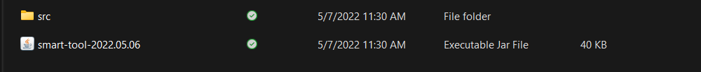

## Functions

### Main Screen

Users can access to “Create Records” , “Advanced Search” and main search functions.

*Figure 3. Main Screen*

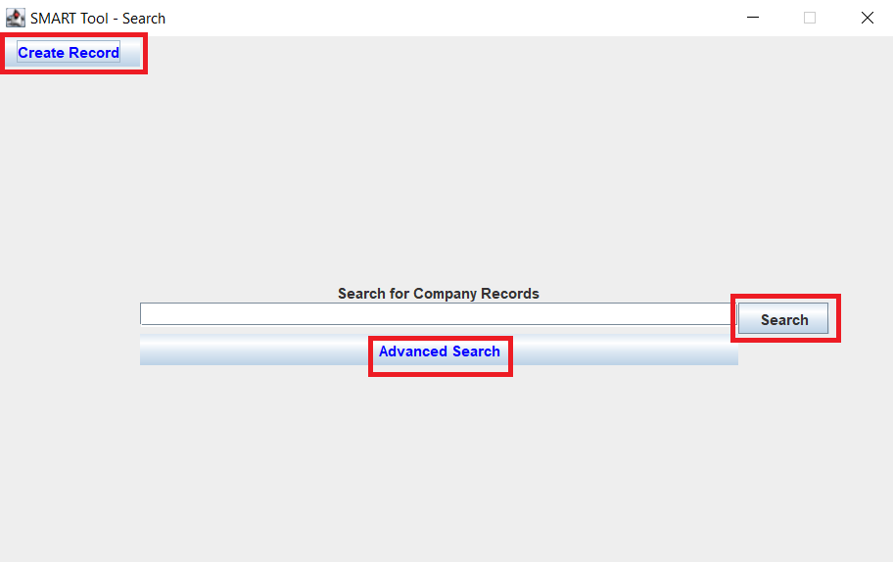

### Create Record

Following display will be shown when “Create Record” button on main screen clicks.

*Figure 4. Create Record Display*

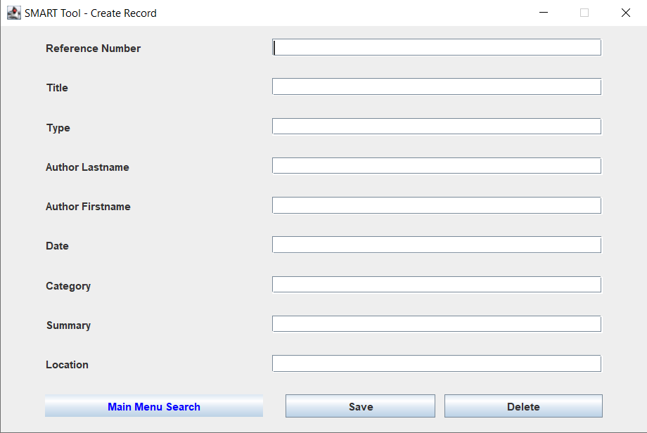

#### Reference Number

Please follow the acceptable format.

Reference Number Format: Initial of Document Type - YY - Unique Number

Acceptable initial of document types are: “R” “L” “M” “P” “T”

Each initials stand for:

R: Report

L: Letter

M: Memo

P: Presentation

T: Technical

Examples: R-22-12345, M-21-9876, T-19-01

#### Title

Please enter the title of the record.

#### Type

Please enter record type from following selections.

* REPORT
* LETTER
* MEMO
* PRESENTATION
* TECHNICAL

Please use only uppercase.

#### Author Lastname

Please enter author’s lastname who made the record.

#### Author Firstname

Please enter author’s firstname who made the record.

#### Date

Creation date displays automatically. User cannot modify this cell.

#### Category

Please enter the category of record.

#### Summary

Please enter the summary of the record. Maximum length is 500 chiropractors.

#### Location

Please enter record location.

Examples:

* Network File Location: /network/folder/reports/FYQ3/
* URL Address: <http://InternalCompany/OrderForms/PurchaseRequest.html>
* Physical location: Room7, Filing Cabinet B

#### Save Record

Please click “Save” button when all cells are written. Once click the button you will be seen popup asking if save the record.

*Figure 5. Select Option Popup*

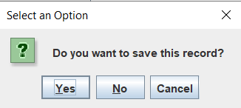

Please click “Yes” to save record. All cells are grayed out when record is successfully saved.

*Figure 6. Display when record is saved successfully.*

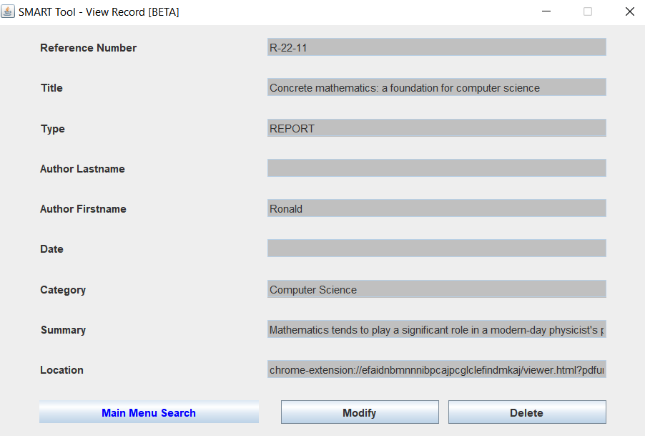

### Search

There are three locations can search records.

#### Main Search

Please enter keyword(s) and click “Search” button to search record(s).

*Figure 7. Main Search Display*

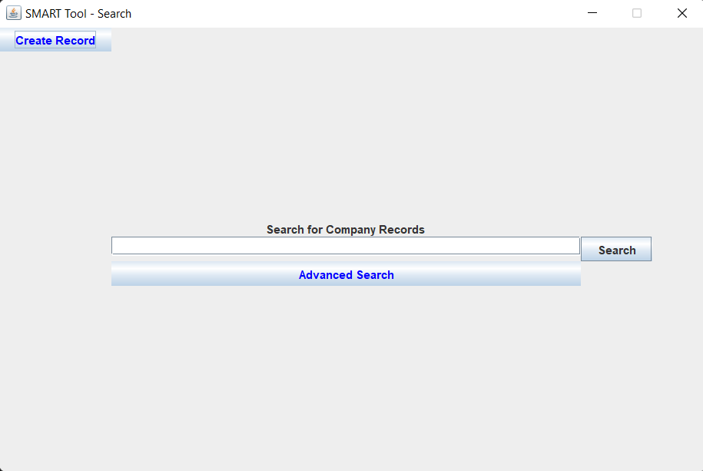

#### General Search

General search is available at Search Result display. Please enter keyword(s) to search record(s).

*Figure 8. General Search Display*

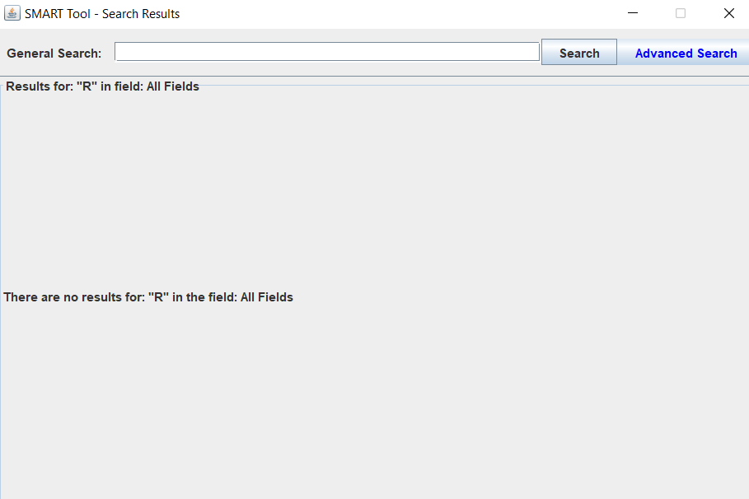

#### Advance Search

Advance search is accessible from two locations. Please click “Advance Search” button from one of following locations. Enter keyword(s) on one cell and click “Search” to search record(s).

*Figure 9. Advance Search button on Main screen*



*Figure 10. Advance Search button on Search Result screen*



*Figure 11. Advance Search Display*

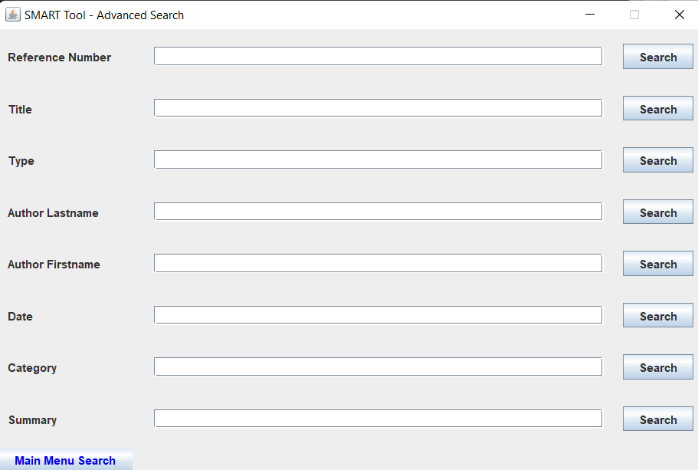

#### Search Result

You will be seen search results when you click “Search” button for Main, General and Advance Search. Please click “Select” button to view record information.

*Figure 12. Search Result Display*

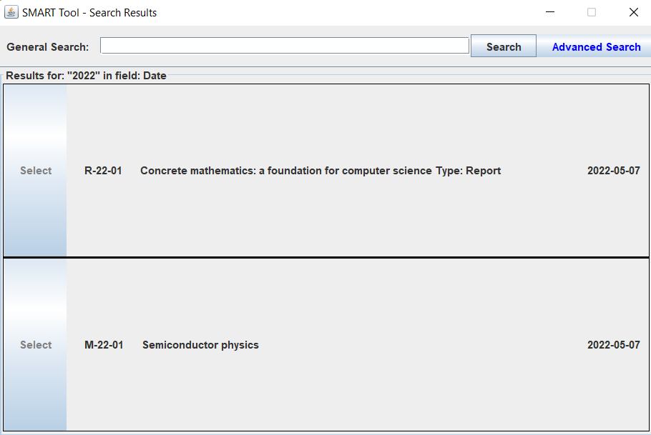

*Figure 13. View Record Display*

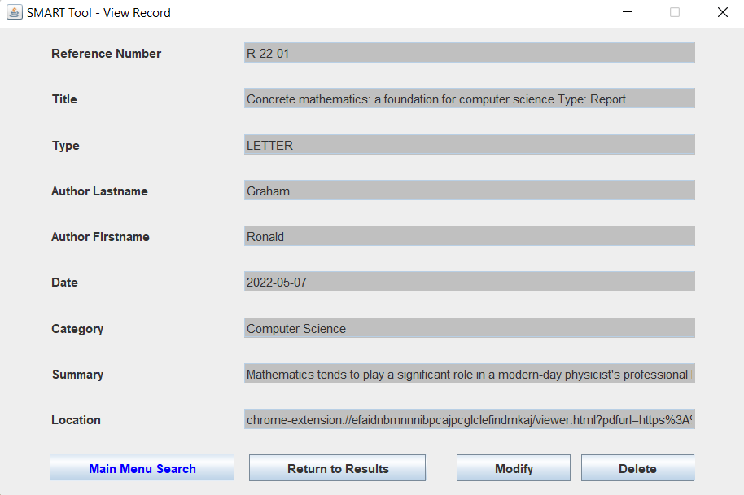

Please click “Return to Results” button if you would like to return view results.

### Modify Record

Click “Modify” to proceed to record modification.

*Figure 14. “Modify” button on View Record Display*



Once “Modify” button is clicked, grayed out cells are turn to white and you can modify the record information.

*Figure 15. Display when “Modify” button is clicked*

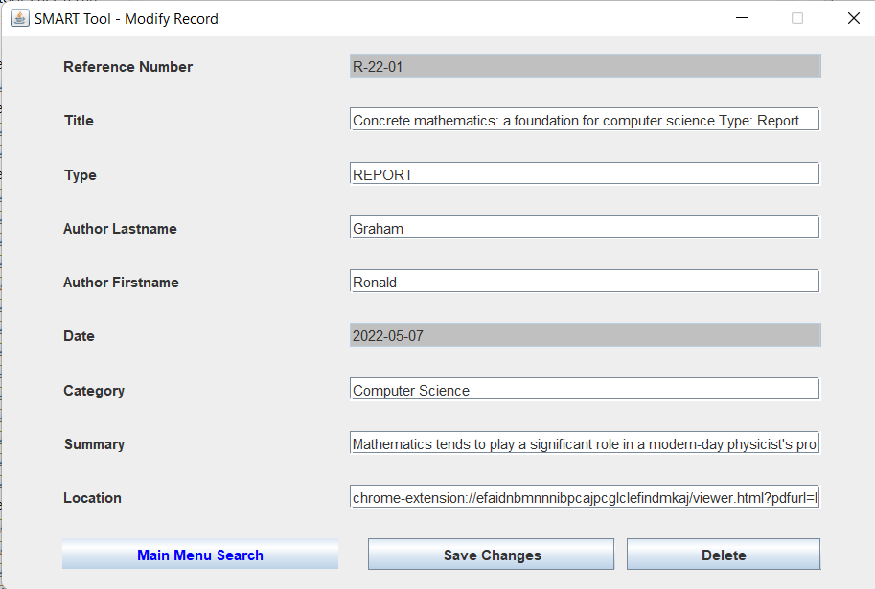

Please click “Save Changes” when modification is done. Popup will be shown. Please click “Yes” .

*Figure 16. Popup asking if save the record changes.*

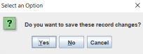

All cells grayed out and changes are saved successfully.

*Figure 17. Display when record changes*

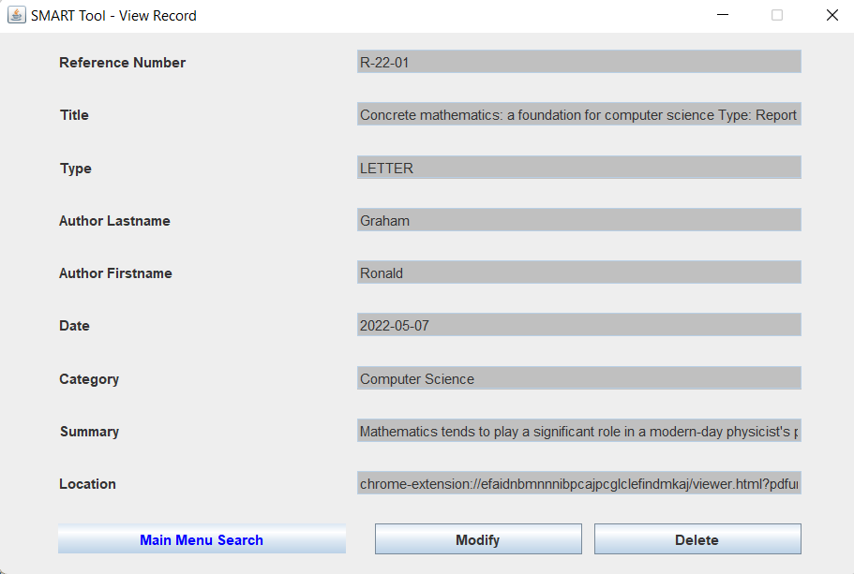

### Delete Record

User can delete record from View Record display. Click “Delete” button to proceed to delete the shown record.

*Figure 18. Delete button on View Record display*



Popup will be shown. Please click “Yes”.

*Figure 19. Popup asking if delete the record*

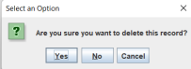

## Help

If you are shown popup with red icon, it is error notification. Please follow the message on the popup.

*Figure 20. Example of Error Notification*

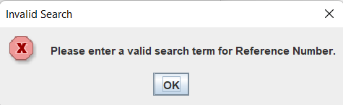

# Test Plan and Results

## Test Plan Introduction

This test plan is for SMART-Tool application. The test verifies that the application works as required and validates that the correct functionality has been delivered. The test establishes the test plan checklist used by the document squad to plan, execute, and documented. It describes the scope of the work performed and the approach taken to execute the tests created to validate that the application performs as required. The details of the test plan are developed according to the requirements specifications, and must show traceability back to those specifications.

## Test Plan Identifier

|  |  |
| --- | --- |
| Test ID | Test Contents |
| W | Static Testing |
| S | Structural Testing |
| P | Performance Testing |
| F | System Testing |
| D | Documentation |
| Q | Questions |
| U | Updates |
| S | Summary |

## Test Plan References

This test plan refers to the following documentations.

* SMART Project Plan
* SMART Design
* Desikan, S (Ramesh, G). (2007). *Software Testing: Principles and Practices.* Peason India

## Test Items - Functions

The following list shows test items and test which inspects if it works correctly. Test details are described at Section 13.

|  |  |
| --- | --- |
| Items to be Tested | Test Name |
| Coding Data Items Declaration, Data Usage, Standards, and Style | Static Testing |
| Application works as expected. | Unit/ Code Functional Testing |
| Code Quality | Code Coverage Testing |
| System Quality | System Testing |

## Software Risk Issues and Features to be Tested

SMART-TOOL needs to be tested from Users viewpoint. The list of features is below.

(H; High, M: Medium, L: :Low)

|  |  |
| --- | --- |
| Features | Risk Level |
| Open the application when user clicks the icon. | H |
| Appropriate window opens when user clicks the button | H |
| User can record the information by clicking “save new record” button with formatted information. | M |
| User can delete saved information appropriate. | M |
| User can search record from main search window. | M |
| User can search record with complete or partial information from advance search window. | M |
| User can view the list of records which match user entered at search window. | M |
| User can view detail information by clicking the record on search result view. | M |
| User can close the application by clicking “x” button. | H |

## Features not to be Tested

User can use with any language. The application targets to English language so that internationalization testing is not included as a feature to be tested.

## Approach

### White Box Testing

White box testing is the way of the program code’s external functionality. White box testing is constructed by two sections, Static Testing and Structural Testing.

#### Static Testing

Static Testing examines;

* The code works with satisfying the functional requirements.
* The code has no functional luck.
* The code ha no errors.

Code walkyhtough method is used to check contents above. Inspector(s) read code physically and raise questions to the Coding Squad. The questions and answers are shared and solved as team issues.

#### Structural Testing

Structural Testing demonstrates examination by two sections following.

##### Unit/ Code Functional Testing

Quick check before subjecting before extensive code coverage testing. Test contents are same as performance testing(sec. 6.1).

##### Code Coverage Testing

Code coverage testing is a measurement which described degree of which the source code of the program has been tested. It is consisted by 4 types of testing.

###### Statement Coverage

Statement coverage is for to cover all the possible paths, lines and statements in source code. Statement coverage is calculated by following formula:

Statement Coverage = (Total statements exercised / Total number of executable statements in program) * 100

The numbers “Total statements exercised”, “Total number of executable statements in program” are obtained by same process as following example.

Example:

Consider about following code.

**public** **class** Print {

**public** **static** **void** main(String[] args) {

**int** a=2;

**if** (a>=0)

System.***out***.println("a is equal or grater than zero.");

**else**

System.***out***.println("a is smaller than zero");

}

}

Total number of source code is 6. If a is 2, highlighted codes (4 lines) are executed.

**public** **class** Print {

**public** **static** **void** main(String[] args) {

**int** a=2;

**if** (a>=0)

System.***out***.println("a is equal or grater than zero.");

**else**

System.***out***.println("a is smaller than zero");

}

}

Statement coverage

=4/6

≈0.67

For actual testing, EclEmma is used. It is a Java coverage tool. As a setting, installation from Eclipse Marketplace is required.

Following result displays when “Launch Print” button is clicked. Following is the result of above code when a=2.

*Figure 21. Statement Coverage Testing Result*

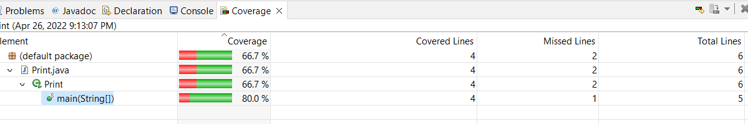

###### Branch Coverage

Branch coverage is for ensuring that each decision condition from every branch is executed at least once.

Branch coverage is calculated by following formula:

Branch Coverage = (Total branch exercised / Total number of branch in program) * 100

Branch Coverage test result of example code using EclEmma is following.

*Figure 22. Branch Coverage Testing Result*

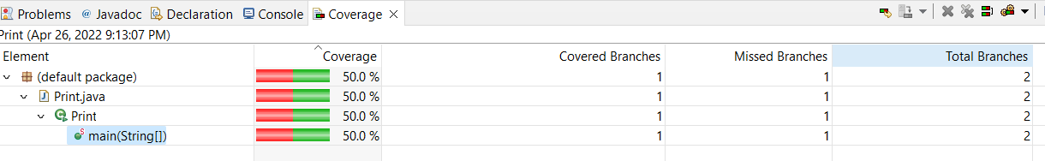

###### Complexity Coverage

Cyclomatic Complexity test is executed for each non-abstract method. The test tool summarizes complexity for classes, package and groups.

The formal definition of the cyclomatic complexity v(G) is based on the representation of following formula.

Cyclomatic Complexity

v(G) = B - D + 1 (B: number of branches, D: number of decision points)

The tool also calculates covered and missed complexity for each method. Finally, Complexity Coverage is calculated using following formula.

Complexity Coverage = (Covered Complexity / Total Complexity) * 100

Actual result for example code is following.

*Figure 23. Complexity Coverage Testing Result*

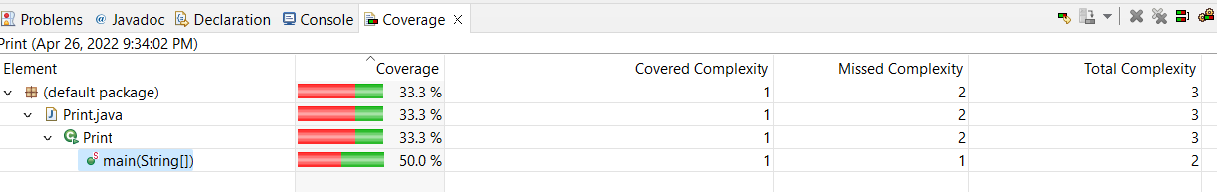

Also, colored code will be provides to analyse lines.

Annotations: Green - Fully Covered Line, Yellow - Partly Covered Line, Red - Never executed Line

Example is following.

*Figure 24. Colored Code Example*

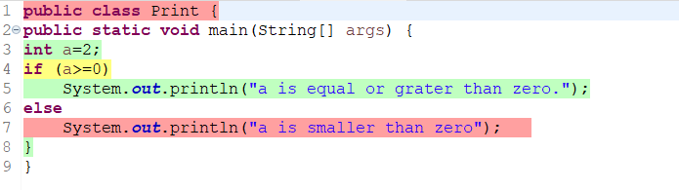

### Black Box Testing

#### Performance Testing

Performance Testing is conducted if there is no issue fount at Unit/Code Functional testing. It will be conducted with larger number of data sets. For the application, it will be focused on the “Create Record” function. Randomly extracted data from Google scholar is used. The test checks if application catches positive errors when saving them. Test sizes for each phases are following.

|  |  |  |
| --- | --- | --- |
| File Name | Data Set Size | Number of Positive Errors |
| Phase 2 Performance Testing | 1 | 6 |
| Phase 3 Performance Testing | 5 | 5 |
| Final Week Performance Testing | 30 | 20 |

#### Stress Testing

Stress testing is verification of application stability and reliability. For smart-tool, Netbeans profile tool is used. Following the example when Netbean executes profiling. Using Garbage collection result, memory leak is checked as well. Pick random time and write each numbers in the check list cells.

*Figure 25. Stress Testing Result Example*

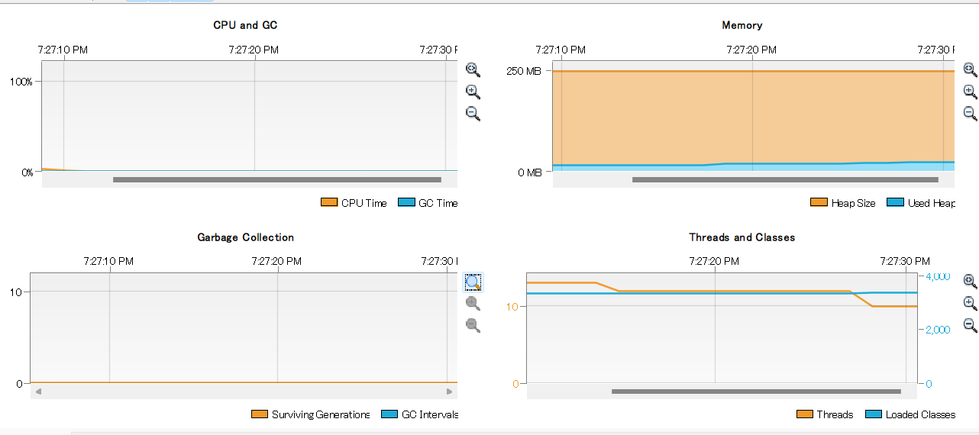

#### Regression Testing

Registration test is designated for ensuring that software works appropriately when enhancements or defect fixes are made.

### Item Pass/Fail Criteria

#### Static Testing (W Section on the Check List)

Item will be passed when there is no significant remarks on the final week check list.

#### Structural Testing (S Section on the Check List)

* S-01: Item will be passes when output matches the expected result.
* S-02: There is no certain percentage to pass the test. Read the colored lines and correct code if it is required.

#### Performance Testing (P Section on the Check List)

The application will pass the test when it catches correct positive errors.

#### Stress Testing (F Section on the Check List)

There is no certain percentage to pass the test. If unusual percent change is observed during profiling. Note ant let coding squad know about it.

### Suspension Criteria and Resumption Requirement

Test plan schedule is made based on the SMART Project Plan. Test plans may be modified or paused if following situations are happen.

* Schedule delay
* Schedule change caused significant application structure change
* Application Fatal Errors

## Test Deliverable

### Test Cases

|  |  |  |  |  |
| --- | --- | --- | --- | --- |
| Test Case | Input | Expected Output | Actual Output | Pass |
| 1 | Execute Application | App GUI is displayed. |  |  |
| 2 | Click “Create Record” button. | GUI “Create Record” appears. |  |  |
| 3. | Enter Information in each cells.  Title: Concrete mathematics: a foundation for computer science  Type: Report  Author Lastname: Graham  Author Fistname: Ronald  Category: Computer Science  Summary:  Mathematics tends to play a significant role in a modern-day physicist's professional life. This is a theme deftly brought out by Wigner in a celebrated essay on the unreasonable effectiveness of mathematics in the natural sciences-particularly, its effectiveness in physics.  Location: chrome-extension://efaidnbmnnnibpcajpcglclefindmkaj/viewer.html?pdfurl=https%3A%2F%2Faip.scitation.org%2Fdoi%2Fpdf%2F10.1063%2F1.4822863&pdffilename=1.4822863.pdf | User is shown the popup asking if you want to save the record. Then “Selected Record” screen with all of the input they entered will be shown when user clicks” yes”. |  |  |
| 4 | User clicks the “Save” button with modified information. | Users is shown a popup asking if they are sure they want to save, with “Yes”, “No” and “Cancel” buttons as the choices. |  |  |
| 5 | User attempts to create a record without filling in all of the fields. | User is shown a popup which prompts them to fill in every field when creating a record. |  |  |
| 6 | User entered Summery excess of 500 character limit.  Input data: Mathematics tends to play a significant role in a modern-day physicist's professional life. This is a theme deftly brought out by Wigner in a celebrated essay on the unreasonable effectiveness of mathematics in the natural sciences-particularly, its effectiveness in physics. It is pointed out that " ... mathematical concepts turn up in entirely unexpected connections. Moreover, they often permit an unexpectedly close and accurate description of the phenomena in these connections. " Despite the seemingly restrictive subtitle of this book, Concrete Mathematics: A Foundation for Computer Science, is first and foremost a most approachable book on mathematics: | Popup shows message that summary should be within 500 characters. |  |  |
| 7 | Entered Invalid “Type”  Input Data: Article | User is shown a popup message to enter valid “Type” |  |  |
| 8 | User Types Data into Text Box and clicks "Search" | User receives a list of records that contain the input in the specified field of the advanced search. (For example, if they put a partial title in the title field they should receive a list of all records with their input in the title. The user should never receive record results where their input matches a data in a different field than the field they were searching under.) |  |  |
| 9 | User Types Data into Text Box and clicks "Search"  Used Data: ronald | Application is case sensitive. There is no matched information |  |  |
| 10 | User clicks "Search" without typing in text box | User is notified that text box must not be empty |  |  |
| 11 | User clicks “Return to Result” button | User can return to search result list. |  |  |
| 12 | User clicks “x” | User exits the program |  |  |
| 13 | User clicks the “Delete” button on Modify Record screen. | Users is shown a popup asking if they are sure they want to delete the record, with “Yes” and “Cancel” buttons as the two choices. |  |  |
| 14 | User attempts to enter duplicated information in the system | Error message about duplication |  |  |

### Check Lists

#### Phase 1 Check List

|  |  |  |
| --- | --- | --- |
| Phase 1 Check List | | |
| **W** | **Static Testing** | |
| **W-01** | **Data Item Declaration** | |
| W-01-01 | Are the variable names meaningful? |  |
| W-01-02 | If the programming language allows mixed case names, are there variable names with confusing use of lower case letters and capital letters? |  |
| W-01-03 | Are the variable initialized? |  |
| W-01-04 | Are there similar sounding names? |  |
| W-01-05 | Are all common structures, constants, and flag to be used in a header file rather than in each file separately? |  |
| **W-02** | **Data Usage** | |
| W-02-01 | Are values of right data types being assigned to the variables? |  |
| W-02-02 | Is the access of data from any standard files, repositories, or databases done through publicly supported interfaces? |  |
| W-02-03 | Has the usage of similar-looking operators (e.g. = and ==) |  |
| **W-03** | **Standards** | |
| W-03-01 | Does the code follow the coding convention of the organization? |  |
| W-03-02 | Does the code follow the coding convention that are platform specific (e.g. GUI calls specific Windows or Swing)? |  |
| **W-04** | **Style** | |
| W-04-01 | Are unhealthy programming constructs being used? |  |
| W-04-02 | Is there usage of specific idiosyncrasies of a particular machine architecture or a given version of an underlying product (e.g. using “undocumented” features)? |  |
| W-04-03 | Is sufficient attention being paid to readability issues like indentation of code? |  |
| **W-05** | **Miscellaneous** | |
| W-05-01 | Have you checked for memory leaks (e.g. memory acquired but not explicitly freed.)? |  |
| **Q** | **Questions** | |
| Q-01 | Question(s) and feedback (s) to the Coding Squad |  |
| Q-02 | Answer(s) from Coding Squad |  |

#### Phase 2 Check List

|  |  |  |  |  |  |  |  |  |  |
| --- | --- | --- | --- | --- | --- | --- | --- | --- | --- |
| Phase 2 Check List | | | | | | | Date: | | |
| Application version conducted test: | | | | | | | | | |
| Environment Information | | | | | | | | | |
| OS | |  | | Processor | |  | | | |
| Memory | |  | | Storage | |  | | | |
| **U** | **Update(s) from Phase 1** | | | | | | | | |
| U-01 | Update(s) based on the questions and answers made at Phase 1 | | |  | | | | | |
| U-02 | Is Regression test required for the updates? | | |  | | | | | |
| **W** | **Static Testing** | | | | | | | | |
| **W-01** | **Data Item Declaration** | | | | | | | | |
| W-01-01 | Are the variable names meaningful? | | |  | | | | | |
| W-01-02 | If the programming language allows mixed case names, are there variable names with confusing use of lower case letters and capital letters? | | |  | | | | | |
| W-01-03 | Are the variable initialized? | | |  | | | | | |
| W-01-04 | Are there similar sounding names? | | |  | | | | | |
| W-01-05 | Are all common structures, constants, and flag to be used in a header file rather than in each file separately? | | |  | | | | | |
| **W-02** | **Data Usage** | | | | | | | | |
| W-02-01 | Are values of right data types being assigned to the variables? | | |  | | | | | |
| W-02-02 | Is the access of data from any standard files, repositories, or databases done through publicly supported interfaces? | | |  | | | | | |
| W-02-03 | Has the usage of similar-looking operators (e.g. = and ==) | | |  | | | | | |
| **W-03** | **Standards** | | | | | | | | |
| W-03-01 | Does the code follow the coding convention of the organization? | | |  | | | | | |
| W-03-02 | Does the code follow the coding convention that are platform specific (e.g. GUI calls specific Windows or Swing)? | | |  | | | | | |
| **W-04** | **Style** | | | | | | | | |
| W-04-01 | Are unhealthy programming constructs being used? | | |  | | | | | |
| W-04-02 | Is there usage of specific idiosyncrasies of a particular machine architecture or a given version of an underlying product (e.g. using “undocumented” features)? | | |  | | | | | |
| W-04-03 | Is sufficient attention being paid to readability issues like indentation of code? | | |  | | | | | |
| **W-05** | **Miscellaneous** | | | | | | | | |
| W-05-01 | Have you checked for memory leaks (e.g. memory acquired but not explicitly freed.)? | | |  | | | | | |
| **S** | **Structural Testing** | | | | | | | | |
| **S-01** | **Unit/Code Functional Testing** | | |  | | | | | |
| S-01-01 | Test cases | | |  | | | | | |
| Test Case | | Input | | Expected Output | | |  |  |
| 1 | | Execute Application | | App GUI is displayed. | | |  |  |
| 2 | | Click “Create Record” button. | | GUI “Create Record” appears. | | |  |  |
| 3. | | Enter Information in each cells.  Title:  Type: Report  Author Lastname: Graham  Author Fistname: Ronald  Category: Computer Science  Summary:  Mathematics tends to play a significant role in a modern-day physicist's professional life. This is a theme deftly brought out by Wigner in a celebrated essay on the unreasonable effectiveness of mathematics in the natural sciences-particularly, its effectiveness in physics.  Location: chrome-extension://efaidnbmnnnibpcajpcglclefindmkaj/viewer.html?pdfurl=https%3A%2F%2Faip.scitation.org%2Fdoi%2Fpdf%2F10.1063%2F1.4822863&pdffilename=1.4822863.pdf | | User is shown the “Selected Record” screen with all of the input they entered. | | |  |  |
| 4 | | User clicks the “Save” button with modified information. | | Users is shown a popup asking if they are sure they want to save, with “Yes” and “Cancel” buttons as the two choices. | | |  |  |
| 5 | | User attempts to create a record without filling in all of the fields. | | User is shown a popup which prompts them to fill in every field when creating a record. | | |  |  |
| 6 | | User entered Summery excess of 500 character limit.  Input data: Mathematics tends to play a significant role in a modern-day physicist's professional life. This is a theme deftly brought out by Wigner in a celebrated essay on the unreasonable effectiveness of mathematics in the natural sciences-particularly, its effectiveness in physics. It is pointed out that " ... mathematical concepts turn up in entirely unexpected connections. Moreover, they often permit an unexpectedly close and accurate description of the phenomena in these connections. " Despite the seemingly restrictive subtitle of this book, Concrete Mathematics: A Foundation for Computer Science, is first and foremost a most approachable book on mathematics: | | Popup shows message that summary should be within 500 characters. | | |  |  |
| 7 | | User Types Data into Text Box and clicks "Search"  Used Data: Title, Author Lastname | | User receives list of Data matching input regardless of field | | |  |  |
| 8 | | User clicks "Search" without typing in text box | | User is notified that text box must not be empty | | |  |  |
| 9 | | User clicks "Advanced Search" | | User is shown the "Advanced Search" Window | | |  |  |
| 10 | | User clicks “x” | | User exits the program | | |  |  |
| 11 | | User enters invalid characters into any text field within each of the searches and the Create/Modify Record screen. (We can break this out into individual tests for every text field to ensure error detection is working properly.) | | User is shown an error popup and prompted to try again. | | |  |  |
| 12 | | User clicks the “Delete” button on Create/Modify Record screen. | | Users is shown a popup asking if they are sure they want to delete the record, with “Yes” and “Cancel” buttons as the two choices. | | |  |  |
| 13 | | User enters partial data into any text field under the advanced search. | | User receives a list of records that contain the input in the specified field of the advanced search. (For example, if they put a partial title in the title field they should receive a list of all records with their input in the title. The user should never receive record results where their input matches a data in a different field than the field they were searching under.) | | |  |  |
|  | 14 | | User entered invalid date format | | Error message to enter correct data format | | |  |  |
|  | 15 | | User attempts to enter duplicated information in the system | | Error message about duplication | | |  |  |
| S-01-02 | Successfully conducted debugger function on IDE? | | |  | | | | | |
| **D** | **Documentation** | | | | | | | | |
| D-01 | Is the code adequately documented, especially where the logic is complex or the section of code is critical for product functioning? | | |  | | | | | |
| D-02 | Is appropriate change history documented? | | |  | | | | | |
| D-03 | Are the interfaces and the parameters thereof properly documented | | |  | | | | | |
| **Q** | **Questions** | | | | | | | | |
| Q-01 | Question(s) and feedback (s) to the Coding Squad | | |  | | | | | |
| Q-02 | Answer(s) from Coding Squad | | |  | | | | | |

#### Phase 3 Check List

|  |  |  |  |  |  |  |  |  |
| --- | --- | --- | --- | --- | --- | --- | --- | --- |
| Phase 3 Check List | | | | | | | | |
| Application version conducted test: | | | | | | | | |
| Environment Information | | | | | | | | |
| OS | | |  | Processor | | |  | |
| Memory | | |  | Storage | | |  | |
| **U** | **Update(s) from Phase 1** | | | | | | | |
| U-01 | Update(s) based on the questions and answers made at Phase 1 | | |  | | | | |
| U-02 | Is Regression test required for the updates? | | |  | | | | |
| **W** | **Static Testing** | | | | | | | |
| **W-01** | **Data Item Declaration** | | | | | | | |
| W-01-01 | Are the variable names meaningful? | | |  | | | | |
| W-01-02 | If the programming language allows mixed case names, are there variable names with confusing use of lower case letters and capital letters? | | |  | | | | |
| W-01-03 | Are the variable initialized? | | |  | | | | |
| W-01-04 | Are there similar sounding names? | | |  | | | | |
| W-01-05 | Are all common structures, constants, and flag to be used in a header file rather than in each file separately? | | |  | | | | |
| **W-02** | **Data Usage** | | | | | | | |
| W-02-01 | Are values of right data types being assigned to the variables? | | |  | | | | |
| W-02-02 | Is the access of data from any standard files, repositories, or databases done through publicly supported interfaces? | | |  | | | | |
| W-02-03 | Has the usage of similar-looking operators (e.g. = and ==) | | |  | | | | |
| **W-03** | **Standards** | | | | | | | |
| W-03-01 | Does the code follow the coding convention of the organization? | | |  | | | | |
| W-03-02 | Does the code follow the coding convention that are platform specific (e.g. GUI calls specific Windows or Swing)? | | |  | | | | |
| **W-04** | **Style** | | | | | | | |
| W-04-01 | Are unhealthy programming constructs being used? | | |  | | | | |
| W-04-02 | Is there usage of specific idiosyncrasies of a particular machine architecture or a given version of an underlying product (e.g. using “undocumented” features)? | | |  | | | | |
| W-04-03 | Is sufficient attention being paid to readability issues like indentation of code? | | |  | | | | |
| **W-05** | **Miscellaneous** | | | | | | | |
| W-05-01 | Have you checked for memory leaks (e.g. memory acquired but not explicitly freed.)? | | |  | | | | |
| **S** | **Structural Testing** | | | | | | | |
| **S-01** | **Unit/Code Functional Testing** | | | | | | | |
| S-01-01 | Test cases | | |  | | | | |
| Test Case | Input | | | Expected Output | Actual Output | | Pass |
| 1 | Execute Application | | | App GUI is displayed. |  | |  |
| 2 | Click “Create Record” button. | | | GUI “Create Record” appears. |  | |  |
| 3. | Enter Information in each cells.  Title:  Type: Report  Author Lastname: Graham  Author Fistname: Ronald  Category: Computer Science  Summary:  Mathematics tends to play a significant role in a modern-day physicist's professional life. This is a theme deftly brought out by Wigner in a celebrated essay on the unreasonable effectiveness of mathematics in the natural sciences-particularly, its effectiveness in physics.  Location: chrome-extension://efaidnbmnnnibpcajpcglclefindmkaj/viewer.html?pdfurl=https%3A%2F%2Faip.scitation.org%2Fdoi%2Fpdf%2F10.1063%2F1.4822863&pdffilename=1.4822863.pdf | | | User is shown the “Selected Record” screen with all of the input they entered. |  | |  |
| 4 | User clicks the “Save” button with modified information. | | | Users is shown a popup asking if they are sure they want to save, with “Yes” and “Cancel” buttons as the two choices. |  | |  |
| 5 | User attempts to create a record without filling in all of the fields. | | | User is shown a popup which prompts them to fill in every field when creating a record. |  | |  |
| 6 | User entered Summery excess of 500 character limit.  Input data: Mathematics tends to play a significant role in a modern-day physicist's professional life. This is a theme deftly brought out by Wigner in a celebrated essay on the unreasonable effectiveness of mathematics in the natural sciences-particularly, its effectiveness in physics. It is pointed out that " ... mathematical concepts turn up in entirely unexpected connections. Moreover, they often permit an unexpectedly close and accurate description of the phenomena in these connections. " Despite the seemingly restrictive subtitle of this book, Concrete Mathematics: A Foundation for Computer Science, is first and foremost a most approachable book on mathematics: | | | Popup shows message that summary should be within 500 characters. |  | |  |
| 7 | User Types Data into Text Box and clicks "Search"  Used Data: Title, Author Lastname | | | User receives list of Data matching input regardless of field |  | |  |
| 8 | User clicks "Search" without typing in text box | | | User is notified that text box must not be empty |  | |  |
| 9 | User clicks "Advanced Search" | | | User is shown the "Advanced Search" Window |  | |  |
| 10 | User clicks “x” | | | User exits the program |  | |  |
| 11 | User enters invalid characters into any text field within each of the searches and the Create/Modify Record screen. (We can break this out into individual tests for every text field to ensure error detection is working properly.) | | | User is shown an error popup and prompted to try again. |  | |  |
| 12 | User clicks the “Delete” button on Create/Modify Record screen. | | | Users is shown a popup asking if they are sure they want to delete the record, with “Yes” and “Cancel” buttons as the two choices. |  | |  |
| 13 | User enters partial data into any text field under the advanced search. | | | User receives a list of records that contain the input in the specified field of the advanced search. (For example, if they put a partial title in the title field they should receive a list of all records with their input in the title. The user should never receive record results where their input matches a data in a different field than the field they were searching under.) |  | |  |
|  | 14 | User entered invalid date format | | | Error message to enter correct data format |  | |  |
|  | 15 | User attempts to enter duplicated information in the system | | | Error message about duplication |  | |  |
| S-01-02 | Successfully conducted debugger function on IDE? | | |  | | | | |
| **S-02** | **Code Coverage Testing** | | | | | | | |
| S-02-01 | Statement coverage percentage | | |  | | | | |
| S-02-02 | Path coverage percentage | | |  | | | | |
| S-02-03 | Condition coverage percentage | | |  | | | | |
| S-02-04 | Function coverage percentage | | |  | | | | |
| **P** | **Performance Testing** | | | | | | | |
| P-01 | Test Cases | | |  | | | | |
| P-01-01 | Data sets size | | |  | | | | |
| P-01-02 | Average | | | | | | | |
| Number of True Positive Errors | | | Number of Actual Positive Errors | | | Precision | |
|  | | |  | | |  | |
| **P-02** | **Performance Testing Analysis and Tuning** | | | | | | | |
| P-02-01 | Performance Testing Analysis | | |  | | | | |
| P-02-02 | Is tuning required? | | |  | | | | |
| **D** | **Documentation** | | | | | | | |
| D-01 | Is the code adequately documented, especially where the logic is complex or the section of code is critical for product functioning? | | |  | | | | |
| D-02 | Is appropriate change history documented? | | |  | | | | |
| D-03 | Are the interfaces and the parameters thereof properly documented | | |  | | | | |
| **Q** | **Questions** | | | | | | | |
| Q-01 | Question(s) and feedback (s) to the Coding Squad | | |  | | | | |
| Q-02 | Answer(s) from Coding Squad | | |  | | | | |

#### Final Week Check List

|  |  |  |  |  |  |  |  |  |  |  |  |  |  |  |  |  |  |  |
| --- | --- | --- | --- | --- | --- | --- | --- | --- | --- | --- | --- | --- | --- | --- | --- | --- | --- | --- |
| Final Week Check List | | | | | | | | | | | | | | Date: | | | | |
| Application version conducted test: | | | | | | | | | | | | | | | | | | |
| Inspector | | | | |  | | | | | | | | | | | | | |
| Environment Information | | | | | | | | | | | | | | | | | | |
| OS | |  | | | | | | | | | Processor | | |  | | | | |
| Memory | |  | | | | | | | | | Storage | | |  | | | | |
| **U** | **Update(s) from Phase 1** | | | | | | | | | | | | | | | | | |
| U-01 | Update(s) based on the questions and answers made at Phase 1 | | | | | | | | | |  | | | | | | | |
| U-02 | Is Regression test required for the updates? | | | | | | | | | |  | | | | | | | |
| **W** | **Static Testing** | | | | | | | | | | | | | | | | | |
| **W-01** | **Data Item Declaration** | | | | | | | | | | | | | | | | | |
| W-01-01 | Are the variable names meaningful? | | | | | | | | | |  | | | | | | | |
| W-01-02 | If the programming language allows mixed case names, are there variable names with confusing use of lower case letters and capital letters? | | | | | | | | | |  | | | | | | | |
| W-01-03 | Are the variable initialized? | | | | | | | | | |  | | | | | | | |
| W-01-04 | Are there similar sounding names? | | | | | | | | | |  | | | | | | | |
| W-01-05 | Are all common structures, constants, and flag to be used in a header file rather than in each file separately? | | | | | | | | | |  | | | | | | | |
| **W-02** | **Data Usage** | | | | | | | | | | | | | | | | | |
| W-02-01 | Are values of right data types being assigned to the variables? | | | | | | | | | |  | | | | | | | |
| W-02-02 | Is the access of data from any standard files, repositories, or databases done through publicly supported interfaces? | | | | | | | | | |  | | | | | | | |
| W-02-03 | Has the usage of similar-looking operators (e.g. = and ==) | | | | | | | | | |  | | | | | | | |
| **W-03** | **Standards** | | | | | | | | | | | | | | | | | |
| W-03-01 | Does the code follow the coding convention of the organization? | | | | | | | | | |  | | | | | | | |
| W-03-02 | Does the code follow the coding convention that are platform specific (e.g. GUI calls specific Windows or Swing)? | | | | | | | | | |  | | | | | | | |
| **W-04** | **Style** | | | | | | | | | | | | | | | | | |
| W-04-01 | Are unhealthy programming constructs being used? | | | | | | | | | |  | | | | | | | |
| W-04-02 | Is there usage of specific idiosyncrasies of a particular machine architecture or a given version of an underlying product (e.g. using “undocumented” features)? | | | | | | | | | |  | | | | | | | |
| W-04-03 | Is sufficient attention being paid to readability issues like indentation of code? | | | | | | | | | |  | | | | | | | |
| **W-05** | **Miscellaneous** | | | | | | | | | | | | | | | | | |
| W-05-01 | Have you checked for memory leaks (e.g. memory acquired but not explicitly freed.)? | | | | | | | | | |  | | | | | | | |
| **S** | **Structural Testing** | | | | | | | | | | | | | | | | | |
| **S-01** | **Unit/Code Functional Testing** | | | | | | | | | |  | | | | | | | |
| S-01-01 | Test Cases | | | | | | | | | | | | | | | | | |
| Test Case# | | Input | | | | | | | | Expected Output | | | | Actual Output | | | Pass |
| 1 | | Execute Application | | | | | | | | App GUI is displayed. | | | |  | | |  |
| 2 | | Click “Create Record” button. | | | | | | | | GUI “Create Record” appears. | | | |  | | |  |
| 3. | | Enter Information in each cells.  Title: Concrete mathematics: a foundation for computer science  Type: Report  Author Lastname: Graham  Author Fistname: Ronald  Category: Computer Science  Summary:  Mathematics tends to play a significant role in a modern-day physicist's professional life. This is a theme deftly brought out by Wigner in a celebrated essay on the unreasonable effectiveness of mathematics in the natural sciences-particularly, its effectiveness in physics.  Location: chrome-extension://efaidnbmnnnibpcajpcglclefindmkaj/viewer.html?pdfurl=https%3A%2F%2Faip.scitation.org%2Fdoi%2Fpdf%2F10.1063%2F1.4822863&pdffilename=1.4822863.pdf | | | | | | | | User is shown the popup asking if you want to save the record. Then “Selected Record” screen with all of the input they entered will be shown when user clicks” yes”. | | | |  | | |  |
| 4 | | User clicks the “Save” button with modified information. | | | | | | | | Users is shown a popup asking if they are sure they want to save, with “Yes”, “No” and “Cancel” buttons as the choices. | | | |  | | |  |
| 5 | | User attempts to create a record without filling in all of the fields. | | | | | | | | User is shown a popup which prompts them to fill in every field when creating a record. | | | |  | | |  |
| 6 | | User entered Summery excess of 500 character limit.  Input data: Mathematics tends to play a significant role in a modern-day physicist's professional life. This is a theme deftly brought out by Wigner in a celebrated essay on the unreasonable effectiveness of mathematics in the natural sciences-particularly, its effectiveness in physics. It is pointed out that " ... mathematical concepts turn up in entirely unexpected connections. Moreover, they often permit an unexpectedly close and accurate description of the phenomena in these connections. " Despite the seemingly restrictive subtitle of this book, Concrete Mathematics: A Foundation for Computer Science, is first and foremost a most approachable book on mathematics: | | | | | | | | Popup shows message that summary should be within 500 characters. | | | |  | | |  |
| 7 | | Entered Invalid “Type”  Input Data: Article | | | | | | | | User is shown a popup message to enter valid “Type” | | | |  | | |  |
| 8 | | User Types Data into Text Box and clicks "Search" | | | | | | | | User receives a list of records that contain the input in the specified field of the advanced search. (For example, if they put a partial title in the title field they should receive a list of all records with their input in the title. The user should never receive record results where their input matches a data in a different field than the field they were searching under.) | | | |  | | |  |
| 9 | | User Types Data into Text Box and clicks "Search"  Used Data: ronald | | | | | | | | Application is case sensitive. There is no matched information | | | |  | | |  |
| 10 | | User clicks "Search" without typing in text box | | | | | | | | User is notified that text box must not be empty | | | |  | | |  |
| 11 | | User clicks “Return to Result” button | | | | | | | | User can return to search result list. | | | |  | | |  |
| 12 | | User clicks “x” | | | | | | | | User exits the program | | | |  | | |  |
| 14 | | User clicks the “Delete” button on Modify Record screen. | | | | | | | | Users is shown a popup asking if they are sure they want to delete the record, with “Yes” and “Cancel” buttons as the two choices. | | | |  | | |  |
| 16 | | User attempts to enter duplicated information in the system | | | | | | | | Error message about duplication | | | |  | | |  |
| S-01-02 | Successfully conducted debugger function on IDE? | | | | | | | | | | yes | | | | | | | |
| **S-02** | **Code Coverage Testing** | | | | | | | | | | | | | | | | | |
| S-02-01 | Statement coverage percentage | | | | | | | | | |  | | | | | | | |
| S-02-02 | Branch coverage percentage | | | | | | | | | |  | | | | | | | |
| S-02-03 | Complexity coverage percentage | | | | | | | | | |  | | | | | | | |
| S-02-04 | Code Coverage Results | | | | | | | | | |  | | | | | | | |
| **P** | **Performance Testing** | | | | | | | | | | | | | | | | | |
| P-01 | Test Cases | | | | | | | | | |  | | | | | | | |
| P-01-01 | Data sets size | | | | | | | | | |  | | | | | | | |
| P-01-02 | Results | | | | | | | | | |  | | | | | | | |
| Number of True Positive Errors | | | | | | | Number of Actual Positive Errors | | | | | | | | Precision | | |
|  | | | | | | |  | | | | | | | |  | | |
| **P-02** | **Performance Testing Analysis and Tuning** | | | | | | | | | | | | | | | | | |
| P-02-01 | Performance Testing Analysis | | | | | | | | | |  | | | | | | | |
| P-02-02 | Is tuning required? | | | | | | | | | |  | | | | | | | |
| **F** | **Stress Testing** | | | | | | | | | | | | | | | | | |
| F-01-01 |  | | | | | | | | | | | | | | | | | |
|  | Create Data Size: | | | | | | | | | | | | | | | | | |
| Main Search | | | | | | | | | | | | | | | | | |
|  | | | Time | | | CPU Time | | | GPU Time | | | Heap Size | | | | Used Heap | |
| 1 | | |  | | |  | | |  | | |  | | | |  | |
| 2 | | |  | | |  | | |  | | |  | | | |  | |
| 3 | | |  | | |  | | |  | | |  | | | |  | |
| 4 | | |  | | |  | | |  | | |  | | | |  | |
| 5 | | |  | | |  | | |  | | |  | | | |  | |
| Average | | |  | | |  | | |  | | |  | | | |  | |
| Advance Search | | | | | | | | | | | | | | | | | |
|  | | | Time | | CPU Time | | | | | GPU Time | Heap Size | | | | Used Heap | | |
| 1 | | |  | |  | | | | |  |  | | | |  | | |
| 2 | | |  | |  | | | | |  |  | | | |  | | |
| 3 | | |  | |  | | | | |  |  | | | |  | | |
| 4 | | |  | |  | | | | |  |  | | | |  | | |
| 5 | | |  | |  | | | | |  |  | | | |  | | |
| Average | | |  | |  | | | | |  |  | | | |  | | |
| **D** | **Documentation** | | | | | | | | | | | | | | | | | |
| D-01 | Is the code adequately documented, especially where the logic is complex or the section of code is critical for product functioning? | | | | | | | | | |  | | | | | | | |
| D-02 | Is appropriate change history documented? | | | | | | | | | |  | | | | | | | |
| D-03 | Are the interfaces and the parameters thereof properly documented | | | | | | | | | |  | | | | | | | |
| **S** | **Summary** | | | | | | | | | | | | | | | | | |
|  | | | | | | | | | | | | | | | | | | |
| **A** | **Approval** | | | | | | | | | | | | | | | | | |
| Signature | | | | | | | | |  | | | | | | | | | |

### Testing Specifications using Check List

#### Static Testing (W Section on the Check List)

Answer all questions on the check list reading all codes.

Regarding W-05-01, use the Garbage Collection result when Stress test is executed.

*Figure 26. Garbage Collection Result Example*

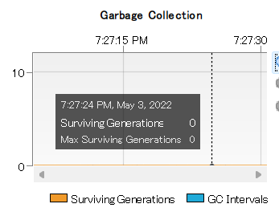

#### Structural Testing (S Section on the Check List)

* S-01: Execute all test cases on the check list.
* S-02: Execute all test cases on Eclipse which has EclEmma plugin. Result will be display as same as Section 13.2.2 at “Coverage” tab.

#### Performance Testing (P Section on the Check List)

Using “Performance Testing Data” file. Input each data on the file one by one and check if the application catches errors correctly. Write result on the check sheet.

#### Stress Testing (F Section on the Check List)

Start profiling session on Netbeans IDE. Execute a function (e.g. Create Record) .

Pick time randomly and write down the result on the check list. Repeat 5 times and get average by calculation.

*Figure 27. Selected Stress Test Result at 7:27:24*

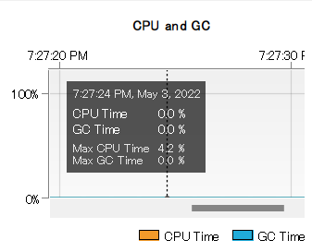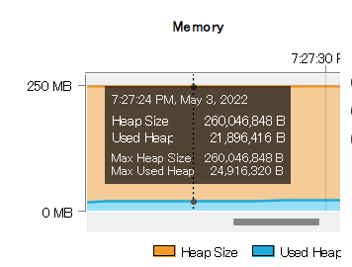

## Environmental Needs

In addition to the system requirements (Section 3.3) two IDEs are required.

* Eclipse3.8 or higher
* Netbeans 7.1 or higher

## Staffing and Responsibilities

Documentation Squad takes primary actions for test management.

Document Squad takes following responsibilities.

* Seeking risks.
* Selecting features to be tested and not tested.
* Setting overall strategy for the plan.
* Providing for resolution of scheduling conflicts.

## Schedule

Test will be provided using check list (Sec. 10). Test contents for each phases are following. Regression Test will be added to the Test contents when enhancements or defect fixes are made on the application.

* Phase 1 (13 Apr - 19 Apr): Static Testing
* Phase 2 (20 Apr - 26 Apr): Static Testing
* Phase 3 (27 Apr - 3 May): Static Testing, Structural Testing, Performance Testing (w/ Larger data sets), (Regression Testing, if it is applicable)
* Final Week (4 May - 10 May): Static Testing, Structural Testing, Performance Testing, Stress Testing. (Regression Testing, if it is applicable)

## Planning Risks and Contingencies

### Overall Risks

Overall Risks to the project with testing process are following

* Lack of personnel resources when testing is to begin.
* Lack of availability if required hardware, software, data or tools.
* Lack of availability if required hardware, software, data or tools.
* Late delivery of the software.
* Change to the original requirements or designs.

### Actions will be Taken

If schedule or requirements change, the following actions will be taken.

* The test schedule and development schedule will move out an appropriate number of days.
* The number of test performed will be reduced.
* The number of acceptable defects will be increased.
* The scope of the plan may be changed.

## Approvals

All SMART team members take responsibility as an approver for the completion of the project or to proceed to the next level.

Once schedule test is done, document organizer post it on the Discord and all members should review it. Update will be made until all members approve the document. Same process will be taken for test plan update.

Once the application passes all tests, Project manager signs the check sheet and it is considered as approves the project.

## Test Results

### Phase 1 Test Results

Tests executions and screen shots are on Phase 1 Test Report.

|  |  |  |
| --- | --- | --- |
| Phase 1 Check List | | |
| **W** | **Static Testing** | |
| **W-01** | **Data Item Declaration** | |
| W-01-01 | Are the variable names meaningful? | Yes. Following classes’ variables are meaningful.  - Main  - App  - MemoryDataAccessor  - Record  - ConsoleView  - View  Following classes’ don’t include variables.  - SwingView |
| W-01-02 | If the programming language allows mixed case names, are there variable names with confusing use of lower case letters and capital letters? | Yes. JAVA allows mixture of lower and upper cases for variable names but confusing use was not recognized in following classes.  - Main  - App  - MemoryDataAccessor  - Record  - ConsoleView  - View  Following classes’ don’t include variables.  - SwingView |
| W-01-03 | Are the variable initialized? | Following classes’ variables are not initialized yet due to the progress with coding.  - CopyFiles  - CopyLibs  - ModuleMainClass  -Attribute  - ClassFile  -ConstantPool |
| W-01-04 | Are there similar sounding names? | Yes.  private static final String UTF_8 = "UTF-8";  private static final String UTF8 = "UTF8”  in CopyLibs class are similar but the class is not accomplish so that it is unable to judge if it is changeable or not yet. |
| W-01-05 | Are all common structures, constants, and flag to be used in a header file rather than in each file separately? | Regarding common structure “ dataAccessor” is using interface.  And common method start() is used abstract class. |
| **W-02** | **Data Usage** | |
| W-02-01 | Are values of right data types being assigned to the variables? | Data for record treat as String data type. It is appropriate data type so far. |
| W-02-02 | Is the access of data from any standard files, repositories, or databases done through publicly supported interfaces? | GitHub is used. The project is currently public status. |
| W-02-03 | Has the usage of similar-looking operators (e.g. = and ==) | = is used often but there is no numeric calculation in the project. |
| **W-03** | **Standards** | |
| W-03-01 | Does the code follow the coding convention of the organization? | Yes. Coding squad communicates and makes convention of the organization. If it is required to update, corrections are made by their consensus. |
| W-03-02 | Does the code follow the coding convention that are platform specific (e.g. GUI calls specific Windows or Swing)? | Yes. Coding squad communicates and makes convention of the platform. If it is required to update, corrections are made by their consensus. Current platform is Swing GUI and record data types are json and csv. |
| **W-04** | **Style** | |
| W-04-01 | Are unhealthy programming constructs being used? | Unhealthy programming constructs are not recognized. |
| W-04-02 | Is there usage of specific idiosyncrasies of a particular machine architecture or a given version of an underlying product (e.g. using “undocumented” features)? | Idiosyncrasies or underlying product was not found. |
| W-04-03 | Is sufficient attention being paid to readability issues like indentation of code? | Code was easy to read and indentations were made appropriately. |
| **W-05** | **Miscellaneous** | |
| W-05-01 | Have you checked for memory leaks (e.g. memory acquired but not explicitly freed.)? | Not yet. |
| **Q** | **Questions** | |
| Q-01 | Question(s) and feedback (s) to the Coding Squad | Great progress for the project!  Code is very organized and easy to read. It would be great to add explanations of each classes as header comment.  How would you assume about application status for phase 2? Up to the status, test plan will be changed. |
| Q-02 | Answer(s) from Coding Squad |  |

### Phase 2 Test Results

Tests executions and screen shots are on Phase 2 Test Report.

|  |  |  |  |  |  |  |  |  |
| --- | --- | --- | --- | --- | --- | --- | --- | --- |
| Phase 2 Check List | | | | | | | Date: 23 Apr 22 | |
| Application version conducted test: smart-tool-0.0.3b.jar | | | | | | | | |
| Environment Information | | | | | | | | |
| OS | | Windows 11 Home | | Processor | | AMD Ryzen 7 5800H | | |
| Memory | | 16GB | | Storage | | SSD 512BG | | |
| **U** | **Update(s) from Phase 1** | | | | | | | |
| U-01 | Update(s) based on the questions and answers made at Phase 1 | | | N/A  Phase 1 questions are following.  Code is very organized and easy to read. It  would be great to add explanations of each  classes as header comment.  How would you assume about application  status for phase 2? Up to the status, test  plan will be changed.  Header comments were added and coding progress has no problem for testing. | | | | |
| U-02 | Is Regression test required for the updates? | | | N/A | | | | |
| **W** | **Static Testing** | | | | | | | |
| **W-01** | **Data Item Declaration** | | | | | | | |
| W-01-01 | Are the variable names meaningful? | | | Yes. Following classes’ variables are meaningful.  - App  -CsvDataAccessor  - MemoryDataAccessor  - Record  - AdvancedSearchPanel  -CardView  -ConsoleView  -SearchPanel  -SwingView  -ViewRecordPanel | | | | |
| W-01-02 | If the programming language allows mixed case names, are there variable names with confusing use of lower case letters and capital letters? | | | Yes. JAVA allows mixture of lower and upper cases for variable names but confusing use was not recognized in following classes.  - App  -CsvDataAccessor  -MemoryDataAccessor  -Record  -AdvancedSearchPanel  -CardView  -ConsoleView  -SearchPanel  -SwingView  -ViewRecordPanel | | | | |
| W-01-03 | Are the variable initialized? | | | Following classes’ variables are initialized correctly.  -App  -CsvDataAccessor  -MemoryDataAccessor  -Record  -AdvancedSearchPanel  -ConsoleView  -SwingView  -ViewRecordPanel | | | | |
| W-01-04 | Are there similar sounding names? | | | N/A. Variables are well distinguished by name. | | | | |
| W-01-05 | Are all common structures, constants, and flag to be used in a header file rather than in each file separately? | | | Interface  -DataAccessor  Enum  -RecordType  -ViewType  Abstract class  - Vew  Are used to avoid coding duplication. | | | | |
| **W-02** | **Data Usage** | | | | | | | |
| W-02-01 | Are values of right data types being assigned to the variables? | | | Yes. Data for record treat as String data type. | | | | |
| W-02-02 | Is the access of data from any standard files, repositories, or databases done through publicly supported interfaces? | | | GitHub is used. The project is currently public status. | | | | |
| W-02-03 | Has the usage of similar-looking operators (e.g. = and ==) | | | -!= is used @MemoryDataAccessor  - = is used often but there is no numeric calculation in the project. | | | | |
| **W-03** | **Standards** | | | | | | | |
| W-03-01 | Does the code follow the coding convention of the organization? | | | Yes. Coding squad communicates and makes convention of the organization. If it is required to update, corrections are made by their consensus.  As a result of above, application structure was modified between phase1 and phase 2. | | | | |
| W-03-02 | Does the code follow the coding convention that are platform specific (e.g. GUI calls specific Windows or Swing)? | | | Yes. Coding squad communicates and makes convention of the platform. If it is required to update, corrections are made by their consensus. Current platform is Swing GUI and record data type is csv. | | | | |
| **W-04** | **Style** | | | | | | | |
| W-04-01 | Are unhealthy programming constructs being used? | | | Unhealthy programming constructs are not recognized. | | | | |
| W-04-02 | Is there usage of specific idiosyncrasies of a particular machine architecture or a given version of an underlying product (e.g. using “undocumented” features)? | | | Idiosyncrasies or underlying product was not found. | | | | |
| W-04-03 | Is sufficient attention being paid to readability issues like indentation of code? | | | Code was easy to read and indentations were made appropriately. | | | | |
| **W-05** | **Miscellaneous** | | | | | | | |
| W-05-01 | Have you checked for memory leaks (e.g. memory acquired but not explicitly freed.)? | | | Not yet. | | | | |
| **S** | **Structural Testing** | | | | | | | |
| **S-01** | **Unit/Code Functional Testing** | | |  | | | | |
| S-01-01 | Test cases | | |  | | | | |
| Test Case | | Input | | Expected Output | | | Pass? |
| 1 | | Execute Application | | App GUI is displayed. | | | Yes |
| 2 | | Click “Create Record” button. | | GUI “Create Record” appears. | | | Yes |
| 3. | | Enter Information in each cells.  Title:  Type: Report  Author Lastname: Graham  Author Fistname: Ronald  Category: Computer Science  Summary:  Mathematics tends to play a significant role in a modern-day physicist's professional life. This is a theme deftly brought out by Wigner in a celebrated essay on the unreasonable effectiveness of mathematics in the natural sciences-particularly, its effectiveness in physics.  Location: chrome-extension://efaidnbmnnnibpcajpcglclefindmkaj/viewer.html?pdfurl=https%3A%2F%2Faip.scitation.org%2Fdoi%2Fpdf%2F10.1063%2F1.4822863&pdffilename=1.4822863.pdf | | User is shown the “Selected Record” screen with all of the input they entered. | | | No |
| 4 | | User clicks the “Save” button with modified information. | | Users is shown a popup asking if they are sure they want to save, with “Yes” and “Cancel” buttons as the two choices. | | | No |
| 5 | | User attempts to create a record without filling in all of the fields. | | User is shown a popup which prompts them to fill in every field when creating a record. | | | No message shows. |
| 6 | | User entered Summery excess of 500 character limit.  Input data: Mathematics tends to play a significant role in a modern-day physicist's professional life. This is a theme deftly brought out by Wigner in a celebrated essay on the unreasonable effectiveness of mathematics in the natural sciences-particularly, its effectiveness in physics. It is pointed out that " ... mathematical concepts turn up in entirely unexpected connections. Moreover, they often permit an unexpectedly close and accurate description of the phenomena in these connections. " Despite the seemingly restrictive subtitle of this book, Concrete Mathematics: A Foundation for Computer Science, is first and foremost a most approachable book on mathematics: | | Popup shows message that summary should be within 500 characters. | | | No massage showed. |
| 7 | | User Types Data into Text Box and clicks "Search"  Used Data: Title, Author Lastname | | User receives list of Data matching input regardless of field | | | No message showed. |
| 8 | | User clicks "Search" without typing in text box | | User is notified that text box must not be empty | | | No massage showed. |
| 9 | | User clicks "Advanced Search" | | User is shown the "Advanced Search" Window | | | Yes |
| 10 | | User clicks “x” | | User exits the program | | | Yes |
| 11 | | User enters invalid characters into any text field within each of the searches and the Create/Modify Record screen. (We can break this out into individual tests for every text field to ensure error detection is working properly.) | | User is shown an error popup and prompted to try again. | | | No massage showed. |
| 12 | | User clicks the “Delete” button on Create/Modify Record screen. | | Users is shown a popup asking if they are sure they want to delete the record, with “Yes” and “Cancel” buttons as the two choices. | | | Nothing was happened. |
| 13 | | User enters partial data into any text field under the advanced search. | | User receives a list of records that contain the input in the specified field of the advanced search. (For example, if they put a partial title in the title field they should receive a list of all records with their input in the title. The user should never receive record results where their input matches a data in a different field than the field they were searching under.) | | | No message showed. |
|  | 14 | | User entered invalid date format | | Error message to enter correct data format | | | No |
|  | 15 | | User attempts to enter duplicated information in the system | | Error message about duplication | | | No message showed. |
| S-01-02 | Successfully conducted debugger function on IDE? | | | Yes | | | | |
| **D** | **Documentation** | | | | | | | |
| D-01 | Is the code adequately documented, especially where the logic is complex or the section of code is critical for product functioning? | | | Yes. Comments are stated appropriately. | | | | |
| D-02 | Is appropriate change history documented? | | | Significant changes are stated at section 5. | | | | |
| D-03 | Are the interfaces and the parameters thereof properly documented | | | Yes. | | | | |
| **Q** | **Questions** | | | | | | | |
| Q-01 | Question(s) and feedback (s) to the Coding Squad | | | 1. Reference number cell had better to remove or gray-out at “create record” GUI.  2. I am wondering why “Date” cell was gray-outed. Published date is not required info?  3. Application on the GitHub was not latest. Please push it when anyone is available. | | | | |
| Q-02 | Answer(s) from Coding Squad | | | 1. We are going to leave this as-is for now. Once all of the rest of the functions are working, this may be a feature we implement (Auto-ID based on document type).  2. We greyed out the date cell as it holds the date the record reference was last updated. Perhaps we could add another date field and have clearer names (Record Updated, Record Date)?  3. I have just pushed the latest release (Smart Tool v0.0.5b). Apologies for the delay.  Extra: We will most likely be moving away from SwingView altogether and using CardView instead. The structure of the GUI is identical, but the different “pages” are in their own classes and swapped around at runtime. | | | | |

### Phase 3 Test Results

Tests executions and screen shots are on Phase 3 Test Report.

|  |  |  |  |  |  |  |  |  |
| --- | --- | --- | --- | --- | --- | --- | --- | --- |
| Phase 3 Check List | | | | | | Date: 1 May 2022 | | |
| Application version conducted test: smart-tool-0.0.7 | | | | | | | | |
| Environment Information | | | | | | | | |
| OS | | | Windows 11 Home | Processor | | | | AMD Ryzen 7 5800H |
| Memory | | | 16GB | Storage | | | | SSD 512BG |
| **U** | **Update(s) from Phase 1** | | | | | | | |
| U-01 | Update(s) based on the questions and answers made at Phase 2 | | | N/A  Answers at Phase 2:  1. We are going to leave this as-is for now. Once all of the rest of the functions are working, this may be a feature we implement (Auto-ID based on document type).  2. We greyed out the date cell as it holds the date the record reference was last updated. Perhaps we could add another date field and have clearer names (Record Updated, Record Date)?  3. I have just pushed the latest release (Smart Tool v0.0.5b). Apologies for the delay.  Extra: We will most likely be moving away from SwingView altogether and using CardView instead. The structure of the GUI is identical, but the different “pages” are in their own classes and swapped around at runtime. | | | | |
| U-02 | Is Regression test required for the updates? | | | Not required so far.  If date style changes, test case will be changed. | | | | |
| **W** | **Static Testing** | | | | | | | |
| **W-01** | **Data Item Declaration** | | | | | | | |
| W-01-01 | Are the variable names meaningful? | | | Yes. All classes’ variables are meaningful. | | | | |
| W-01-02 | If the programming language allows mixed case names, are there variable names with confusing use of lower case letters and capital letters? | | | Yes. JAVA allows mixture of lower and upper cases for variable names but confusing uses was not recognized. | | | | |
| W-01-03 | Are the variable initialized? | | | Yes. Variables are initialized correctly. | | | | |
| W-01-04 | Are there similar sounding names? | | | N/A. Variables are well distinguished by name. | | | | |
| W-01-05 | Are all common structures, constants, and flag to be used in a header file rather than in each file separately? | | | nterface  -DataAccessor  Enum  -RecordType  -ViewType  Abstract class  - CardPanel  -View  Are used to avoid coding duplication. | | | | |
| **W-02** | **Data Usage** | | | | | | | |
| W-02-01 | Are values of right data types being assigned to the variables? | | | Yes. Data for record treat as String data type. | | | | |
| W-02-02 | Is the access of data from any standard files, repositories, or databases done through publicly supported interfaces? | | | GitHub is used. The project is currently public status. | | | | |
| W-02-03 | Has the usage of similar-looking operators (e.g. = and ==) | | | -&& is used @App.java  -==, != areused @CsvDataAccessor.java  -!= is used @InputValidator.java  -!= is used @MemoryDataAccessor  -==, != are used @CreateRecordPanel.java  -==, !=are used @ModifyRecordCardPanel.java  - = is used often but there is no numeric calculation in the project. | | | | |
| **W-03** | **Standards** | | | | | | | |
| W-03-01 | Does the code follow the coding convention of the organization? | | | Yes. Coding squad communicates and makes convention of the organization. If it is required to update, corrections are made by their consensus.  Ad a result, GUI was changed to CardView from Swing. | | | | |
| W-03-02 | Does the code follow the coding convention that are platform specific (e.g. GUI calls specific Windows or Swing)? | | | Yes. Coding squad communicates and makes convention of the platform. If it is required to update, corrections are made by their consensus. Current platform is CardView and record type is csv file. | | | | |
| **W-04** | **Style** | | | | | | | |
| W-04-01 | Are unhealthy programming constructs being used? | | | Unhealthy programming constructs are not recognized. | | | | |
| W-04-02 | Is there usage of specific idiosyncrasies of a particular machine architecture or a given version of an underlying product (e.g. using “undocumented” features)? | | | Idiosyncrasies or underlying product was not found. | | | | |
| W-04-03 | Is sufficient attention being paid to readability issues like indentation of code? | | | Code was easy to read and indentations were made appropriately. | | | | |
| **W-05** | **Miscellaneous** | | | | | | | |
| W-05-01 | Have you checked for memory leaks (e.g. memory acquired but not explicitly freed.)? | | | Not yet. | | | | |
| **S** | **Structural Testing** | | | | | | | |
| **S-01** | **Unit/Code Functional Testing** | | | | | | | |
| S-01-01 | Test cases | | |  | | | | |
| Test Case | Input | | | Expected Output | | Actual Output  Pass | |
| 1 | Execute Application | | | App GUI is displayed. | | Yes | |
| 2 | Click “Create Record” button. | | | GUI “Create Record” appears. | | Yes | |
| 3. | Enter Information in each cells.  Title: Concrete mathematics: a foundation for computer science  Type: Report  Author Lastname: Graham  Author Fistname: Ronald  Date: 2022/05/01  Category: Computer Science  Summary:  Mathematics tends to play a significant role in a modern-day physicist's professional life. This is a theme deftly brought out by Wigner in a celebrated essay on the unreasonable effectiveness of mathematics in the natural sciences-particularly, its effectiveness in physics.  Location: chrome-extension://efaidnbmnnnibpcajpcglclefindmkaj/viewer.html?pdfurl=https%3A%2F%2Faip.scitation.org%2Fdoi%2Fpdf%2F10.1063%2F1.4822863&pdffilename=1.4822863.pdf | | | User is shown the “Selected Record” screen with all of the input they entered. | | Yes | |
| 4 | User clicks the “Save” button with modified information. | | | Users is shown a popup asking if they are sure they want to save, with “Yes” and “Cancel” buttons as the two choices. | | Yes | |
| 5 | User attempts to create a record without filling in all of the fields. | | | User is shown a popup which prompts them to fill in every field when creating a record. | | No | |
| 6 | User entered Summery excess of 500 character limit.  Input data: Mathematics tends to play a significant role in a modern-day physicist's professional life. This is a theme deftly brought out by Wigner in a celebrated essay on the unreasonable effectiveness of mathematics in the natural sciences-particularly, its effectiveness in physics. It is pointed out that " ... mathematical concepts turn up in entirely unexpected connections. Moreover, they often permit an unexpectedly close and accurate description of the phenomena in these connections. " Despite the seemingly restrictive subtitle of this book, Concrete Mathematics: A Foundation for Computer Science, is first and foremost a most approachable book on mathematics: | | | Popup shows message that summary should be within 500 characters. | | No | |
| 7 | Entered Invalid “Type” | | | User is shown a popup message to enter valid “Type” | | No | |
| 8 | User Types Data into Text Box and clicks "Search"  Used Data: Title 1 | | | User receives a list of records that contain the input in the specified field of the advanced search. (For example, if they put a partial title in the title field they should receive a list of all records with their input in the title. The user should never receive record results where their input matches a data in a different field than the field they were searching under.) | | No | |
| 9 | User Types Data into Text Box and clicks "Search"  Used Data: title 1 | | | User receives list of Data matching input regardless of field | | Yes | |
| 10 | User clicks "Search" without typing in text box | | | User is notified that text box must not be empty | | Yes | |
| 11 | User clicks "Advanced Search" | | | User is shown the "Advanced Search" Window | | Yes | |
| 12 | User clicks “x” | | | User exits the program | | Yes | |
| 13 | User enters invalid characters into any text field within each of the searches and the Create/Modify Record screen. (We can break this out into individual tests for every text field to ensure error detection is working properly.) | | | User is shown an error popup and prompted to try again. | | No | |
| 14 | User clicks the “Delete” button on Modify Record screen. | | | Users is shown a popup asking if they are sure they want to delete the record, with “Yes” and “Cancel” buttons as the two choices. | | Yes | |
| 15 | User entered invalid date format | | | Error message to enter correct data format | | No | |
| 16 | User attempts to enter duplicated information in the system | | | Error message about duplication | | No | |
| S-01-02 | Successfully conducted debugger function on IDE? | | | Yes | | | | |
| **S-02** | **Code Coverage Testing** | | | | | | | |
| S-02-01 | Statement coverage percentage | | | Conducted. | | | | |
| S-02-02 | Branch coverage percentage | | | Conducted | | | | |
| S-02-03 | Complexity coverage percentage | | | Conducted | | | | |
| S-02-04 | Code Coverage Result | | | Conducted | | | | |
| **P** | **Performance Testing** | | | | | | | |
| P-01 | Test Cases | | | Conducted | | | | |
| P-01-01 | Data sets size | | | 5 | | | | |
|  | Results | | | Conducted | | | | |
| Number of True Positive Errors | | | Number of Actual Positive Errors Caught | | | | Precision |
| 5 | | | 0 | | | | 0% |
| **P-02** | **Performance Testing Analysis and Tuning** | | | | | | | |
| P-02-01 | Performance Testing Analysis | | | Error catch didn’t work well to satisfy requirements. | | | | |
|  | Is tuning required? | | | Yes, some functions need to be add to the coding. | | | | |
| **D** | **Documentation** | | | | | | | |
| D-01 | Is the code adequately documented, especially where the logic is complex or the section of code is critical for product functioning? | | | Yes comments are written in each classes. | | | | |
| D-02 | Is appropriate change history documented? | | | Yes, it is at section 5. | | | | |
| D-03 | Are the interfaces and the parameters thereof properly documented | | | Yes they are documented. | | | | |
| **Q** | **Questions** | | | | | | | |
| Q-01 | Question(s) and feedback (s) to the Coding Squad | | | -Application window size is fixed. Is it available to be resized by user?  - The app is case sensitive. There is no description about it on Project plan. Do you have a plan to ignore case ? If not, I will modify project plan.  -There is no limit for Summary character size. If leave that function, I will change the requirement.(S-01-01-6)  -If all invalid “Type” was saved as “MEMO”, I will change requirement.(S-01-01-7)  -I couldn’t find invalid character type for the app... We may change the project plan requirement.(S-01-01-13)  - App accepts any format of date type. Answer at Phase 2 was auto input. How should be “Date” requirement?  -It would be great if it has “ return to main menu” @”Search Result” view.  -”Summary” and “Location” cells in view Record window size may be better to be bigger.  - There is a bug about “Author Lastname” and “Date” record. They are disappeared from save data.  -Coverage test result was made after all test cases were conducted. Regarding some codes, I felt they were colored in red because test cases cover all cases? I’d like to hear coding squad’s opinion. | | | | |
| Q-02 | Answer(s) from Coding Squad | | |  | | | | |

### Final Week Test Results

#### Test Check List

|  |  |  |  |  |  |  |  |  |  |  |  |  |  |  |
| --- | --- | --- | --- | --- | --- | --- | --- | --- | --- | --- | --- | --- | --- | --- |
| Final Week Check List | | | | | | | | | | | Date: 9 May 2022 | | | |
| Application version conducted test: smart-tool-2022.05.05 | | | | | | | | | | | | | | |
| Environment Information | | | | | | | | | | | | | | |
| OS | | Windows 11 Home | | | | | | | Processor | | AMD Ryzen 7 5800H | | | |
| Memory | | 16GB | | | | | | | Storage | | SSD 512BG | | | |
| **U** | **Update(s) from Phase 1** | | | | | | | | | | | | | |
| U-01 | Update(s) based on the questions and answers made at Phase 1 | | | | | | | | Application window size is fixed. Is it available to be resized by user?  - The app is case sensitive. There is no description about it on Project plan. Do you have a plan to ignore case ? If not, I will modify project plan.  -There is no limit for Summary character size. If leave that function, I will change the requirement.(S-01-01-6)  -If all invalid “Type” was saved as “MEMO”, I will change requirement.(S-01-01-7)  -I couldn’t find invalid character type for the app... We may change the project plan requirement.(S-01-01-13)  - App accepts any format of date type. Answer at Phase 2 was auto input. How should be “Date” requirement?  -It would be great if it has “ return to main menu” @”Search Result” view.  -”Summary” and “Location” cells in view Record window size may be better to be bigger.  - There is a bug about “Author Lastname” and “Date” record. They are disappeared from save data.  -Coverage test result was made after all test cases were conducted. Regarding some codes, I felt they were colored in red because test cases cover all cases? I’d like to hear coding squad’s opinion. | | | | | |
| U-02 | Is Regression test required for the updates? | | | | | | | |  | | | | | |
| **W** | **Static Testing** | | | | | | | | | | | | | |
| **W-01** | **Data Item Declaration** | | | | | | | | | | | | | |
| W-01-01 | Are the variable names meaningful? | | | | | | | | Yes. All classes’ variables are meaningful. | | | | | |
| W-01-02 | If the programming language allows mixed case names, are there variable names with confusing use of lower case letters and capital letters? | | | | | | | | es. JAVA allows mixture of lower and upper cases for variable names but confusing uses was not recognized. | | | | | |
| W-01-03 | Are the variable initialized? | | | | | | | | Yes. Variables are initialized correctly. | | | | | |
| W-01-04 | Are there similar sounding names? | | | | | | | | N/A. Variables are well distinguished by name. | | | | | |
| W-01-05 | Are all common structures, constants, and flag to be used in a header file rather than in each file separately? | | | | | | | | Interface  -DataAccessor  Enum  -RecordType  -ViewType  Abstract class  -Search  - CardPanel  -RecordCardPanel  -View  Are used to avoid coding duplication. | | | | | |
| **W-02** | **Data Usage** | | | | | | | | | | | | | |
| W-02-01 | Are values of right data types being assigned to the variables? | | | | | | | | Yes. Data for record treat as String data type. | | | | | |
| W-02-02 | Is the access of data from any standard files, repositories, or databases done through publicly supported interfaces? | | | | | | | | GitHub is used. The project is currently public status. | | | | | |
| W-02-03 | Has the usage of similar-looking operators (e.g. = and ==) | | | | | | | | -&& is used @App.java  -==, != , ! areused @CsvDataAccessor.java  -!=,! are used @InputValidator.java  -!= is used @MemoryDataAccessor  -==, != are used @CreateRecordCardPanel.java  -==, !=are used @ModifyRecordCardPanel.java  - = is used often but there is no numeric calculation in the project. | | | | | |
| **W-03** | **Standards** | | | | | | | | | | | | | |
| W-03-01 | Does the code follow the coding convention of the organization? | | | | | | | | Yes. Coding squad communicates and makes convention of the organization. If it is required to update, corrections are made by their consensus. | | | | | |
| W-03-02 | Does the code follow the coding convention that are platform specific (e.g. GUI calls specific Windows or Swing)? | | | | | | | | Yes. Coding squad communicates and makes convention of the platform. If it is required to update, corrections are made by their consensus. | | | | | |
| **W-04** | **Style** | | | | | | | | | | | | | |
| W-04-01 | Are unhealthy programming constructs being used? | | | | | | | | Unhealthy programming constructs are not recognized. | | | | | |
| W-04-02 | Is there usage of specific idiosyncrasies of a particular machine architecture or a given version of an underlying product (e.g. using “undocumented” features)? | | | | | | | | Idiosyncrasies or underlying product was not found. | | | | | |
| W-04-03 | Is sufficient attention being paid to readability issues like indentation of code? | | | | | | | | Code was easy to read and indentations were made appropriately. | | | | | |
| **W-05** | **Miscellaneous** | | | | | | | | | | | | | |
| W-05-01 | Have you checked for memory leaks (e.g. memory acquired but not explicitly freed.)? | | | | | | | | Two survived garbage were found. View section 6.14.4.5 | | | | | |
| **S** | **Structural Testing** | | | | | | | | | | | | | |
| **S-01** | **Unit/Code Functional Testing** | | | | | | | |  | | | | | |
| S-01-01 | Test Cases | | | | | | | | | | | | | |
| Test Case# | | Input | | | | | | Expected Output | | | Actual Output | | Pass |
| 1 | | Execute Application | | | | | | App GUI is displayed. | | | View section 6.14.2.1 | | yes |
| 2 | | Click “Create Record” button. | | | | | | GUI “Create Record” appears. | | | View section 6.14.2.2 | | Yes |
| 3. | | Enter Information in each cells.  Title: Concrete mathematics: a foundation for computer science  Type: Report  Author Lastname: Graham  Author Fistname: Ronald  Category: Computer Science  Summary:  Mathematics tends to play a significant role in a modern-day physicist's professional life. This is a theme deftly brought out by Wigner in a celebrated essay on the unreasonable effectiveness of mathematics in the natural sciences-particularly, its effectiveness in physics.  Location: chrome-extension://efaidnbmnnnibpcajpcglclefindmkaj/viewer.html?pdfurl=https%3A%2F%2Faip.scitation.org%2Fdoi%2Fpdf%2F10.1063%2F1.4822863&pdffilename=1.4822863.pdf | | | | | | User is shown the popup asking if you want to save the record. Then “Selected Record” screen with all of the input they entered will be shown when user clicks” yes”. | | | View section 6.14.2.3 | | Yes |
| 4 | | User clicks the “Save” button with modified information. | | | | | | Users is shown a popup asking if they are sure they want to save, with “Yes”, “No” and “Cancel” buttons as the choices. | | | View section 6.14.2.4 | | Yes |
| 5 | | User attempts to create a record without filling in all of the fields. | | | | | | User is shown a popup which prompts them to fill in every field when creating a record. | | | View section 6.14.2.5 | | Yes |
| 6 | | User entered Summery excess of 500 character limit.  Input data: Mathematics tends to play a significant role in a modern-day physicist's professional life. This is a theme deftly brought out by Wigner in a celebrated essay on the unreasonable effectiveness of mathematics in the natural sciences-particularly, its effectiveness in physics. It is pointed out that " ... mathematical concepts turn up in entirely unexpected connections. Moreover, they often permit an unexpectedly close and accurate description of the phenomena in these connections. " Despite the seemingly restrictive subtitle of this book, Concrete Mathematics: A Foundation for Computer Science, is first and foremost a most approachable book on mathematics: | | | | | | Popup shows message that summary should be within 500 characters. | | | View section 6.14.2.6 | | Yes |
| 7 | | Entered Invalid “Type”  Input Data: Article | | | | | | User is shown a popup message to enter valid “Type” | | | View section 6.14.2.7 | | Yes |
| 8 | | User Types Data into Text Box and clicks "Search" | | | | | | User receives a list of records that contain the input in the specified field of the advanced search. (For example, if they put a partial title in the title field they should receive a list of all records with their input in the title. The user should never receive record results where their input matches a data in a different field than the field they were searching under.) | | | View section 6.14.2.8 | | Yes |
| 9 | | User Types Data into Text Box and clicks "Search"  Used Data: ronald | | | | | | Application is case sensitive. There is no matched information | | | View section 6.14.2.9 | | Yes |
| 10 | | User clicks "Search" without typing in text box | | | | | | User is notified that text box must not be empty | | | View section 6.14.2.10 | | Yes |
| 11 | | User clicks “Return to Result” button | | | | | | User can return to search result list. | | | View section 6.14.2.11 | | Yes |
| 12 | | User clicks “x” | | | | | | User exits the program | | | GUI closed. | | Yes |
| 14 | | User clicks the “Delete” button on Modify Record screen. | | | | | | Users is shown a popup asking if they are sure they want to delete the record, with “Yes” and “Cancel” buttons as the two choices. | | | View section 6.14.2.12 | | Yes |
| 16 | | User attempts to enter duplicated information in the system | | | | | | Error message about duplication | | | View section 6.14.2.14 | | Yes |
| S-01-02 | Successfully conducted debugger function on IDE? | | | | | | | | yes | | | | | |
| **S-02** | **Code Coverage Testing** | | | | | | | | | | | | | |
| S-02-01 | Statement coverage percentage | | | | | | | | View section 6.14.3.1 | | | | | |
| S-02-02 | Branch coverage percentage | | | | | | | | View section 6.14.3.2 | | | | | |
| S-02-03 | Complexity coverage percentage | | | | | | | | View section 6.14.3.3 | | | | | |
| S-02-04 | Code Coverage Results | | | | | | | | View section 6.14.3.4 | | | | | |
| **P** | **Performance Testing** | | | | | | | | | | | | | |
| P-01 | Test Cases | | | | | | | | View section 6.14.4 | | | | | |
| P-01-01 | Data sets size | | | | | | | | 30 | | | | | |
| P-01-02 | Results | | | | | | | |  | | | | | |
| Number of True Positive Errors | | | | | | Number of Actual Positive Errors | | | | | | Precision | |
| 20 | | | | | | 20 | | | | | | 100% | |
| **P-02** | **Performance Testing Analysis and Tuning** | | | | | | | | | | | | | |
| P-02-01 | Performance Testing Analysis | | | | | | | | The application could catch errors correctly. | | | | | |
| P-02-02 | Is tuning required? | | | | | | | | Not required. | | | | | |
| **F** | **Stress Testing** | | | | | | | | | | | | | |
| F-01-01 | View section 6.14.4 | | | | | | | | | | | | | |
|  | Record Data Size: 1000 | | | | | | | | | | | | | |
| Main Search | | | | | | | | | | | | | |
|  | | | Time | CPU Time | | | GPU Time | | Heap Size | | | Used Heap | |
| 1 | | | 10:23:55 | 0.0% | | | 0.0% | | 260046646B | | | 42156048B | |
| 2 | | | 10:23:59 | 1.6% | | | 0.0% | | 260046848B | | | 42156048B | |
| 3 | | | 10:24:00 | 0.8% | | | 0.0% | | 260046848B | | | 44253200B | |
| 4 | | | 10:24:01 | 0.4% | | | 0.0% | | 260046848B | | | 44253200B | |
| 5 | | | 10:24:03 | 0.5% | | | 0.0% | | 260046848B | | | 47396880B | |
| Average | | |  | 0.66% | | | 0.0% | | 260046807.6B | | | 44043075.2B | |
| Advance Search | | | | | | | | | | | | | |
|  | | | Time | CPU Time | | | GPU Time | | Heap Size | | | Used Heap | |
| 1 | | | 10:44:55 | 6.6% | | | 0.0% | | 260046848B | | | 33258208B | |
| 2 | | | 10:44:57 | 7.1% | | | 0.0% | | 260046848B | | | 60519136B | |
| 3 | | | 10:45:00 | 2.5% | | | 0.0% | | 260046848B | | | 118192864B | |
| 4 | | | 10:45:01 | 3.6% | | | 0.0% | | 2600486848B | | | 145455840B | |
| 5 | | | 10:45:03 | 0.0% | | | 0.0% | | 260046848B | | | 151747296B | |
| Average | | |  | 3.96% | | | 0.0% | | 728134848B | | | 101834668.8B | |
| **D** | **Documentation** | | | | | | | | | | | | | |
| D-01 | Is the code adequately documented, especially where the logic is complex or the section of code is critical for product functioning? | | | | | | | | Yes | | | | | |
| D-02 | Is appropriate change history documented? | | | | | | | | Yes. View section 8.4. | | | | | |
| D-03 | Are the interfaces and the parameters thereof properly documented | | | | | | | | Yes. | | | | | |
| **S** | **Summary** | | | | | | | | | | | | | |
| -The application is very functional and well designed.  - The application passed all test cases. I didn’t find functional bugs.  - High percentages for coverage testing. The codes are well covered.  - Through performance testing, it was found the application showed high performance to catch errors.  - Stress test was conducted using data size: 1,000. The application is capable to operate with that data size. | | | | | | | | | | | | | | |
| **A** | **Approval** | | | | | | | | | | | | | |
| Signature --- BRIAN KILHEFFER | | | | | | APPROVED | | | | | | | | |

#### Project Execution

##### execute "java -jar /path/to/smart-tool-2022.05.06.jar"

*Figure 28. Initial Application View*

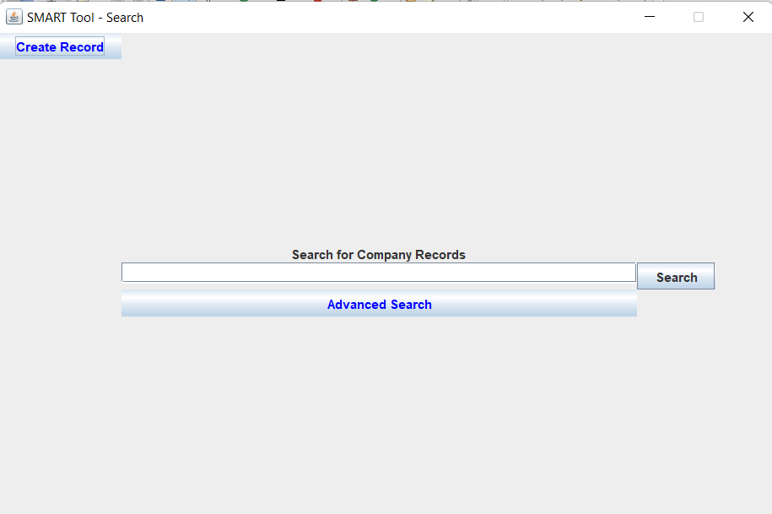

##### Display showed when “Create Record” button is clicked.

*Figure 29. Create Record GUI*

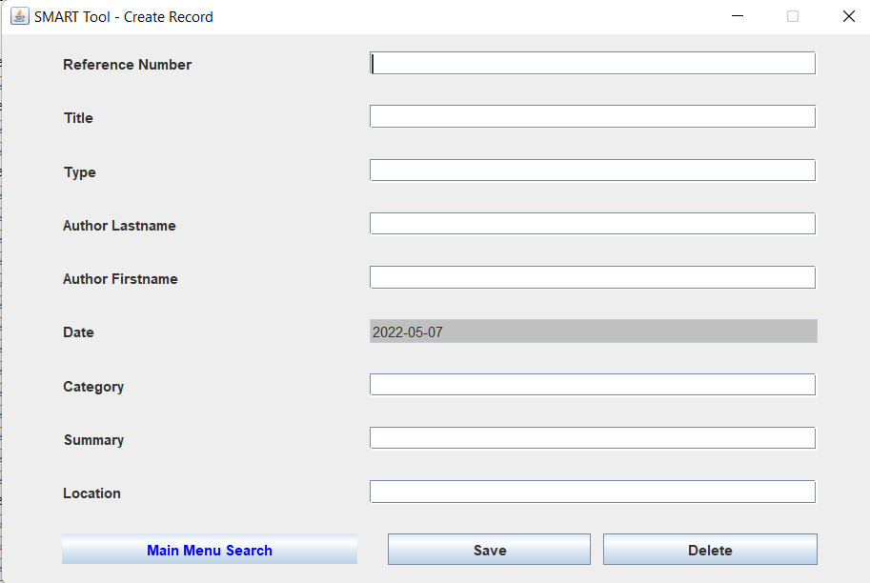

##### Data Input

*Figure 30. Input Data*

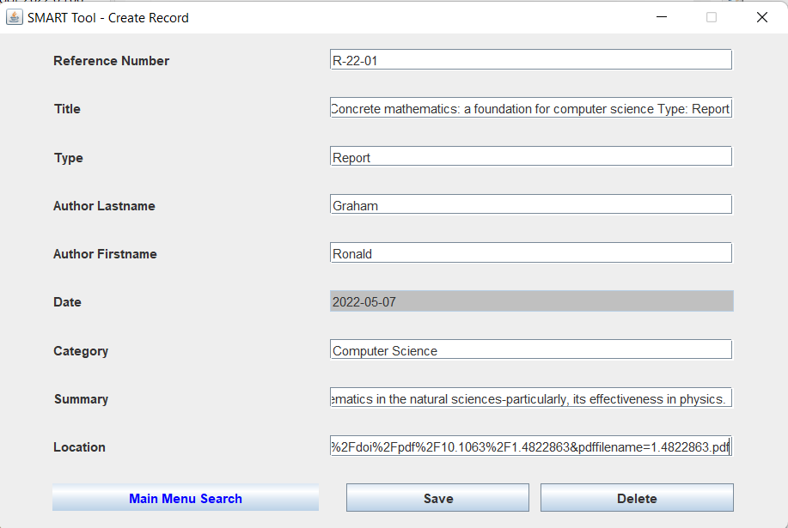

*Figure 31. Display when “Save” button was clicked.*

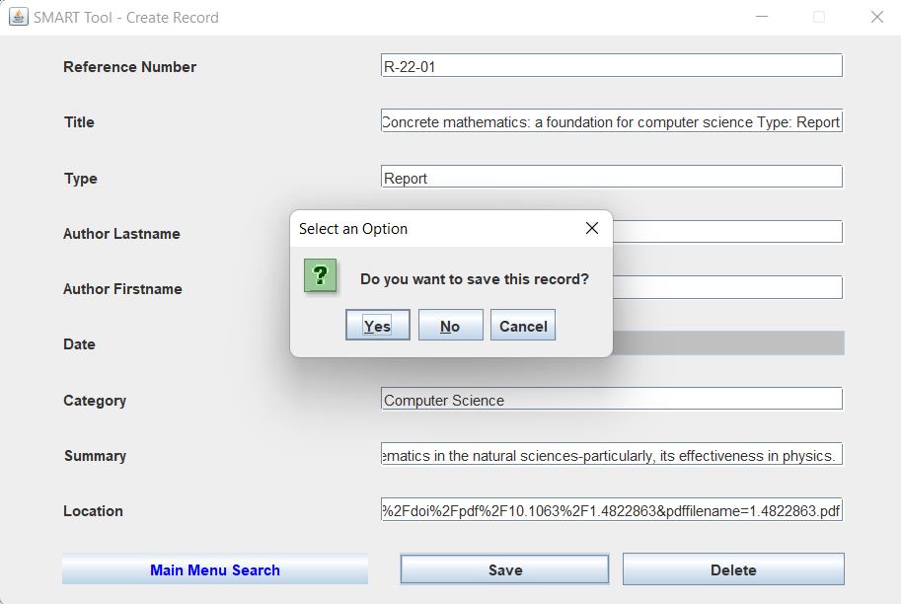

*Figure 32. Display when “Yes” button was clicked.*

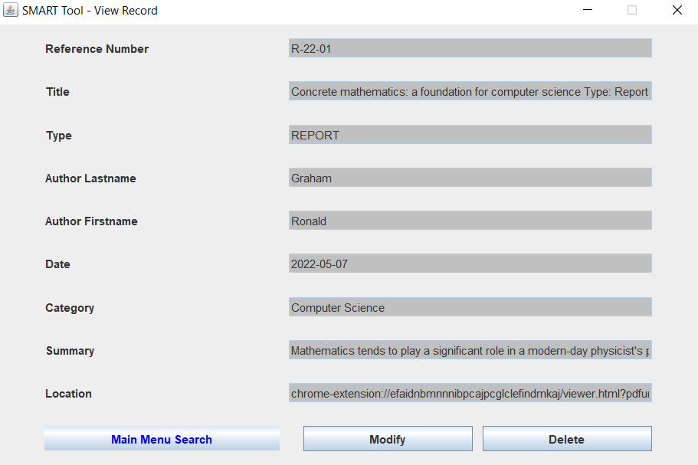

*Figure 33. Display when “No” button was clicked.*

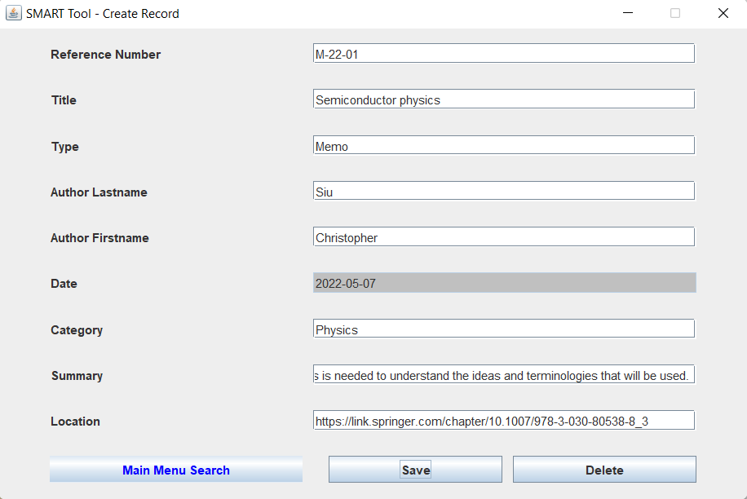

*Figure 34. Display when “Cancel” button was clicked.*

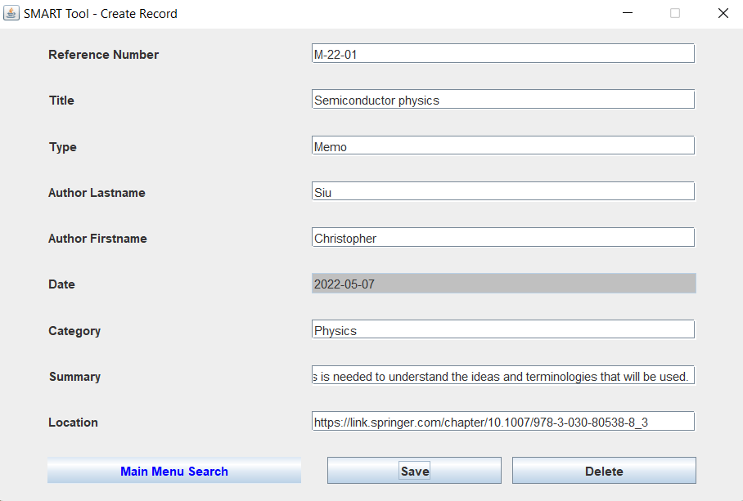

##### Data Modification

*Figure 35. Display when “Modify” button is clicked.*



*Figure 36. Modified Data - Type: Letter*

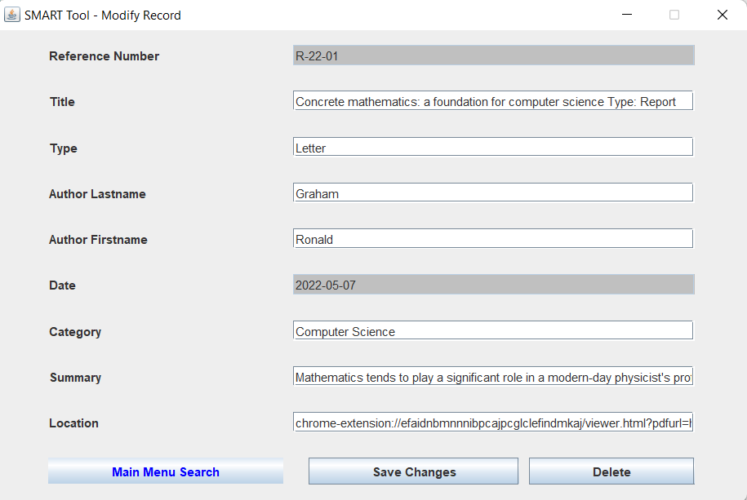

*Figure 37. Display when “Save Changes” button is clicked.*

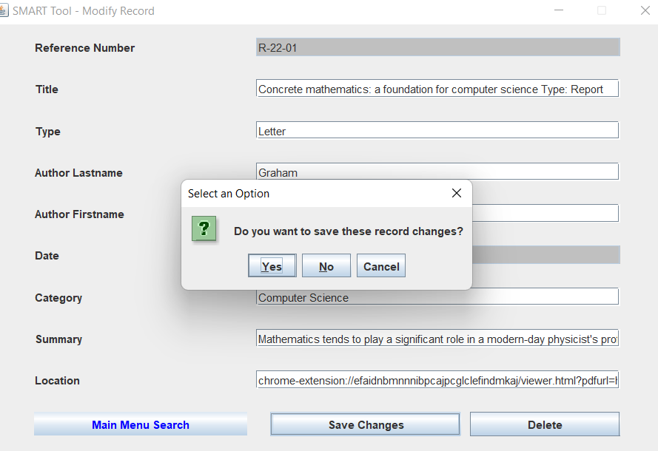

*Figure 38. Display when “Yes” button is clicked.*



##### Incomplete Information

*Figure 39. Input Data*

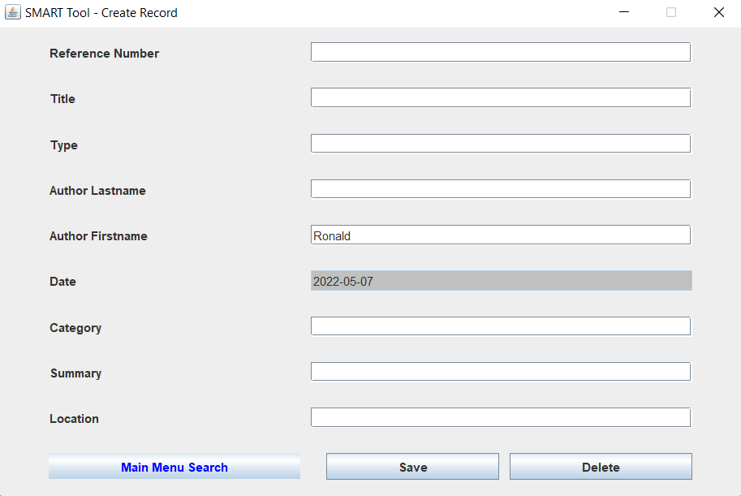

*Figure 40. Display when “Save” button was clicked.*

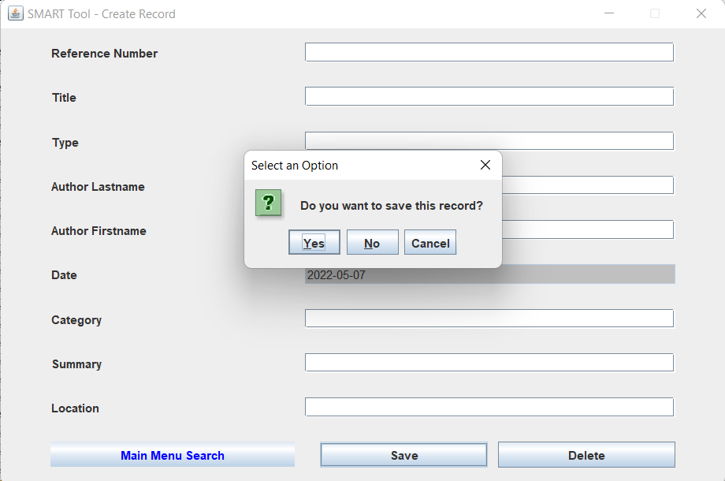

*Figure 41. Display when “Yes” button was clicked.*

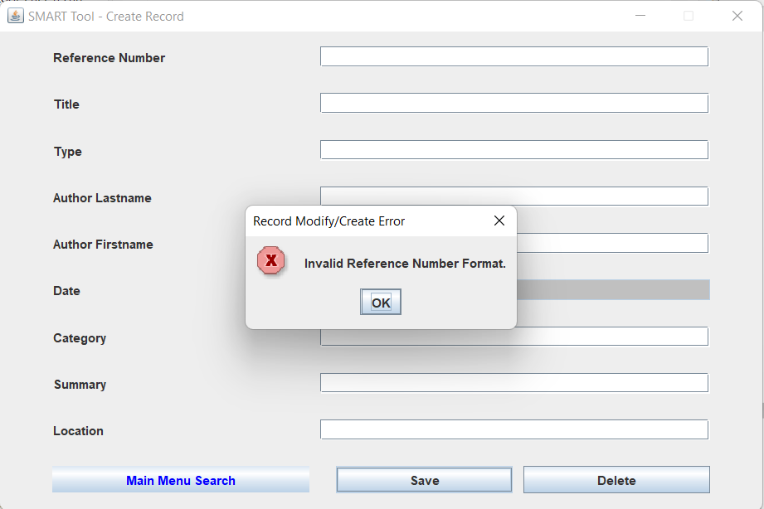

*Figure 42. Input Data*

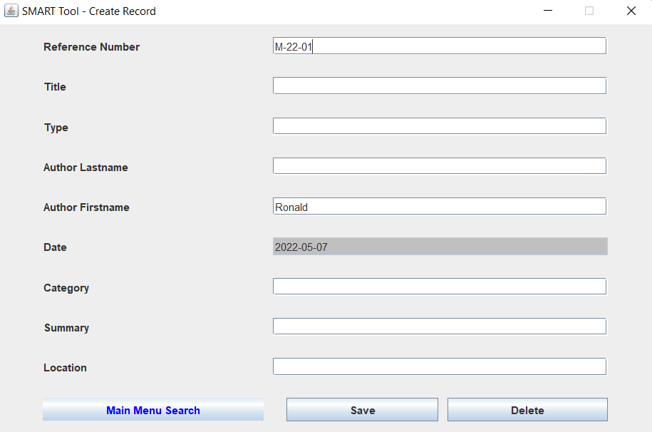

*Figure 43. Display when “Save” and “Yes” button was clicked.*

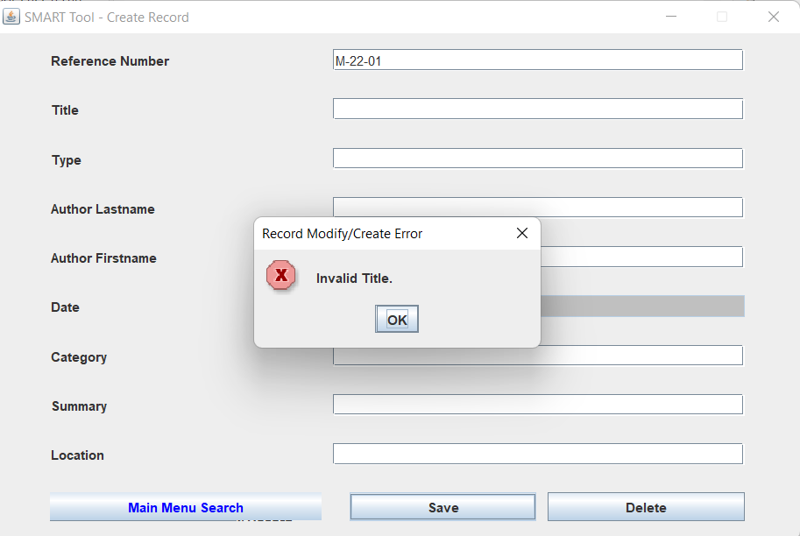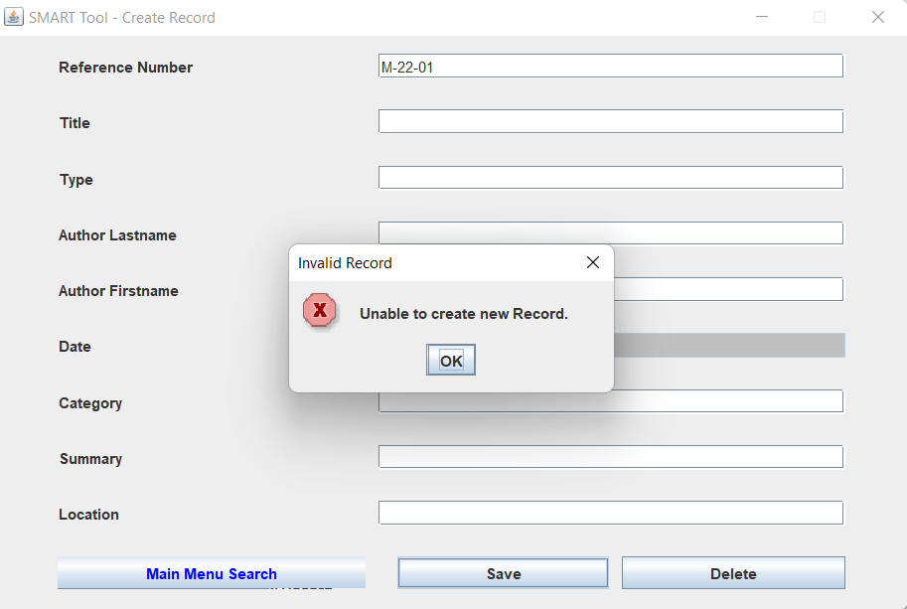

*Figure 44. Input Data*

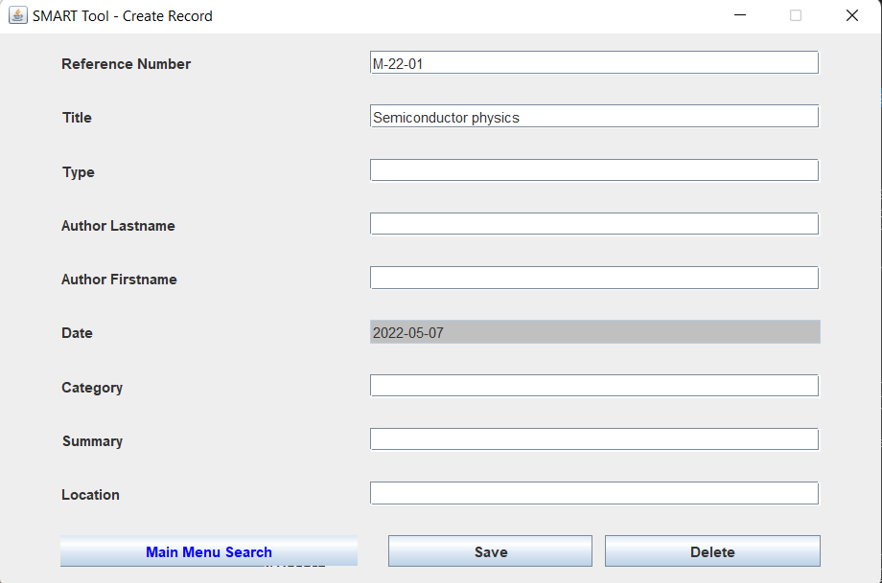

*Figure 45. Display when “Save” and “Yes” button was clicked.*

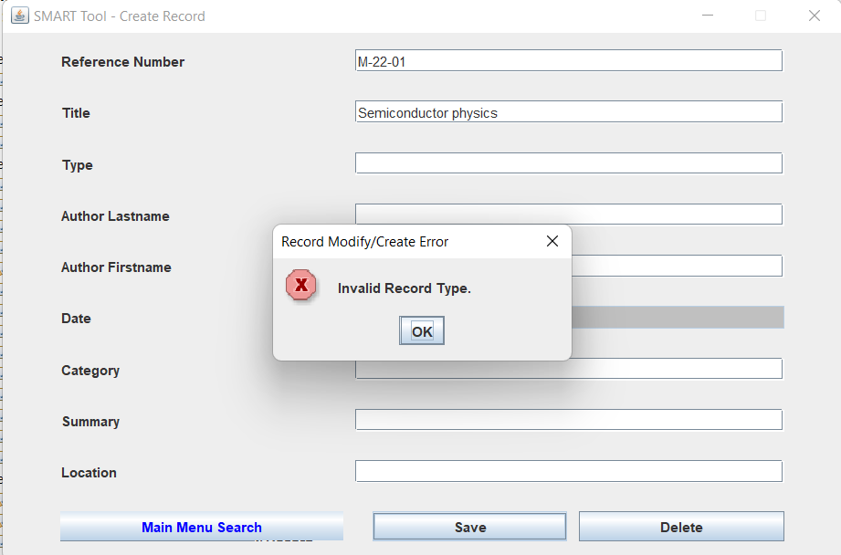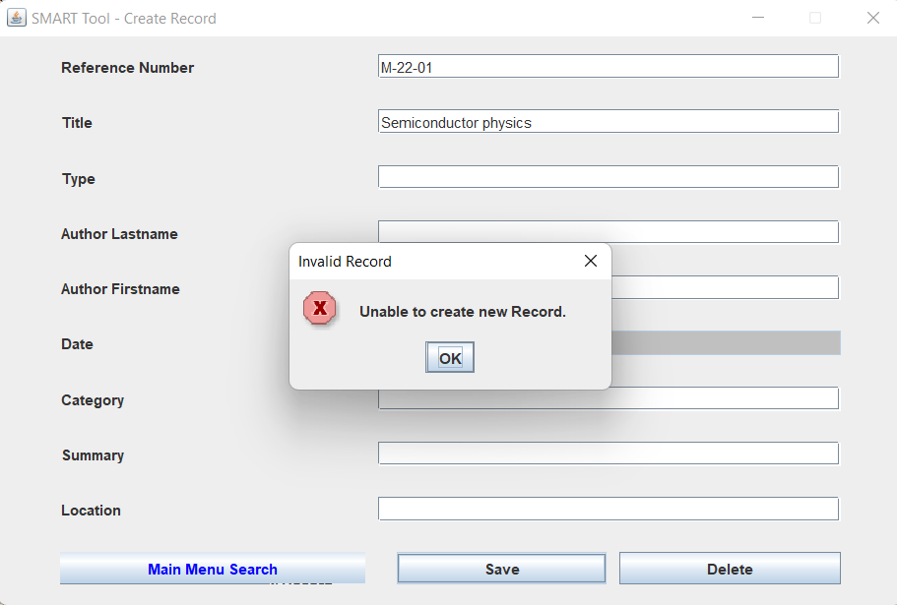

*Figure 46. Input Data*

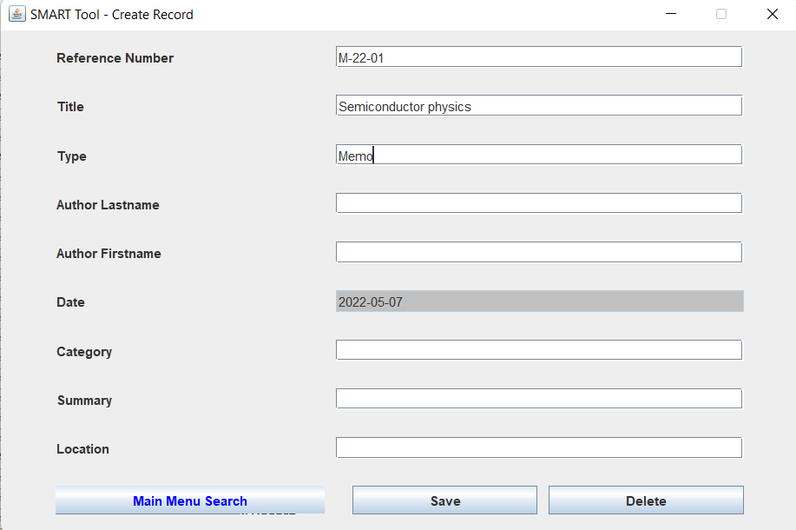

*Figure 47. Display when “Save” and “Yes” button was clicked.*

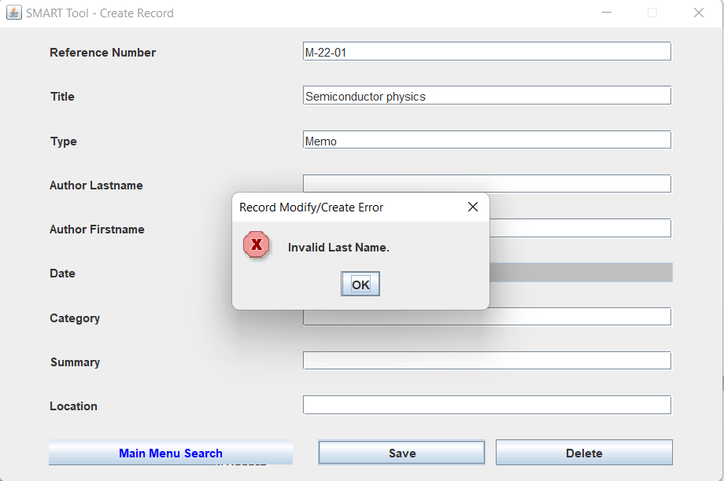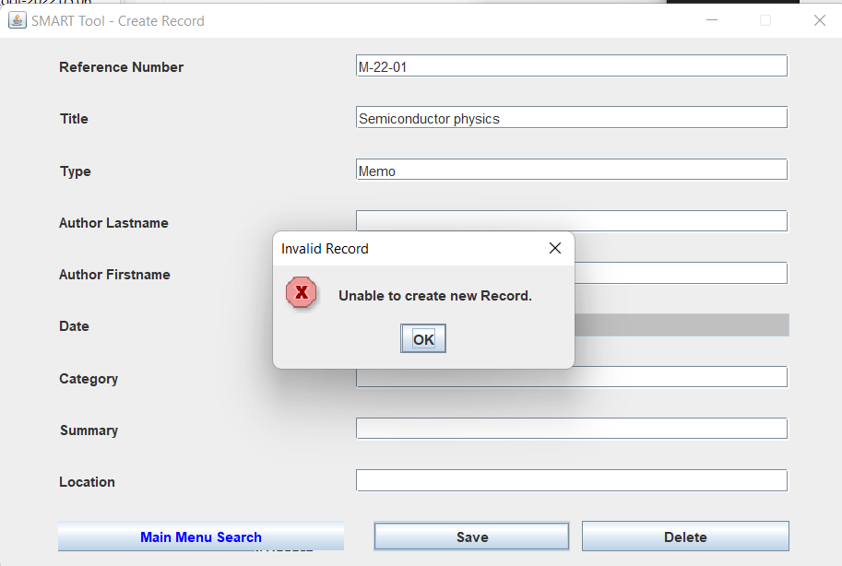

*Figure 48. Input Data*

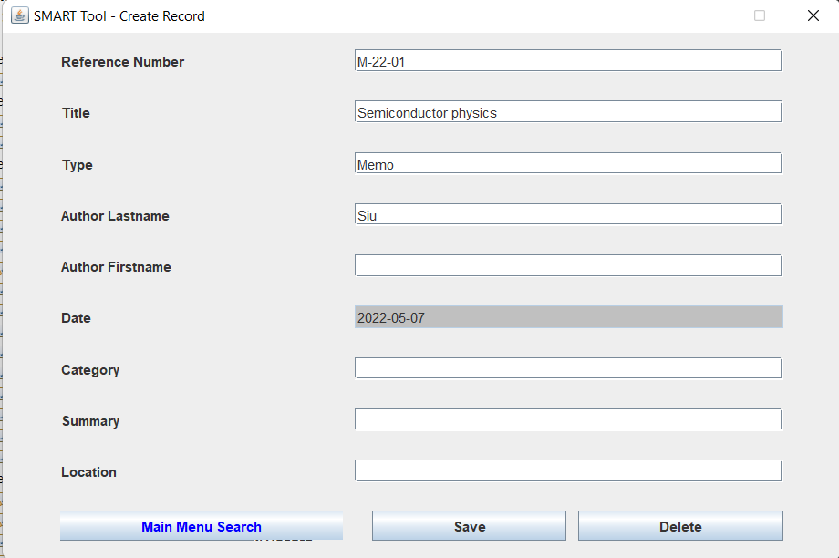

*Figure 49. Display when “Save” and “Yes” button was clicked.*

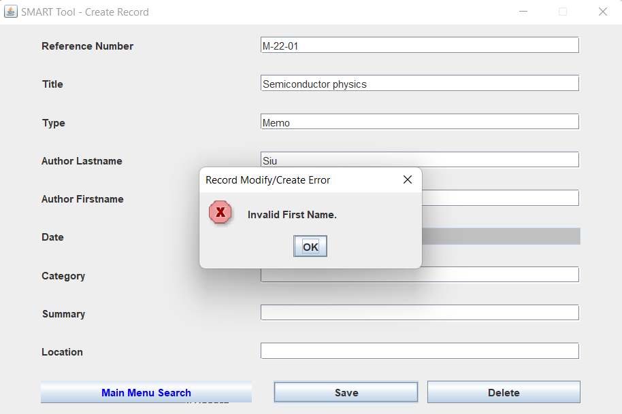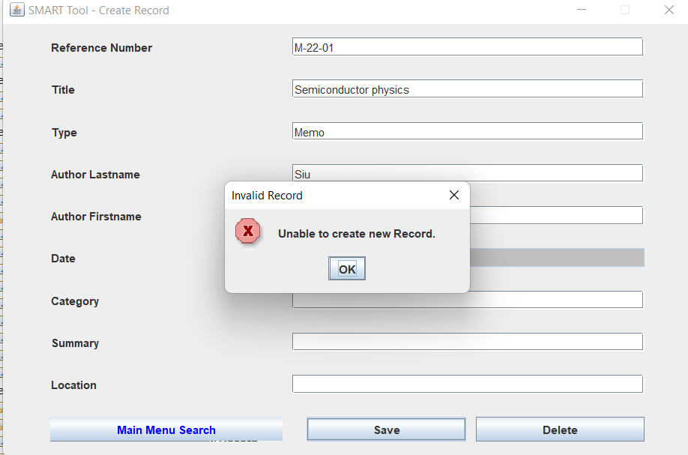

*Figure 50. Input Data*

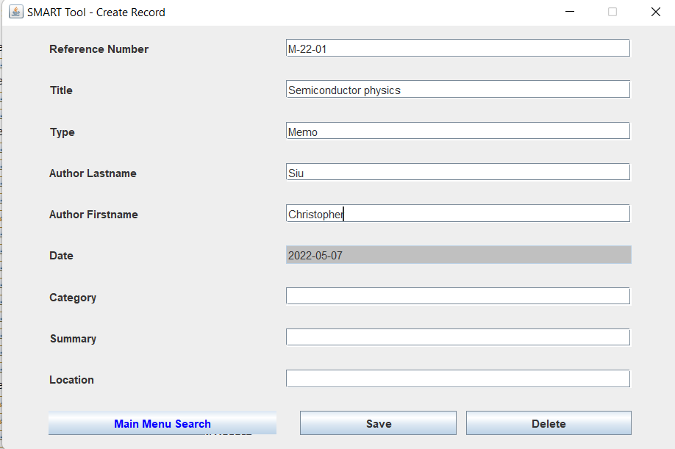

*Figure 51. Display when “Save” and “Yes” button was clicked.*

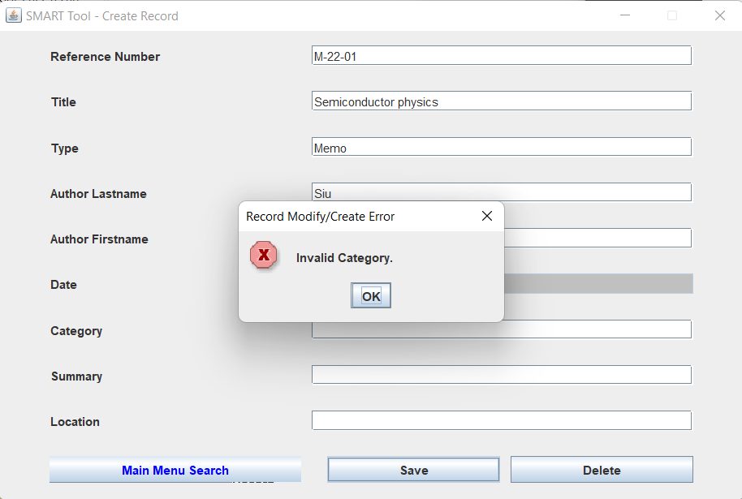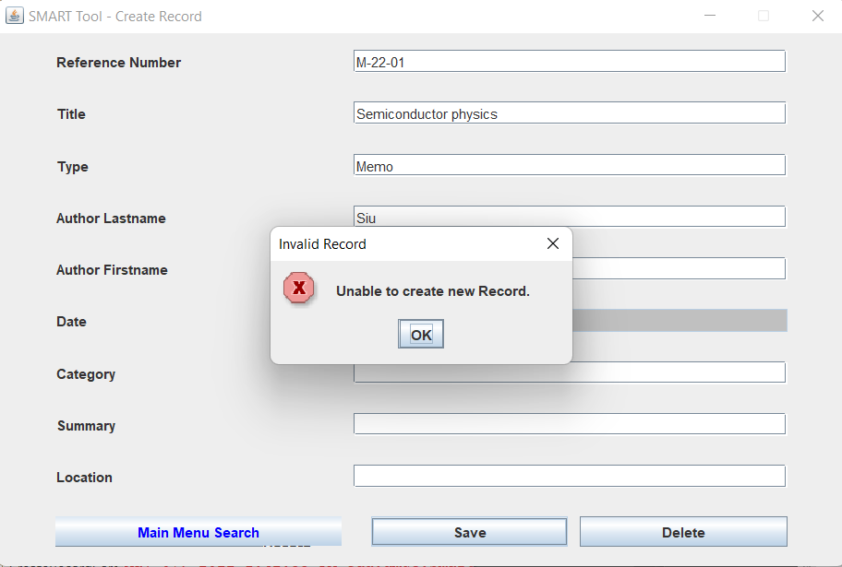

*Figure 52. Input Data*

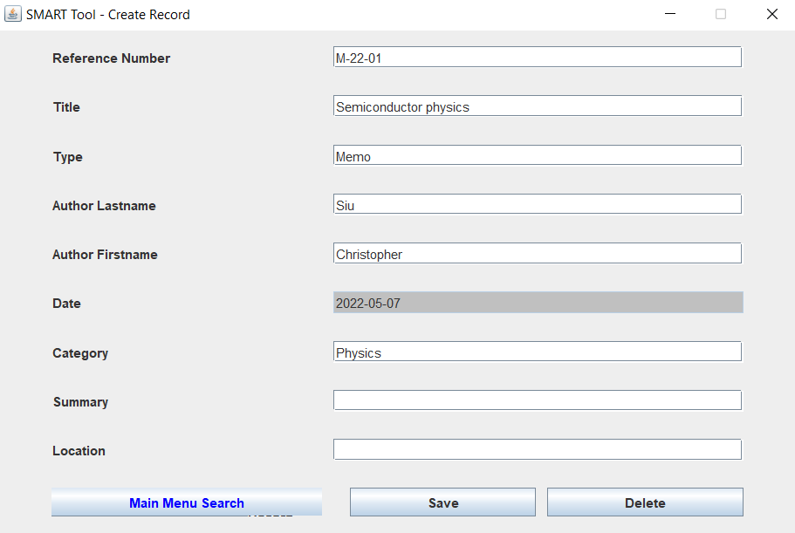

*Figure 53. Display when “Save” and “Yes” button was clicked.*

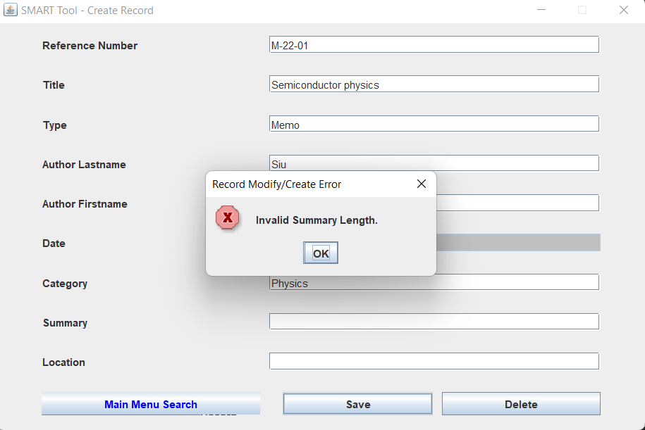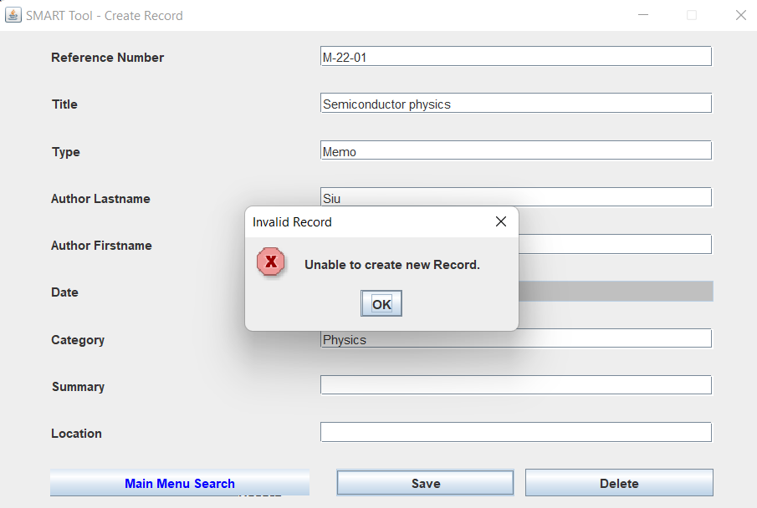

*Figure 54. Input Data*

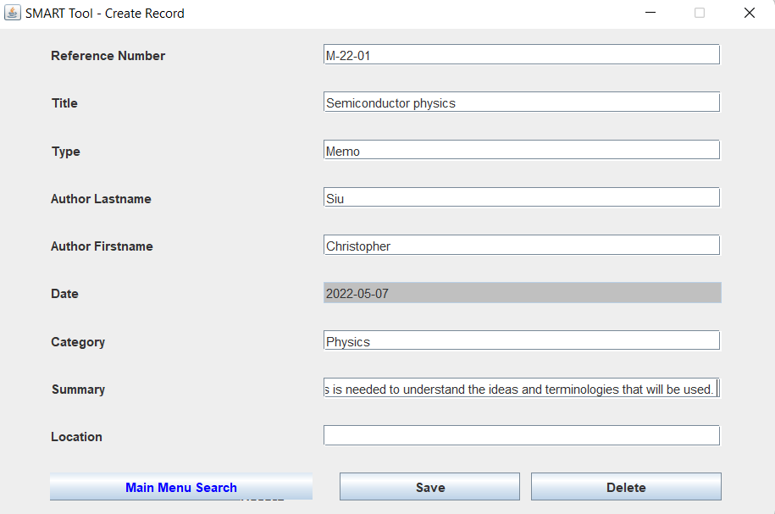

*Figure 55. Display when “Save” and “Yes” button was clicked.*

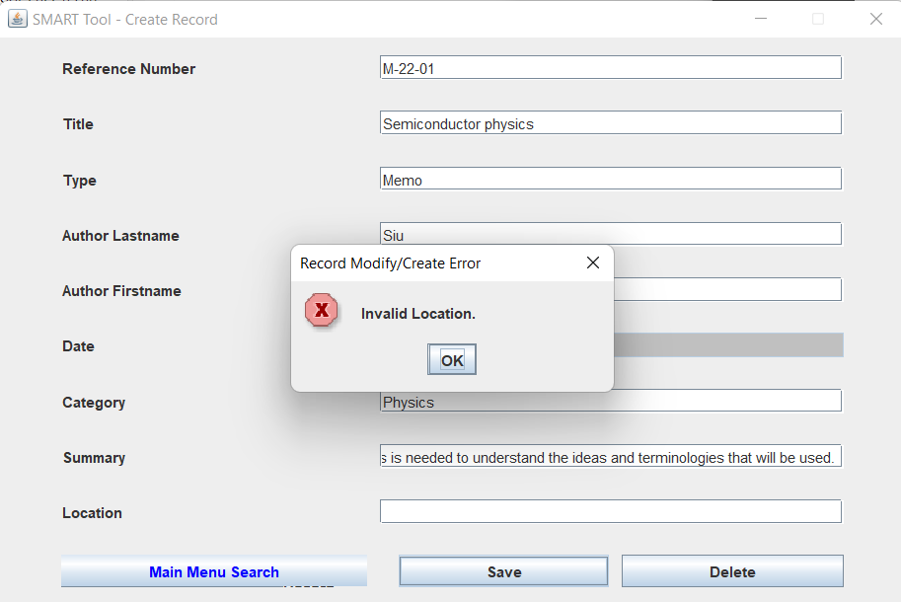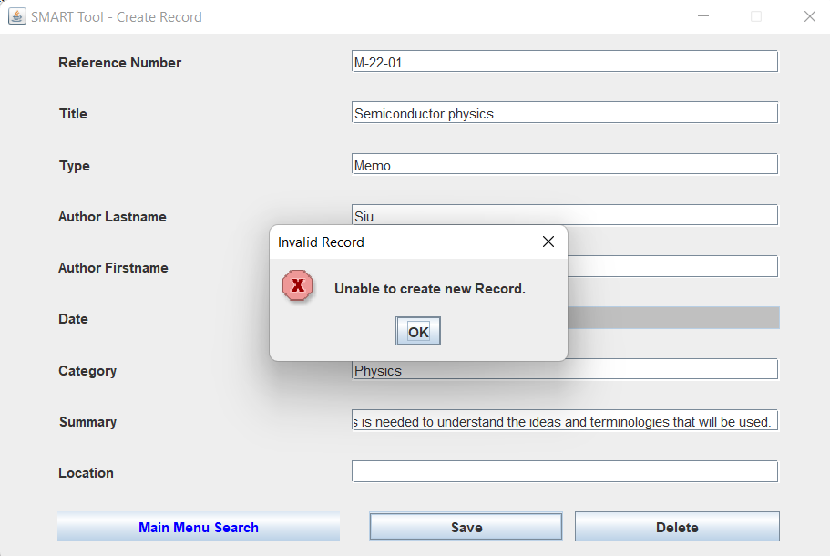

*Figure 56. Input Data*

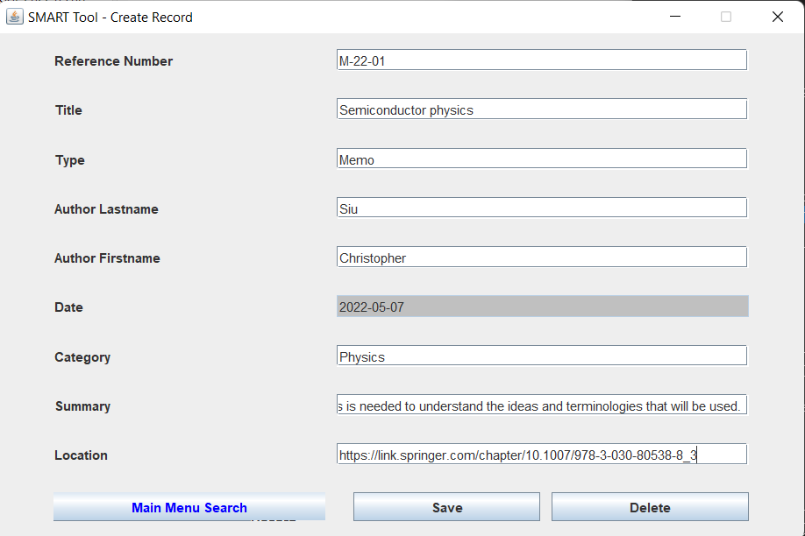

*Figure 57. Display when “Save” and “Yes” button was clicked*

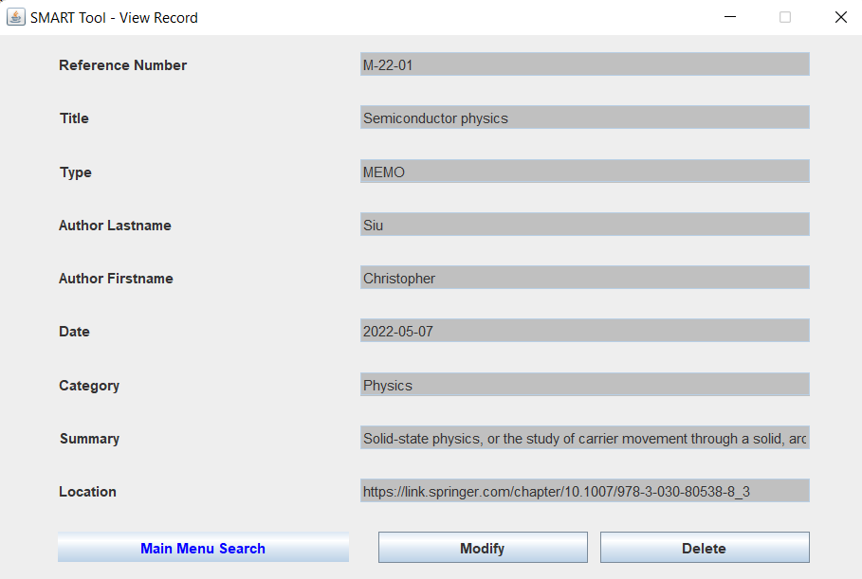

The application accept saving data when all cells are filled.

##### Invalid Summary Character Size

*Figure 58. Input Data*

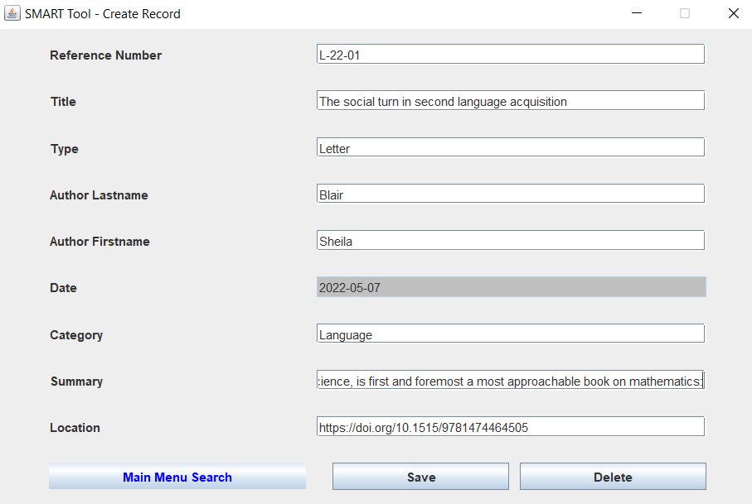

*Figure 59. Display when clicked “Yes” button*

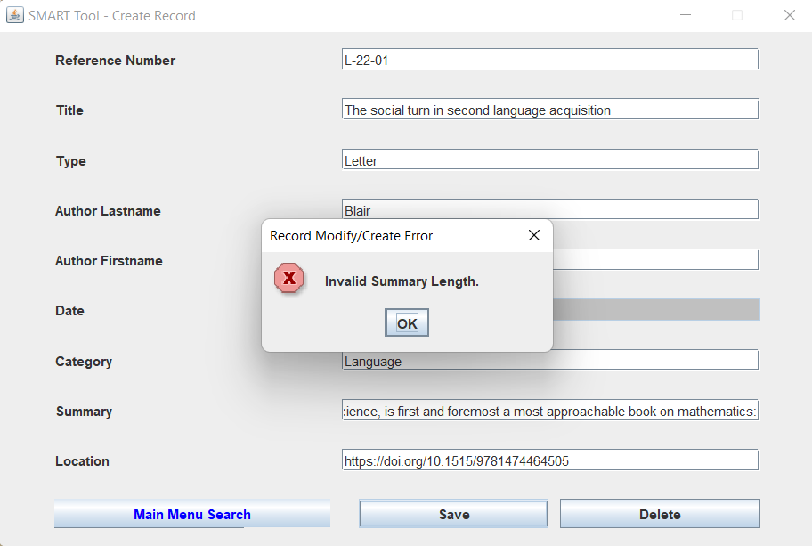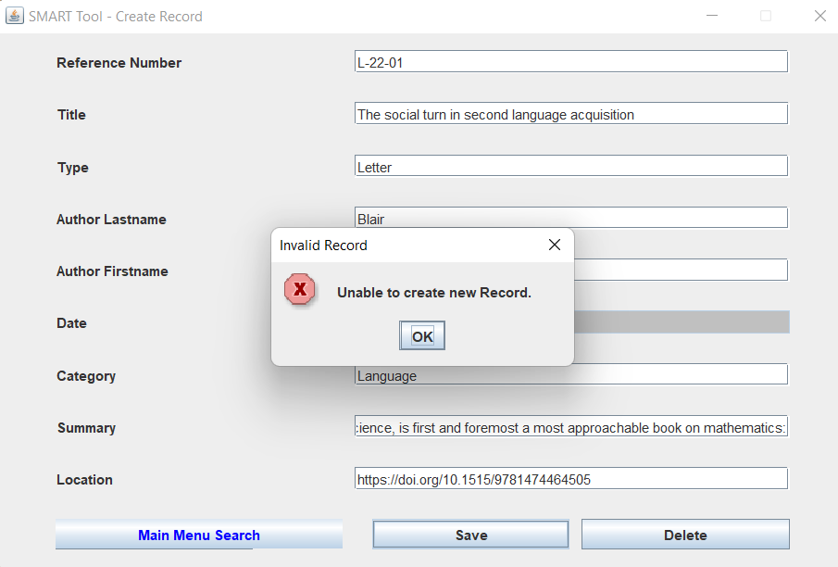

##### Invalid “Type”

*Figure 60. Input Data -* Type: Article

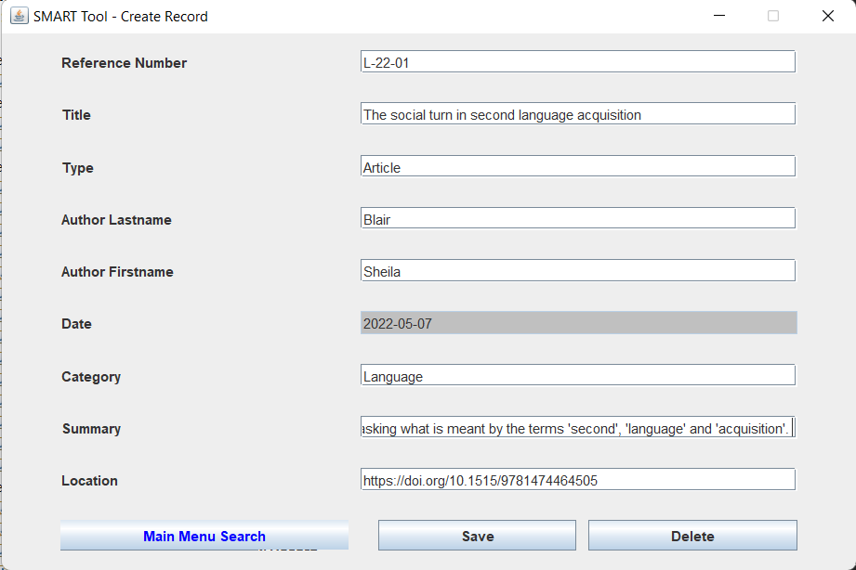

*Figure 61. Display when “Save” and “Yes” button was clicked.*

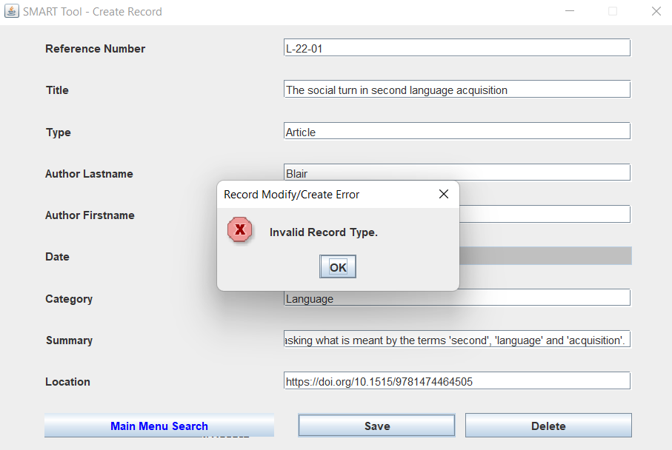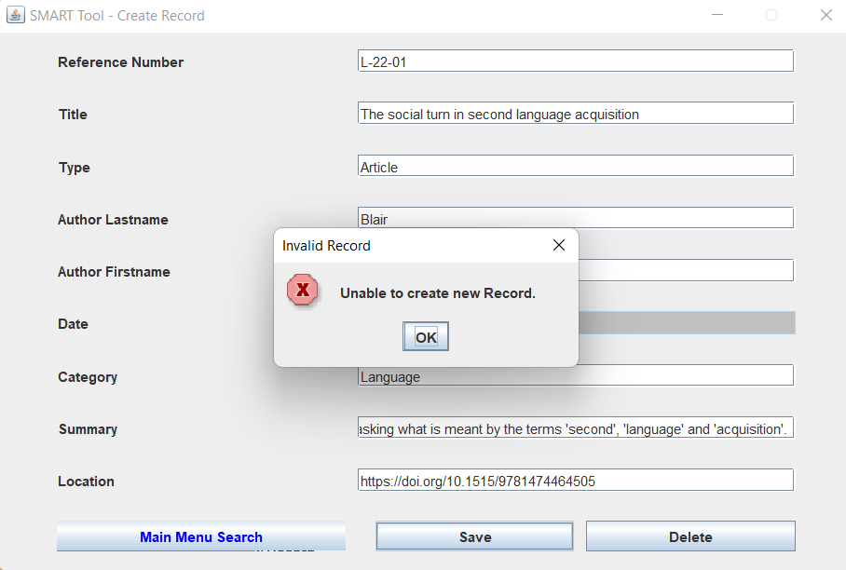

##### Data Search

*Figure 62.Main Search - Input Data -*  R

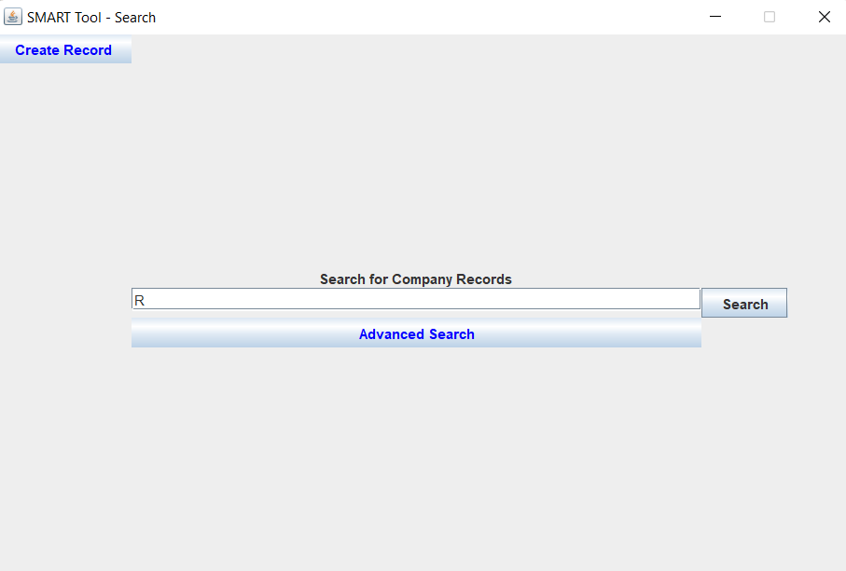

*Figure 63.Display when “Search” button is clicked.*

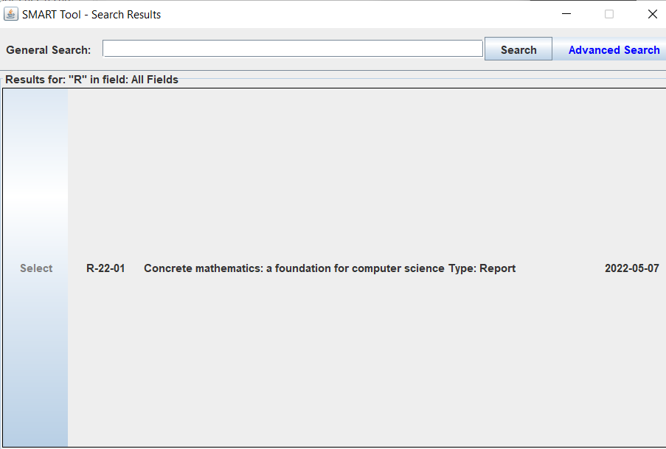

*Figure 64.General Search Input Data -* Computer

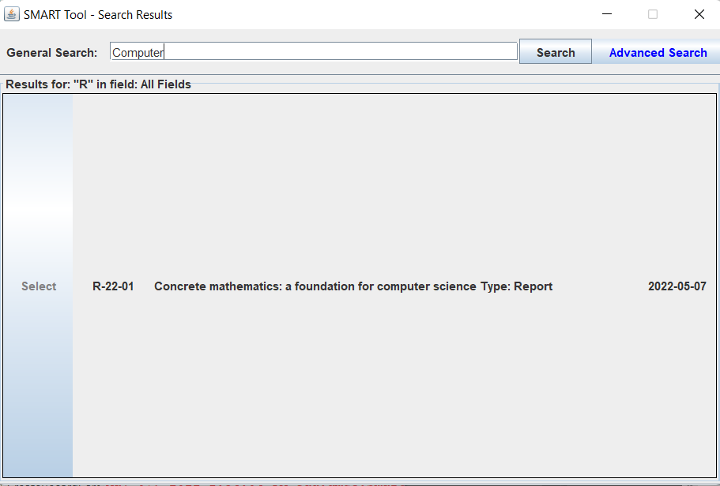

*Figure 65.Display when “Search” button is clicked.*

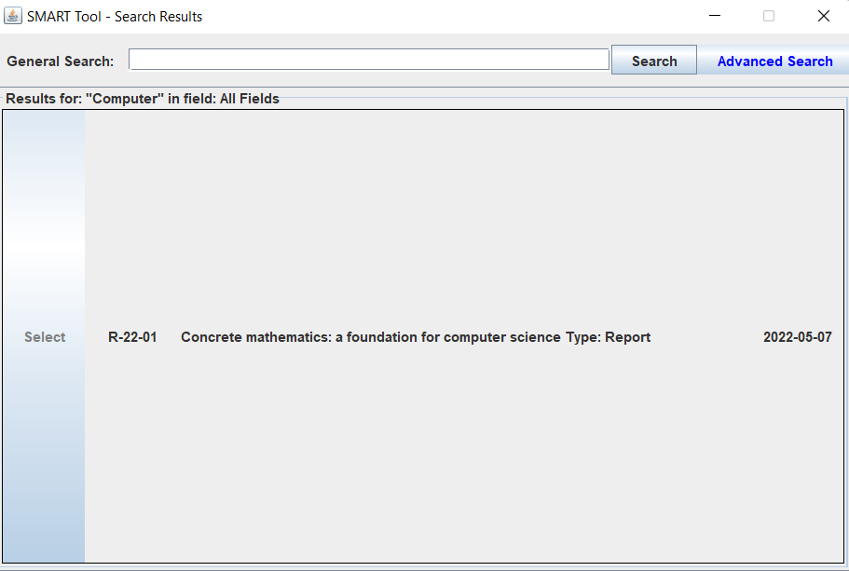

*Figure 66.Advance Search Input Data -* Reference Number: R

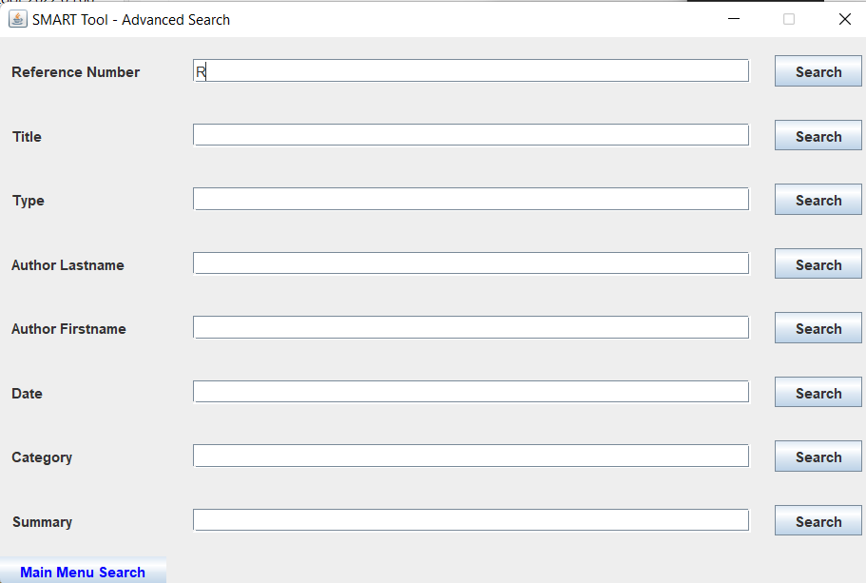

*Figure 67.Display when “Search” button is clicked.*

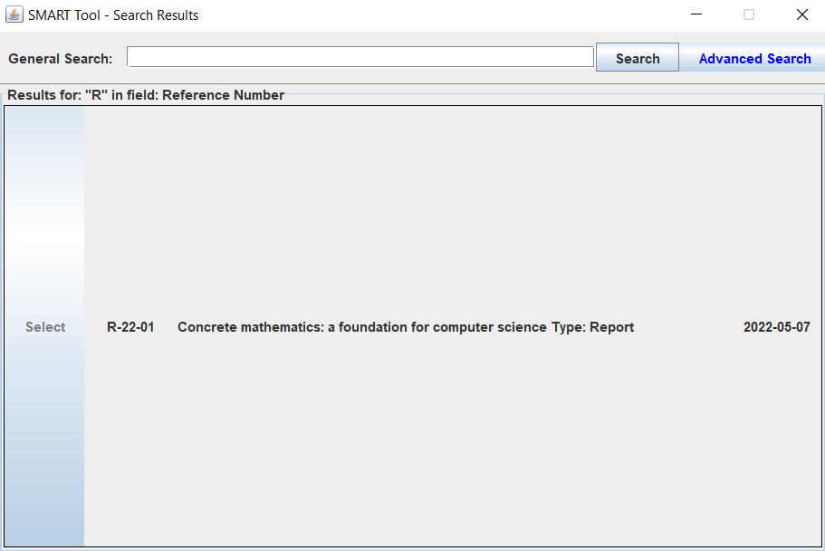

*Figure 68. Input Data - Title:* Concrete

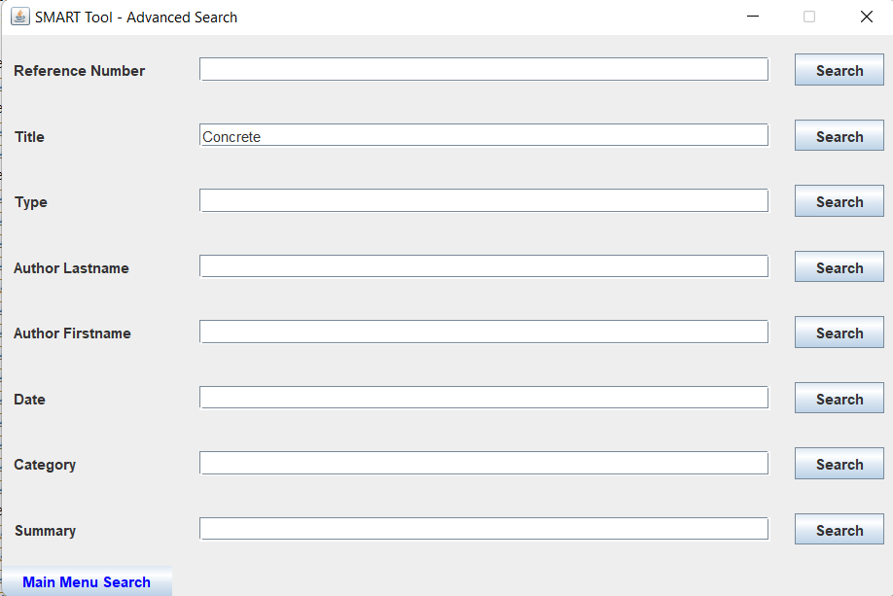

*Figure 69.Display when “Search” button is clicked.*

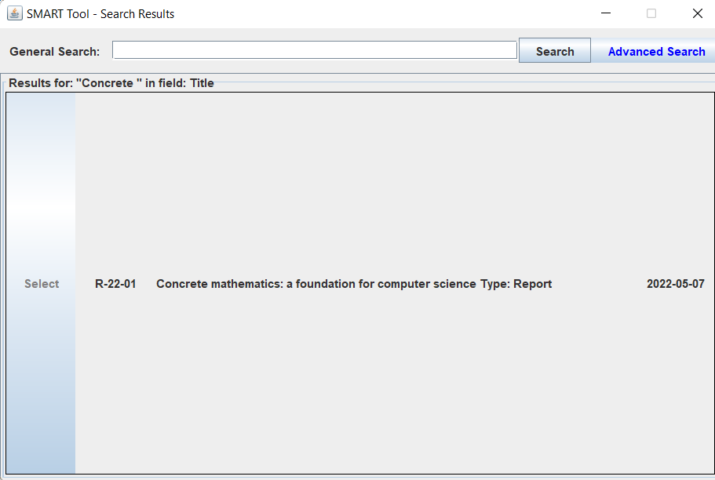

*Figure 70. Input Data -* Type: REPORT

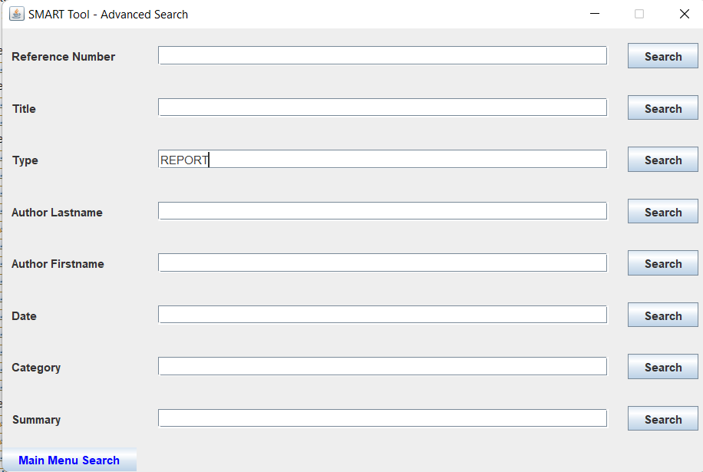

*Figure 71.Display when “Search” button is clicked.*

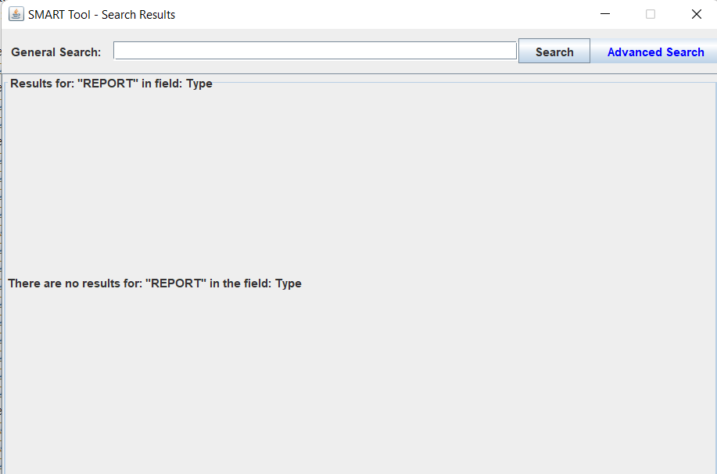

*Figure 72. Input Data -* Author Last name: Graham

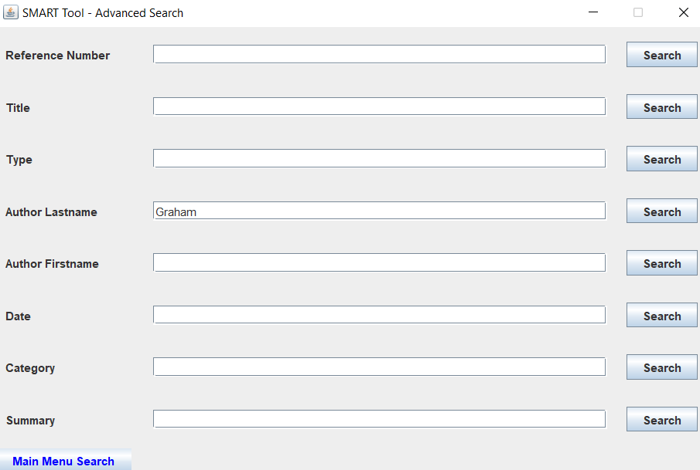

*Figure 73.Display when “Search” button is clicked.*

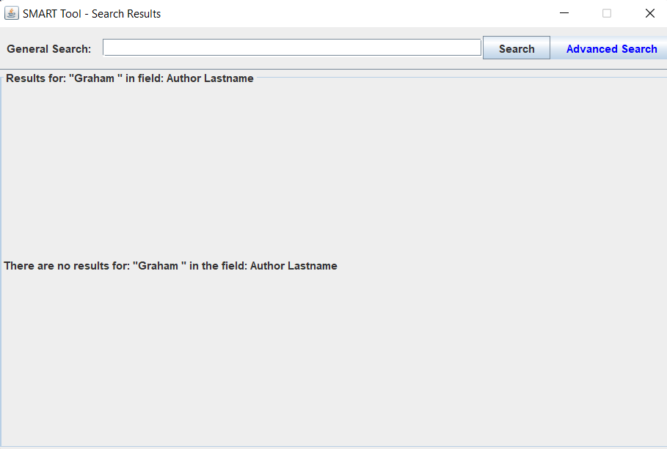

*Figure 74. Input Data -* Author First name: Ronald

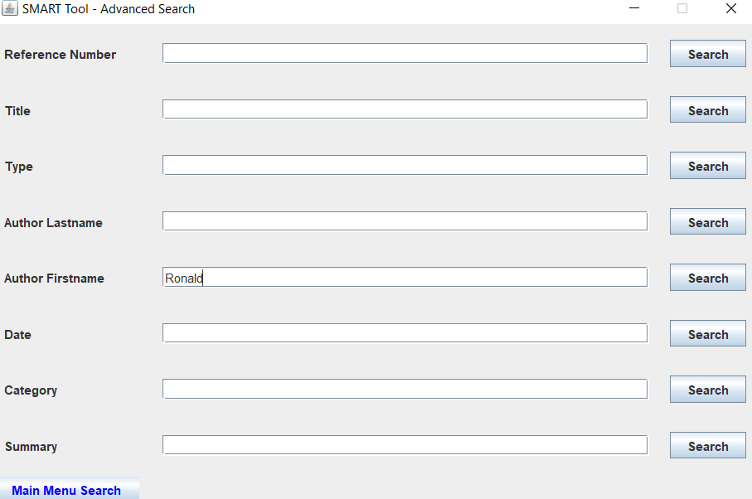

*Figure 75. Display when “Search” button was clicked*

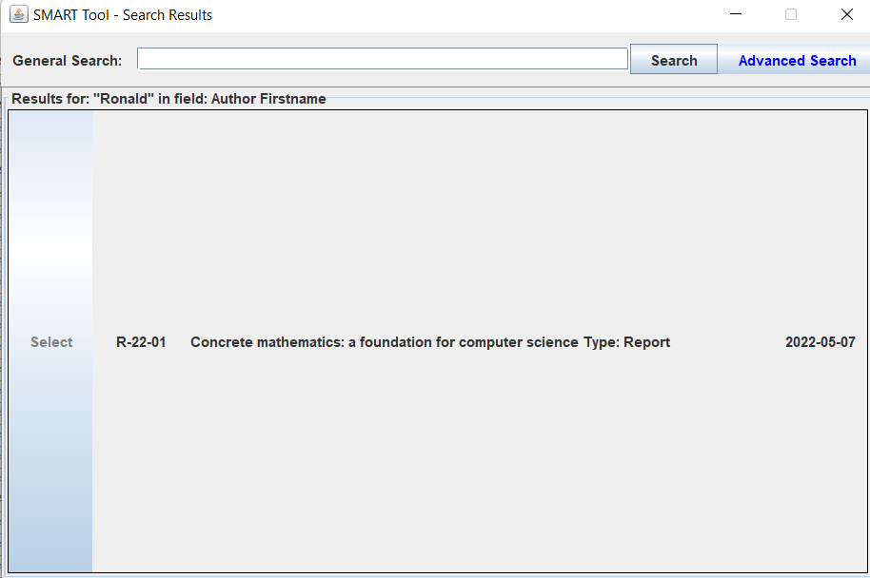

*Figure 76. Input Data -* Date 2022

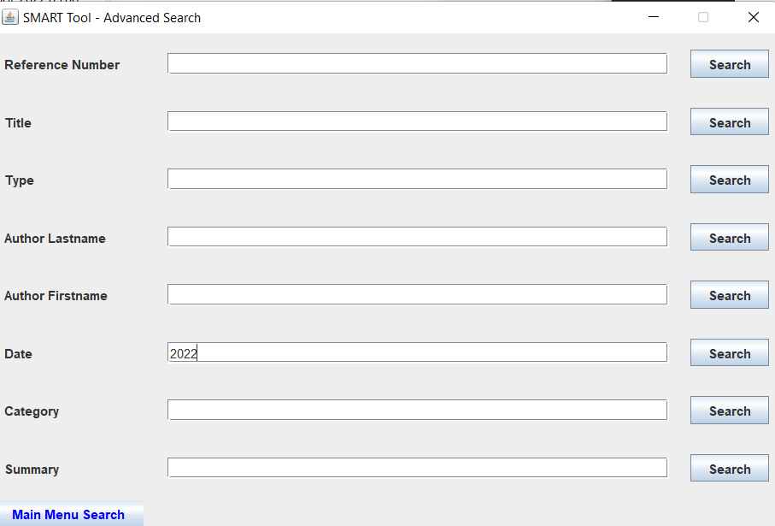

*Figure 77.Display when “Search” button is clicked.*



*Figure 78. Input Data -* Category: Computer

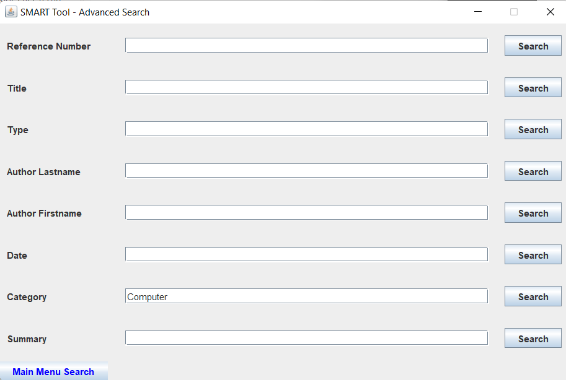

*Figure 79.Display when “Search” button is clicked.*

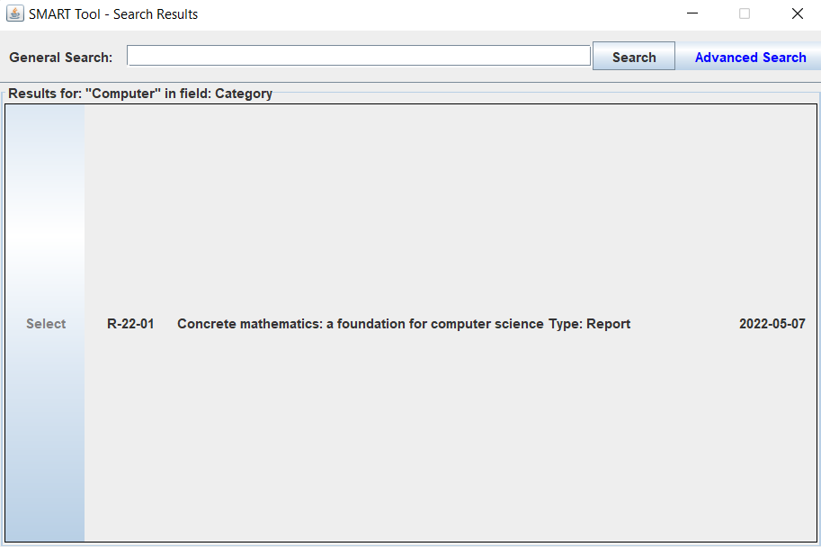

*Figure 80. Input Data -* Summary: Mathematics

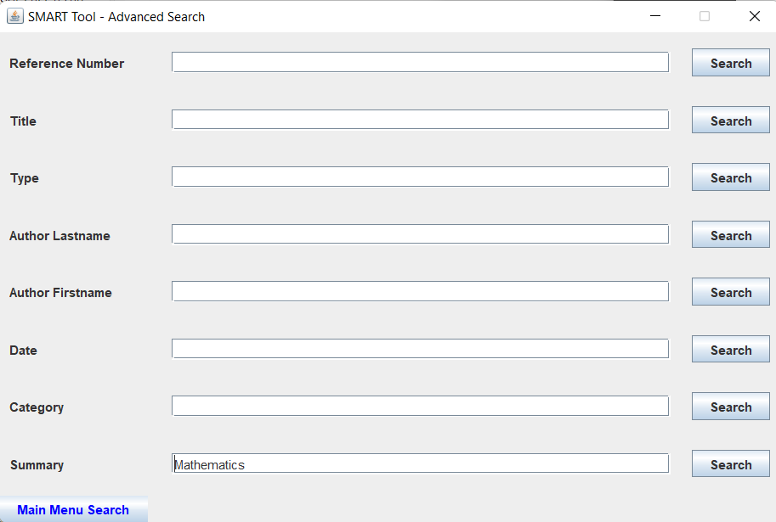

*Figure 81.Display when “Search” button is clicked.*

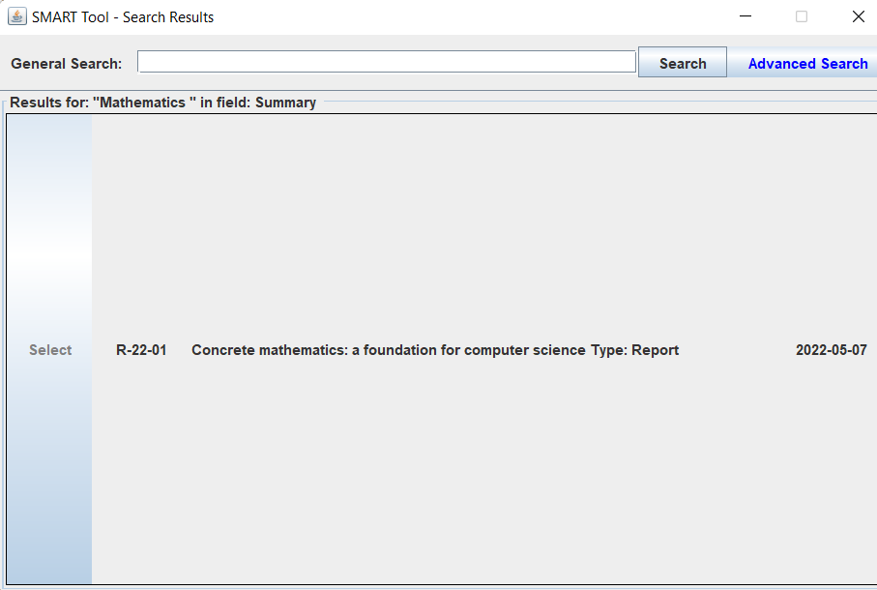

##### Data Search - small caps

*Figure82. Input Data - ronald*

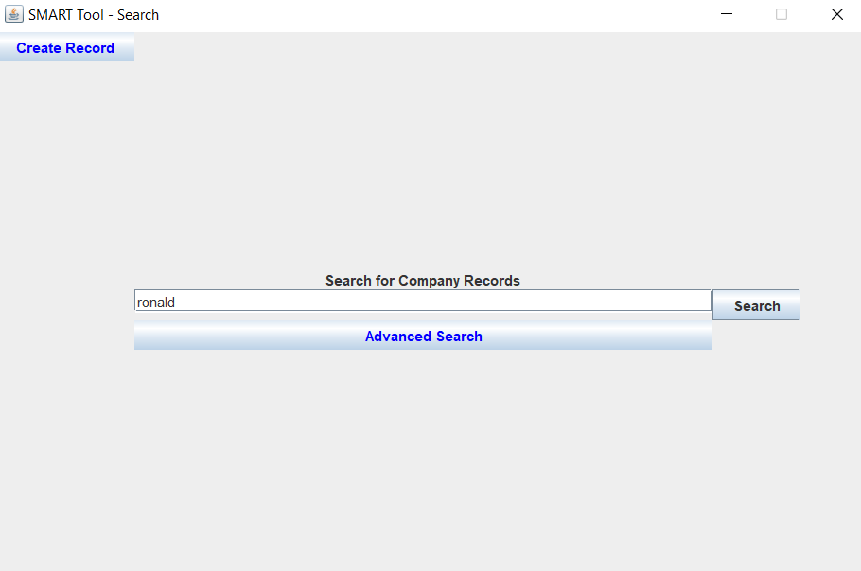

*Figure 83. Display when “Search” button was clicked*

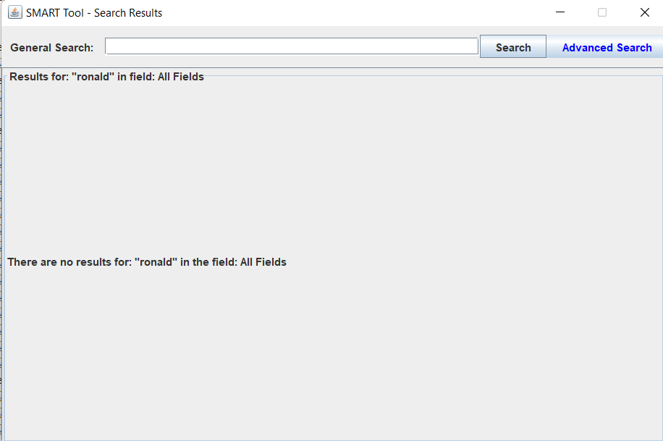

##### User clicks "Search" without typing in text box

*Figure 84. Display when clicked “Search” button with empty input at Main Menu Search.*

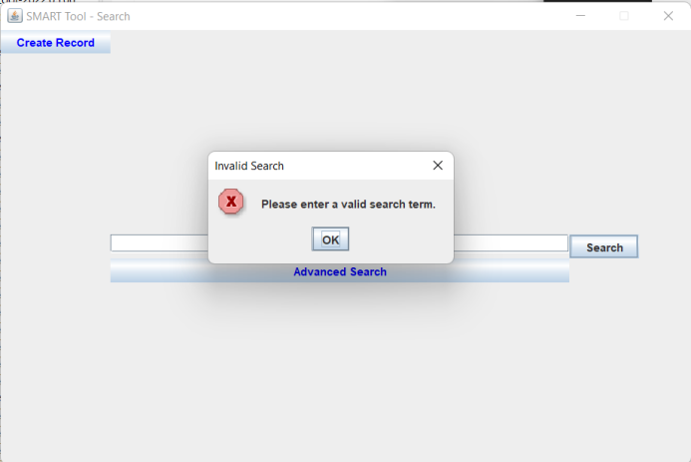

*Figure 85. Display when clicked “Search” button with empty input at General Search.*

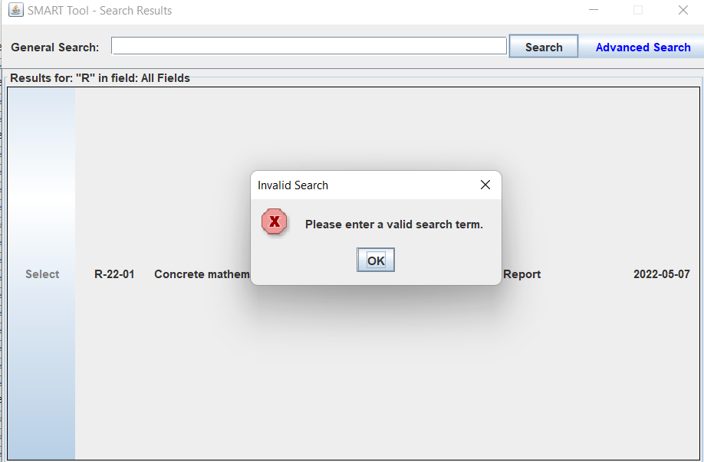

*Figure 86. Display when clicked “Search” button with empty input at Reference Number cell of Advance Search.*

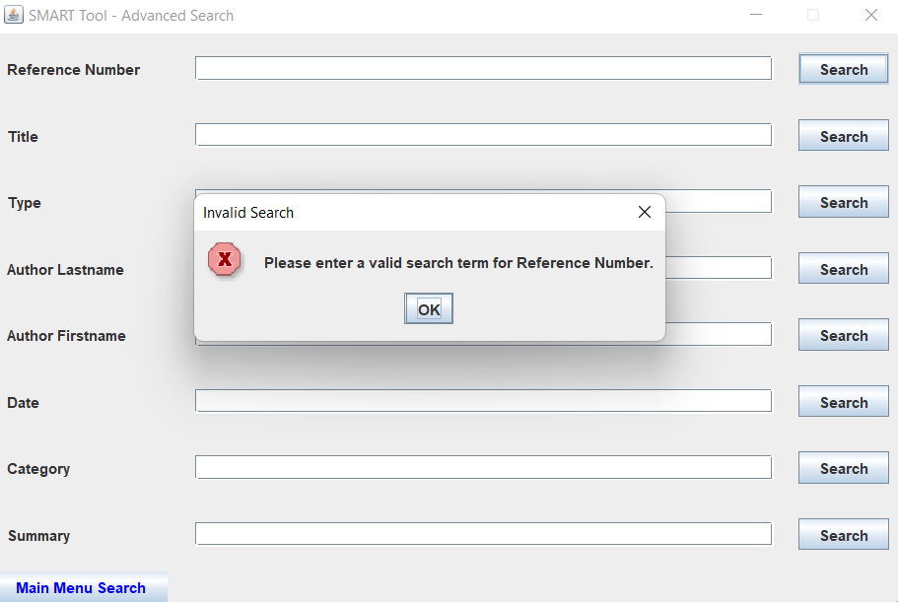

*Figure 87. Display when clicked “Search” button with empty input at Title cell of Advance Search.*

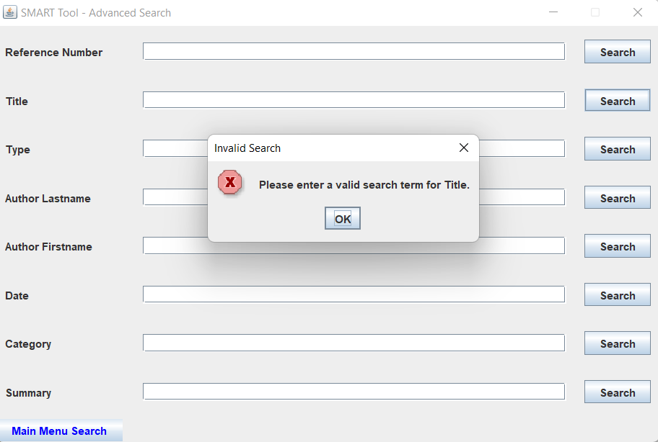

*Figure 88. Display when clicked “Search” button with empty input at Type cell of Advance Search.*

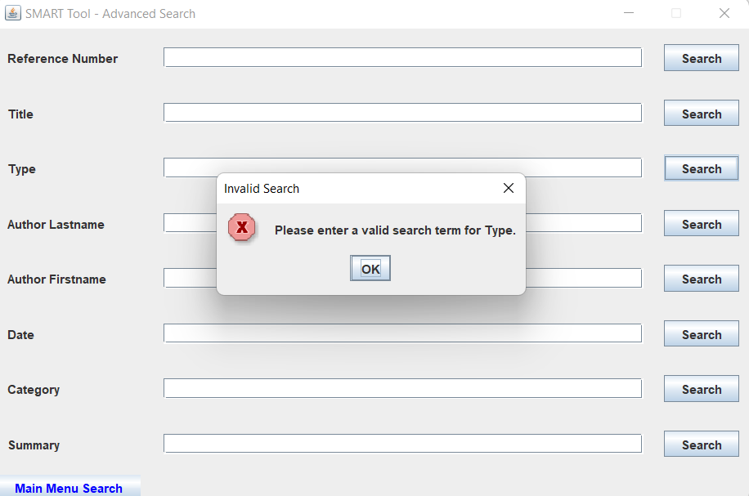

*Figure 89. Display when clicked “Search” button with empty input at Author Lastname cell of Advance Search.*

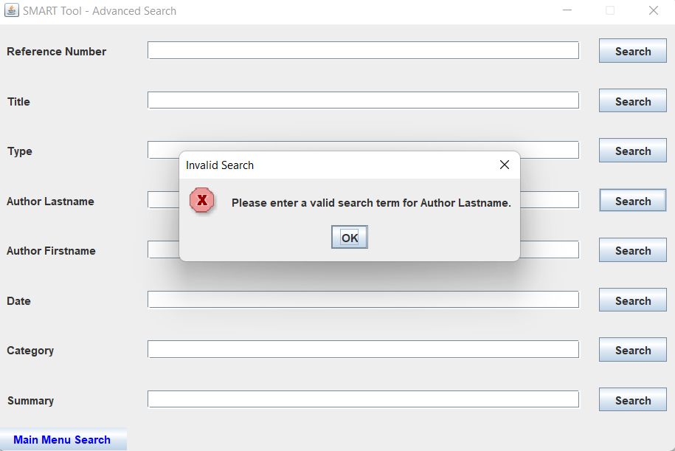

*Figure 90. Display when clicked “Search” button with empty input at Author Firstname cell of Advance Search.*

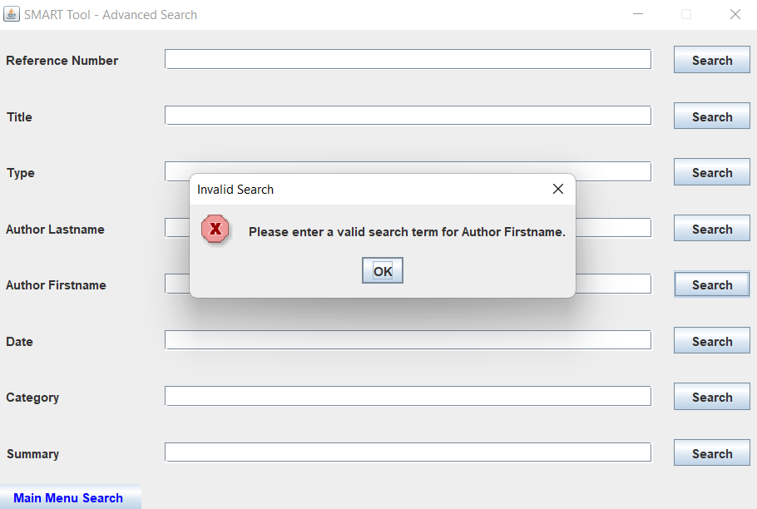

*Figure 91. Display when clicked “Search” button with empty input at Date cell of Advance Search.*

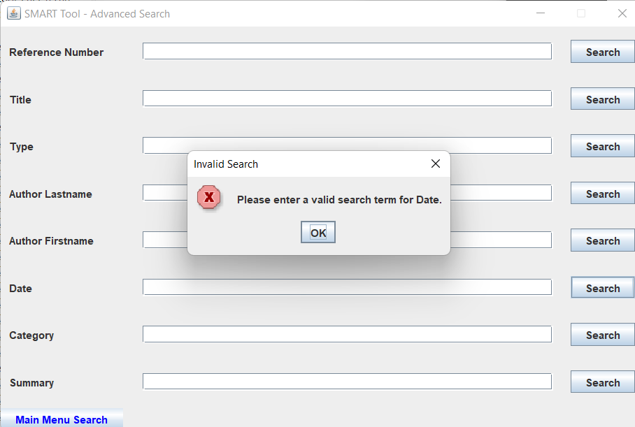

*Figure 92. Display when clicked “Search” button with empty input at Category cell of Advance Search.*

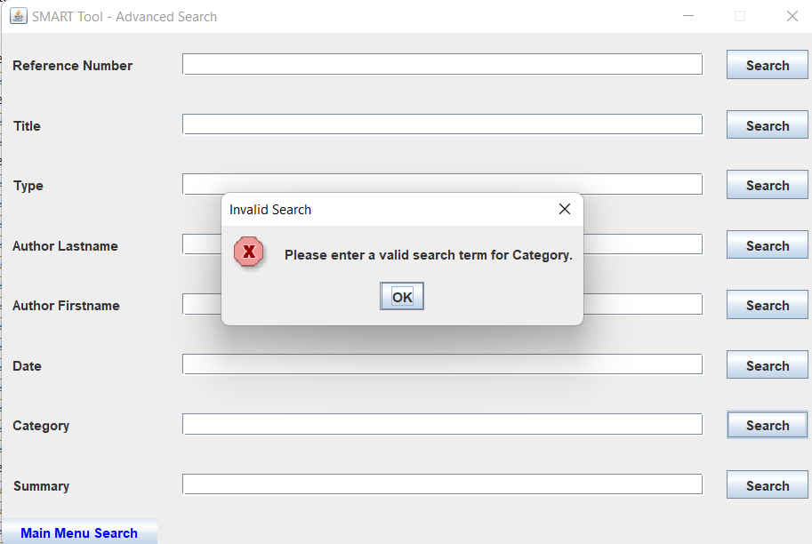

*Figure 93. Display when clicked “Search” button with empty input at Summary cell of Advance Search.*

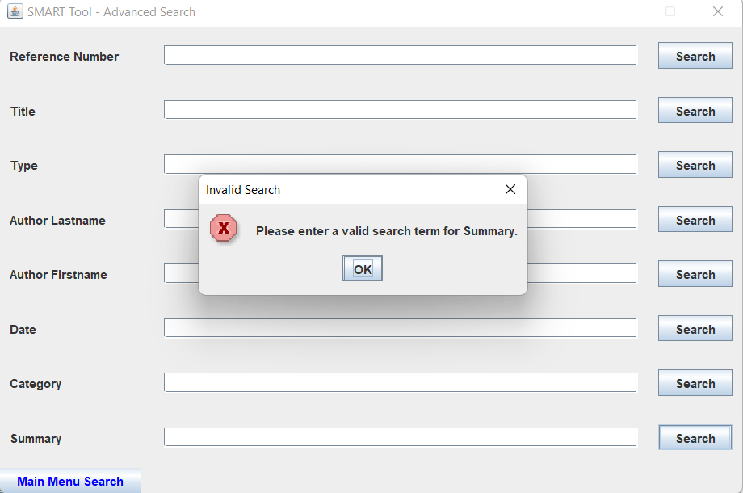

##### Return to Result

*Figure 94. View Record GUI*



*Figure 95. Display when “Return to Results” is clicked.*

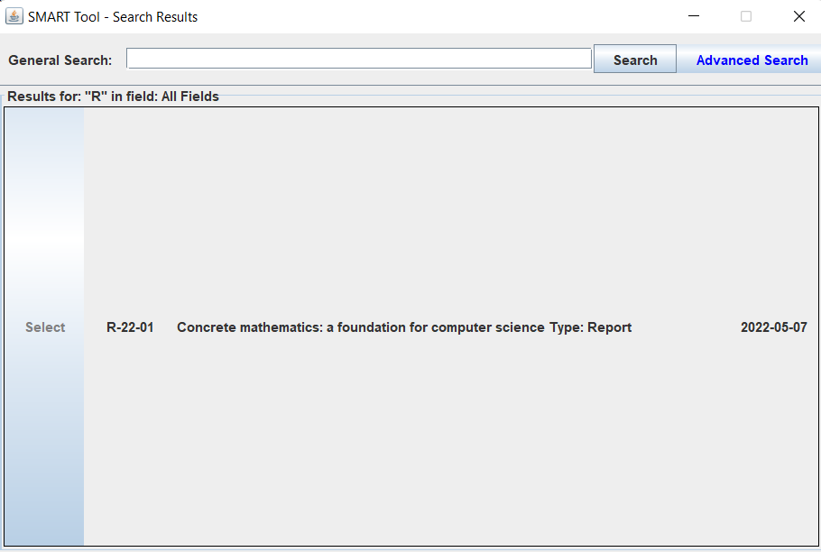

##### Delete Record

*Figure 96. Display when “Delete” button was clicked.*

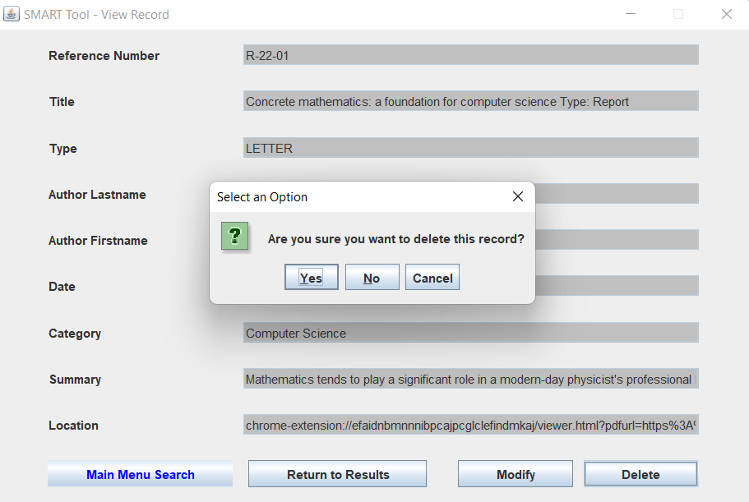

*Figure 97. Display when “Yes” button was clicked.*

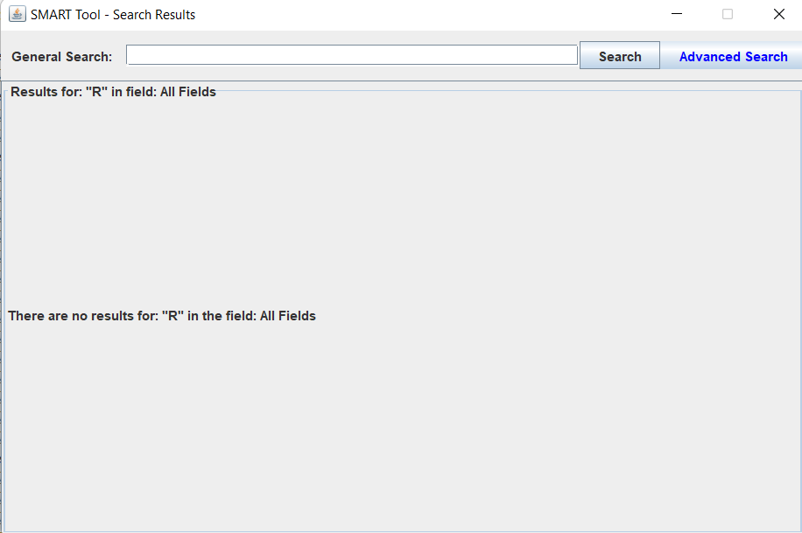

##### Record Duplication

*Figure 98. Display when “Save” button was clicked two times.*

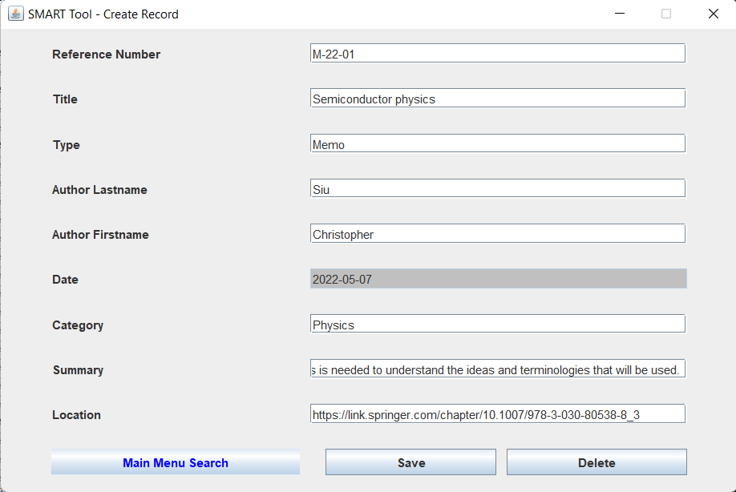

*Figure 99.Display when “Yes” button was clicked.*

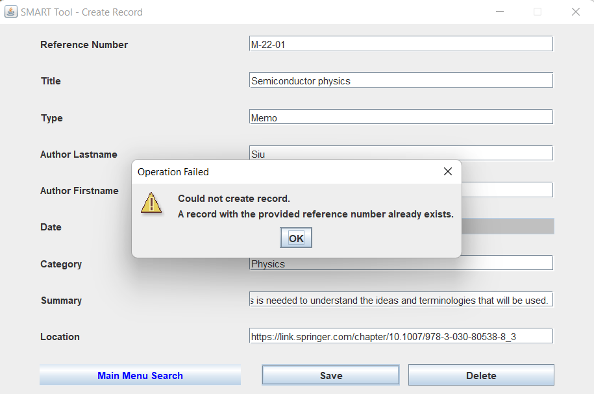

#### Code Coverage Testing

##### Statement Coverage Percentage

*Figure 100. Result of Statement Coverage Testing*

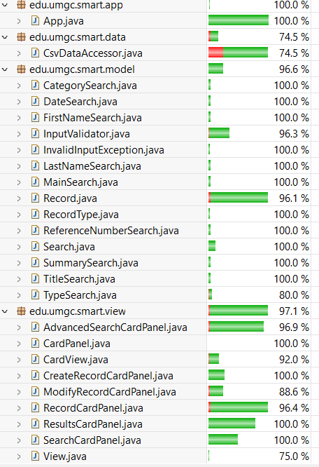

##### Branch Coverage Percentage

*Figure 101. Result of Branch Coverage Testing*

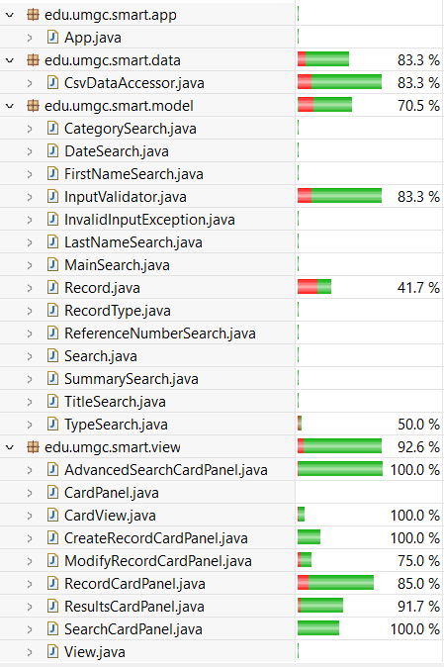

##### Complexity Coverage Percentage

*Figure 102. Result of Complexity Coverage Testing*

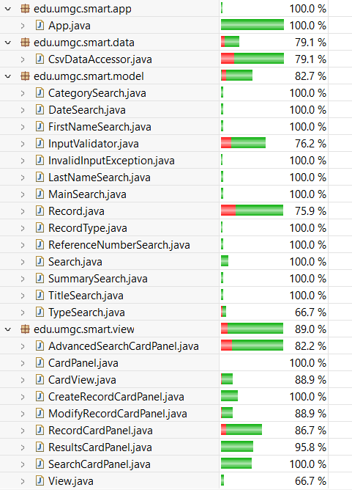

##### Code Coverage Result which other than 100%

###### Source Code Annotation

* Green: Fully Covered Line
* Yellow: Partly Covered Line
* Red: Never executed Line

###### CsvDataAccessor.java

Attn: Line 45,46, 98, 99 - I didn’t have idea of test cases which demonstrate these lines.

*Figure 103. Colored Code*

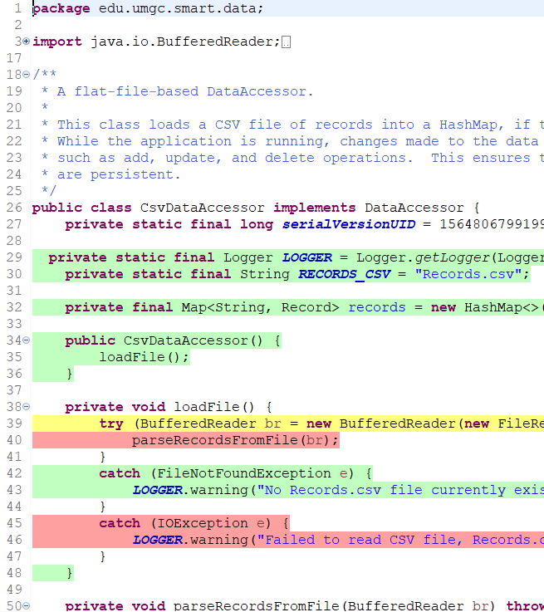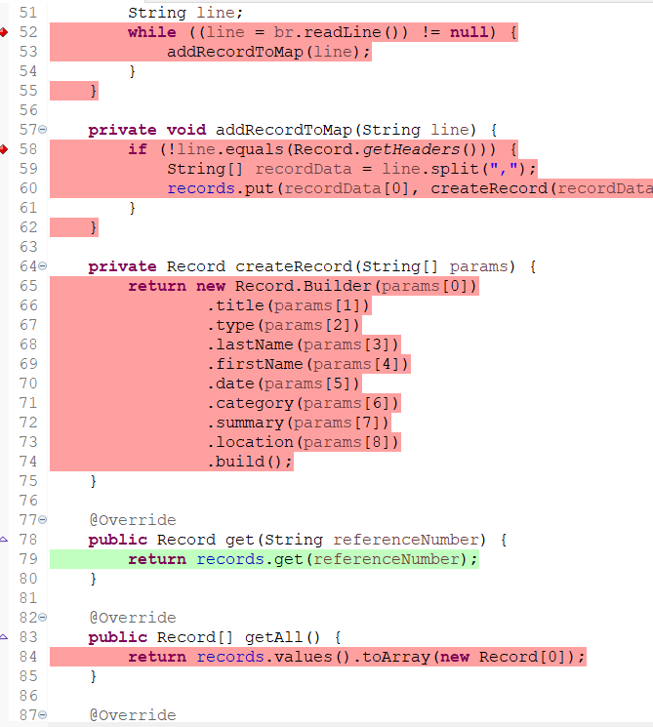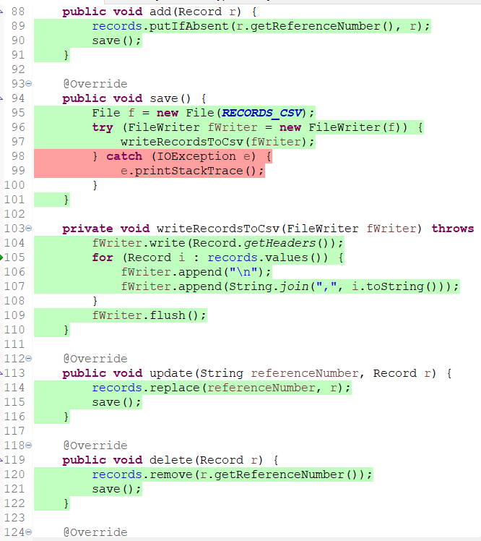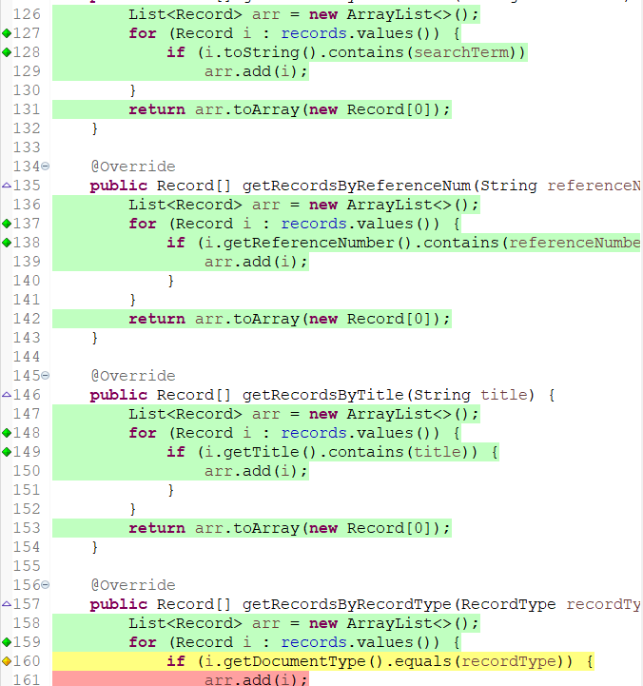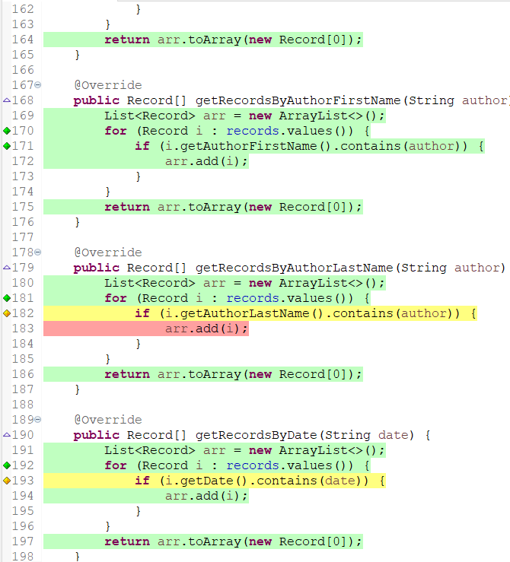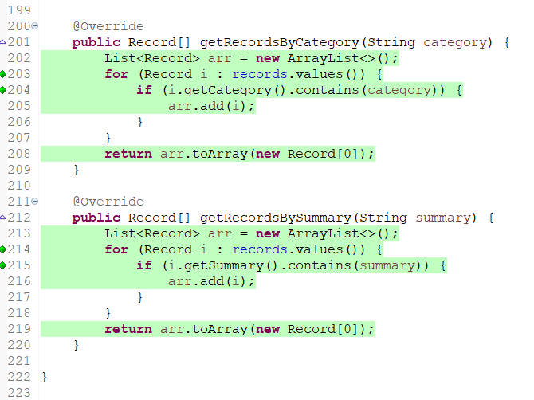

###### InputValidator.java

*Figure 104. Colored Code*

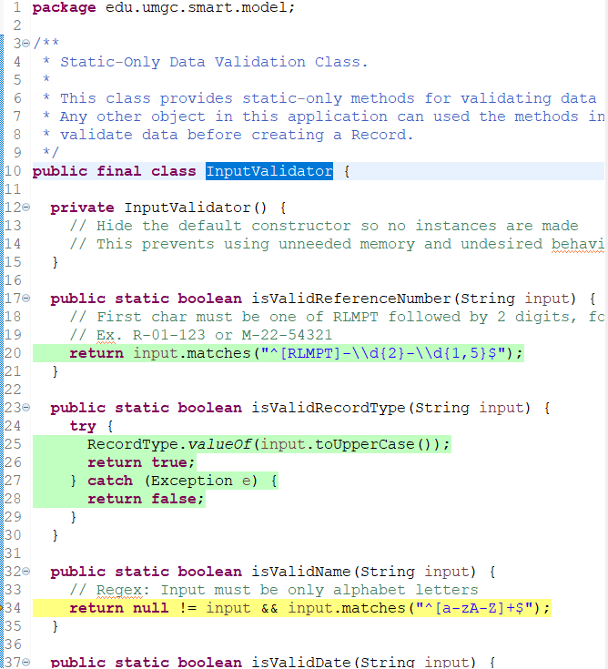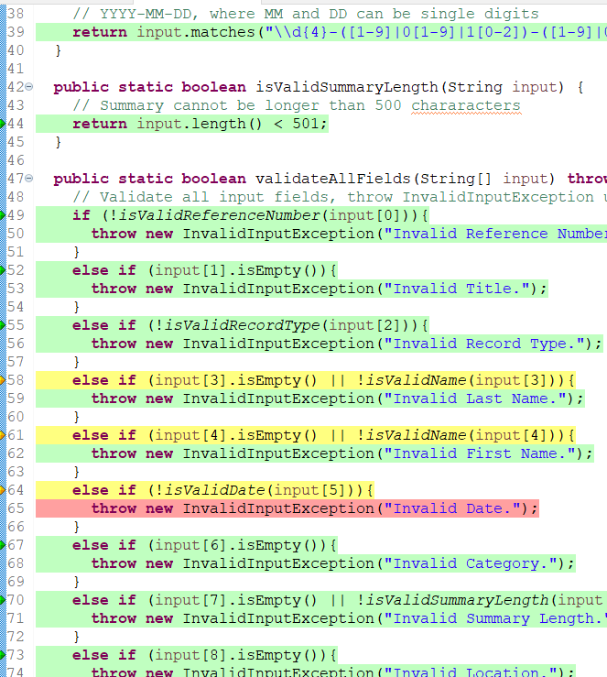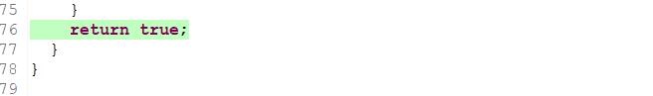

###### Record.java

*Figure 105. Colored Code*

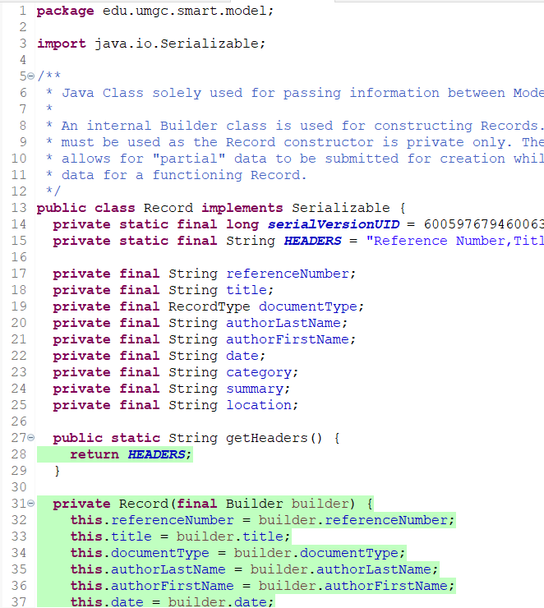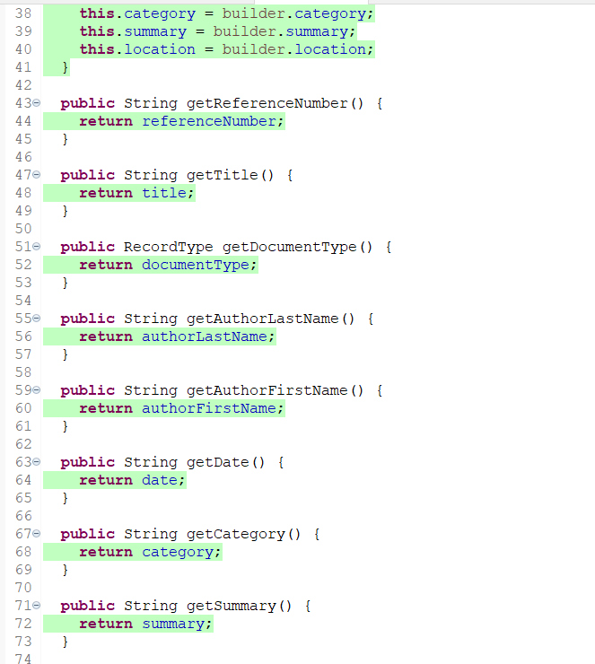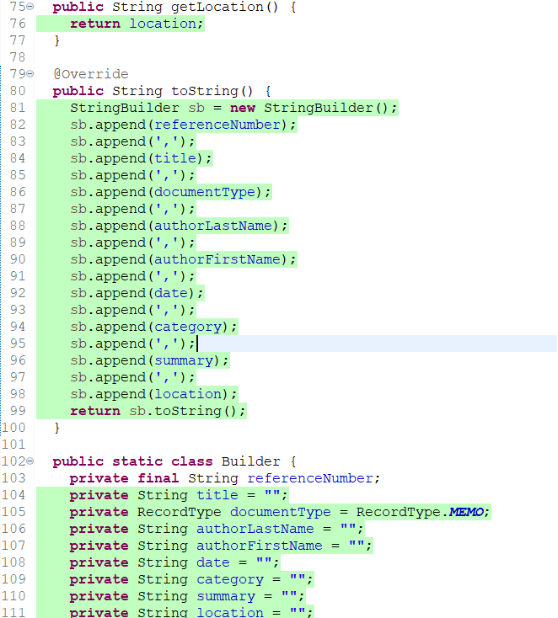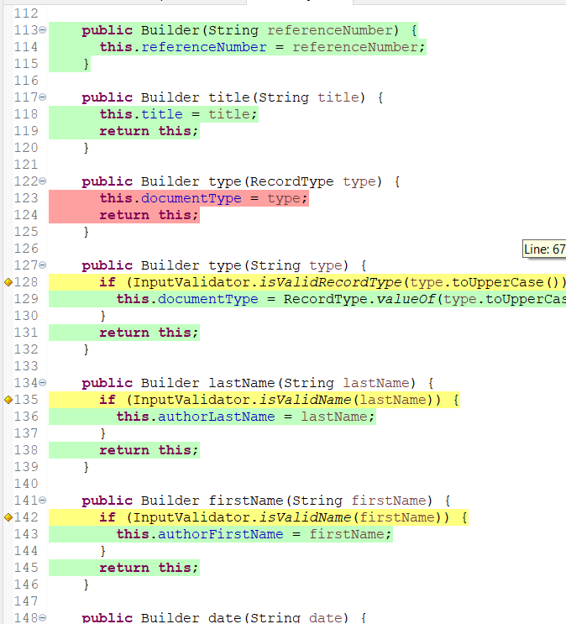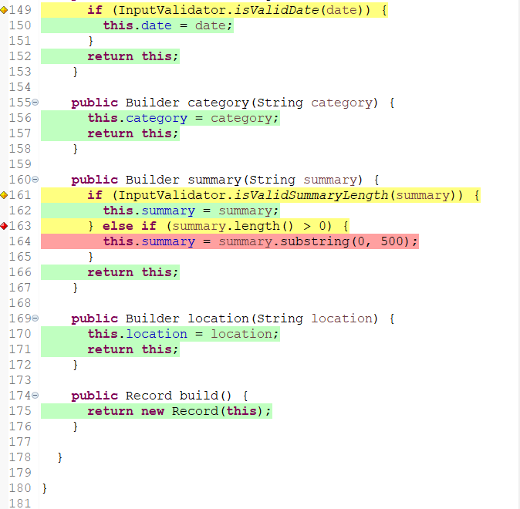

###### TypeSearch.java

*Figure 106. Colored Code*

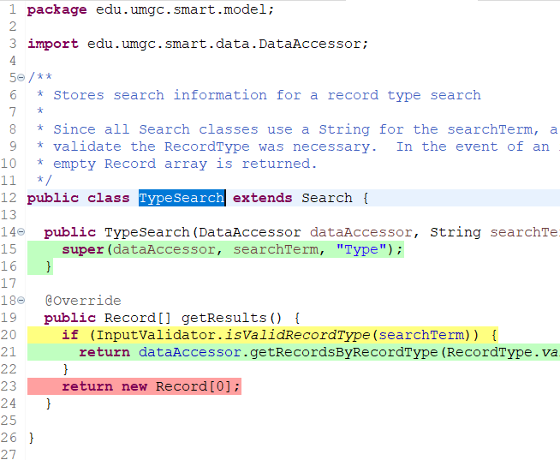

###### AdvancedSearchCardPanel.java

Attn: Line 122 to 125 - I didn’t have idea of test cases which demonstrate these lines.

*Figure 107. Colored Code*

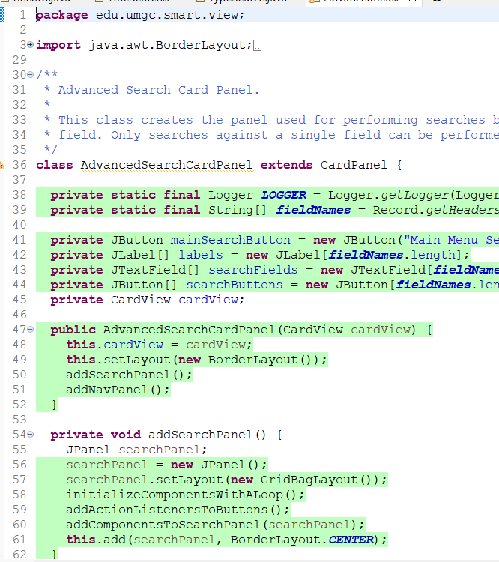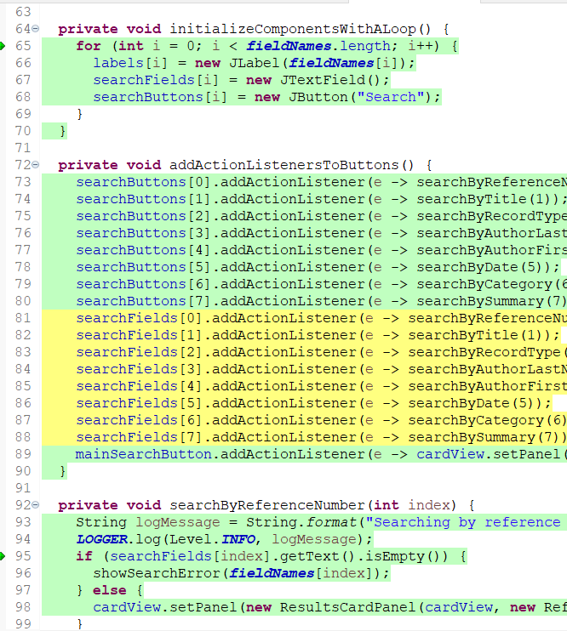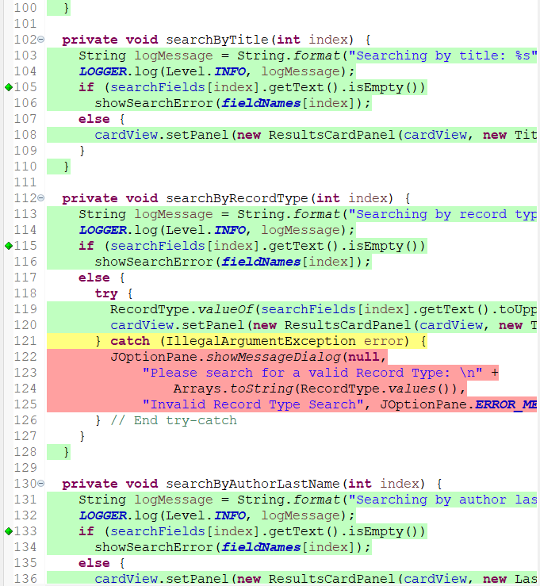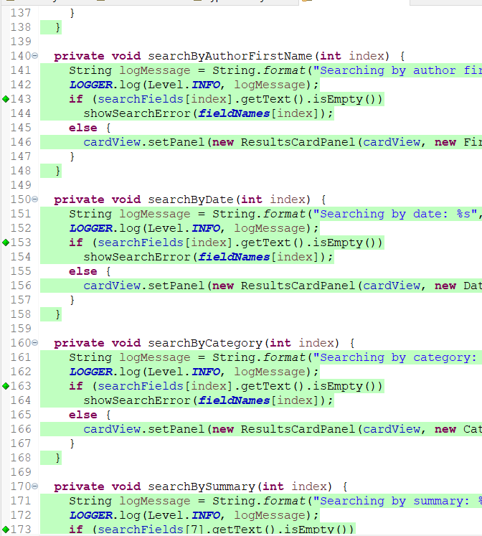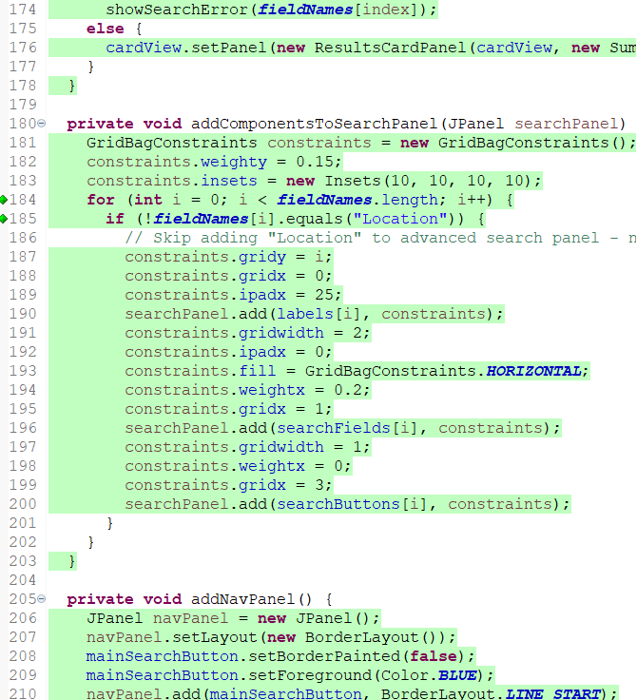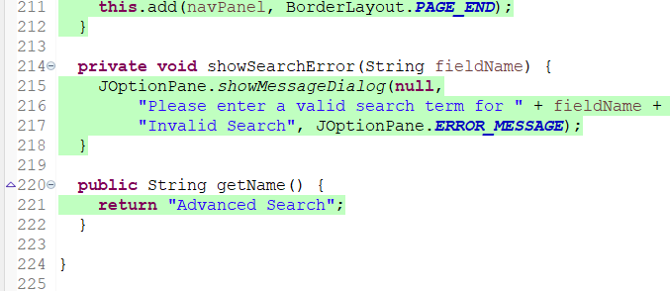

###### CardView.java

*Figure 108. Colored Code*

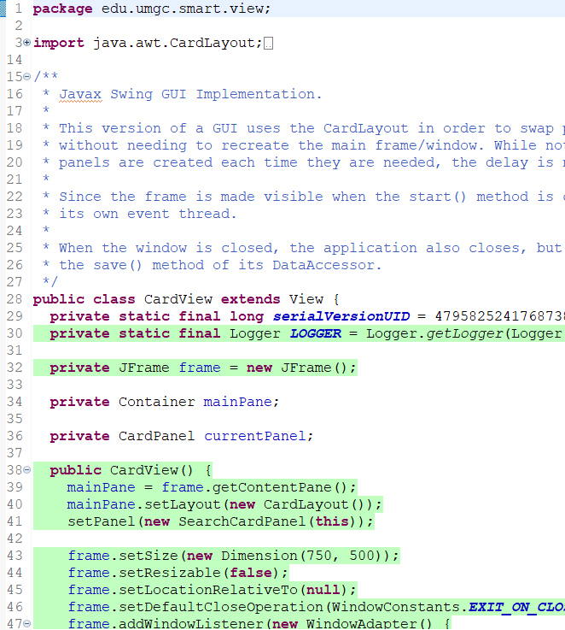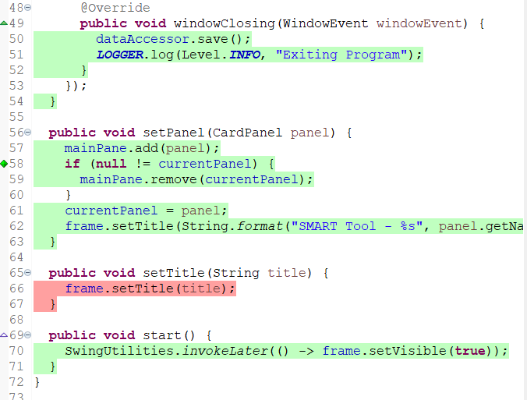

###### ModifyRecordCardPanel.java

Attn: Line 57 to 60 - I didn’t have idea of test cases which demonstrate these lines.

*Figure 109. Colored Code*

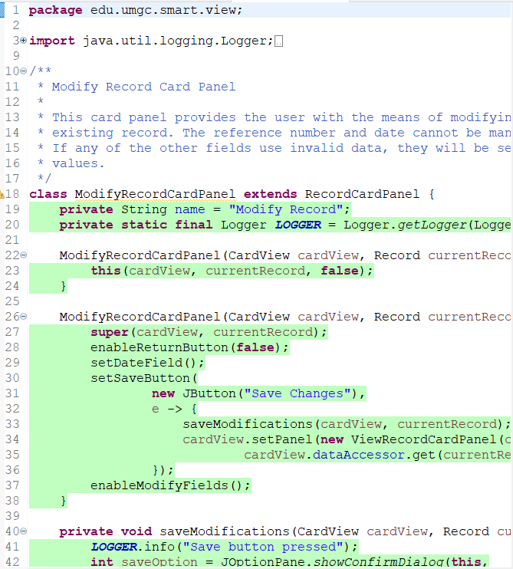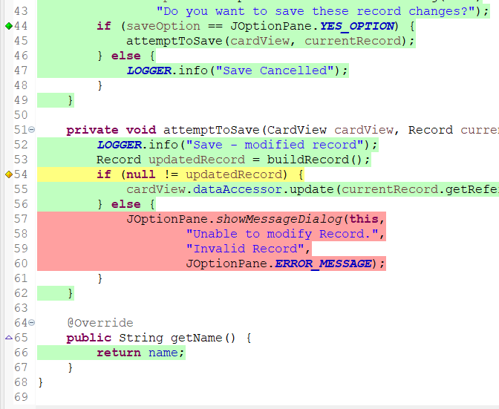

###### RecordCardPanel.java

*Figure 110. Colored Code*

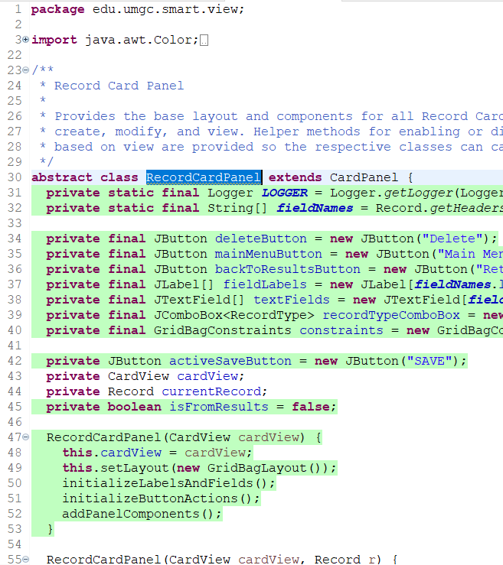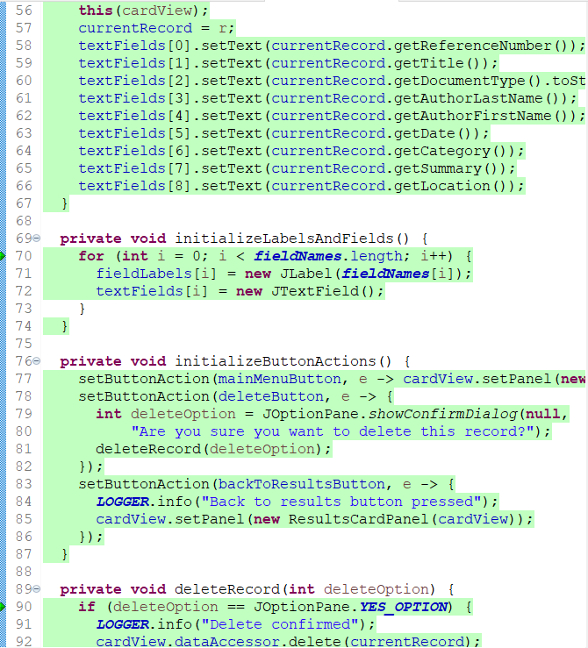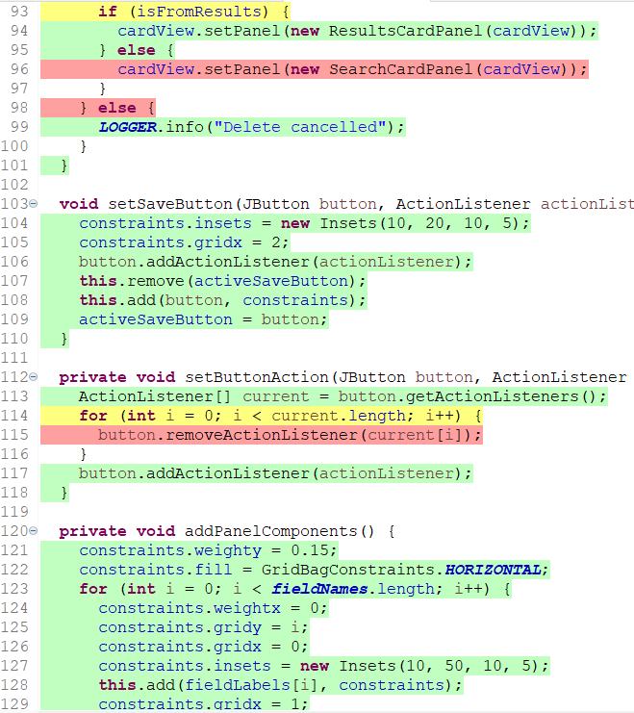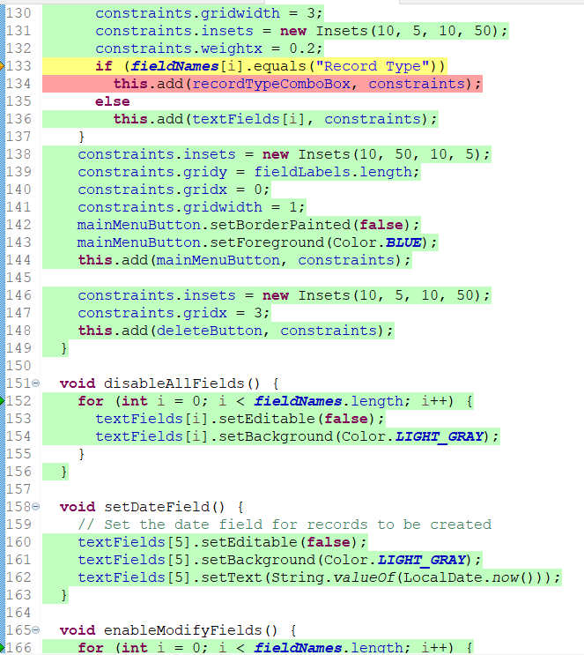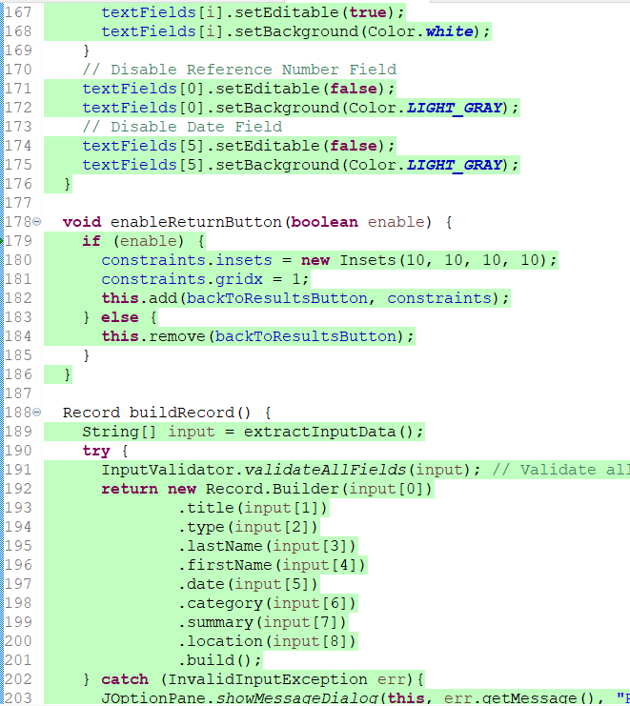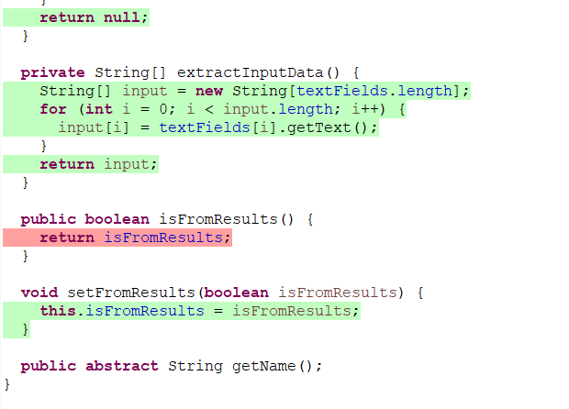

###### View.java

*Figure 111. Colored Code*

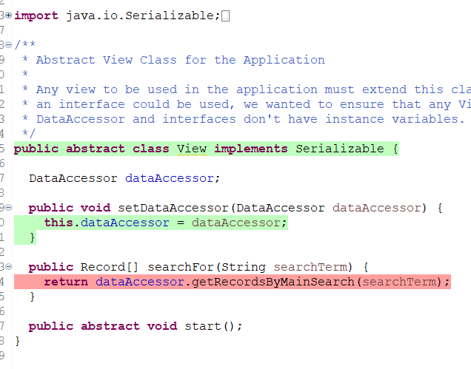

#### Performance Testing

##### Performance Testing Used Data

File name “ Performance Test Data” is used.

Positive Errors on each data sets are following.

|  |  |
| --- | --- |
| Data Set Number | Positive Error |
| 1 | N/A |
| 2 | N/A |
| 3 | Lack of Author’s first name |
| 4 | Lack of Reference Number |
| 5 | Lack of Document Title |
| 6 | N/A |
| 7 | Invalid Summary length |
| 8 | Invalid Document Type |
| 9 | N/A |
| 10 | Lack of Location |
| 11 | Lack of Document Title |
| 12 | Lack of Author’s Last name |
| 13 | N/A |
| 14 | Invalid Reference Number Format |
| 15 | N/A |
| 16 | Lack of Category |
| 17 | Lack of Author’s first name |
| 18 | N/A |
| 19 | Lack of Reference Number |
| 20 | Lack of summary |
| 21 | N/A |
| 22 | Invalid Reference Number Format |
| 23 | N/A |
| 24 | Invalid Summary Size |
| 25 | Lack of Author’s first name |
| 26 | Lack of Document Title |
| 27 | Invalid Document Type |
| 28 | Lack of Author’s Last name |
| 29 | N/A |
| 30 | Lack of Reference Number |

##### Performance Testing Results

Caught Errors

*Figure 111.* Data Set 2

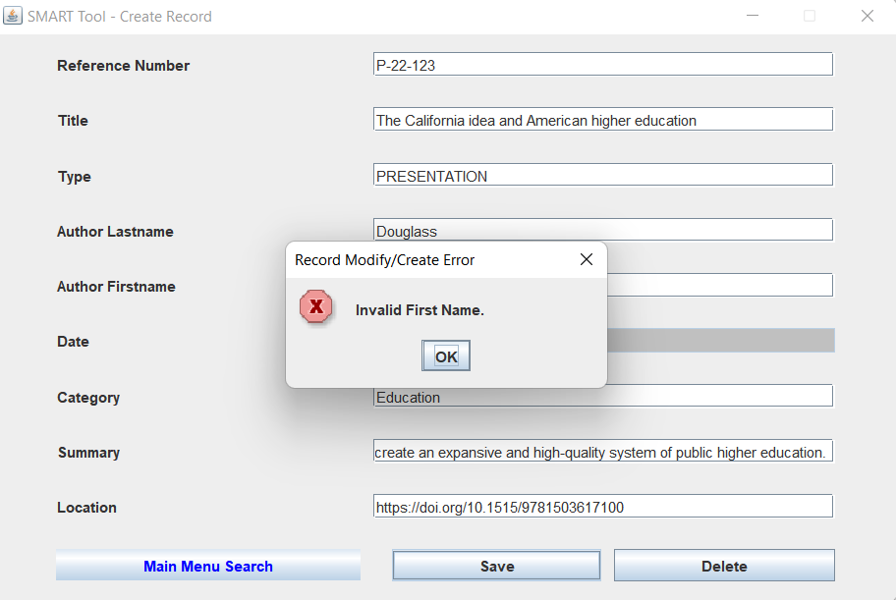

*Figure 112.* Data Set 4

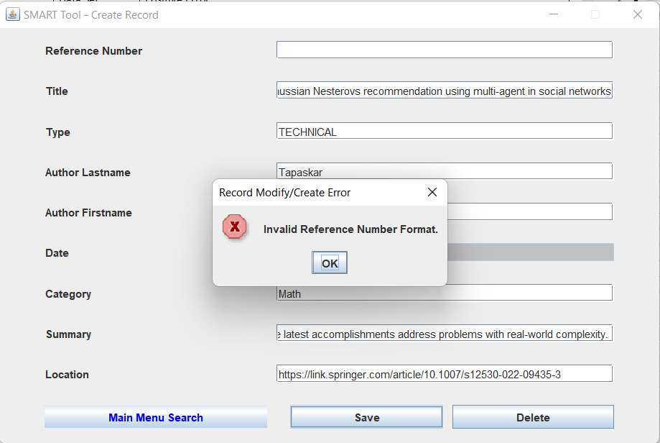

*Figure 113.* Data Set 5

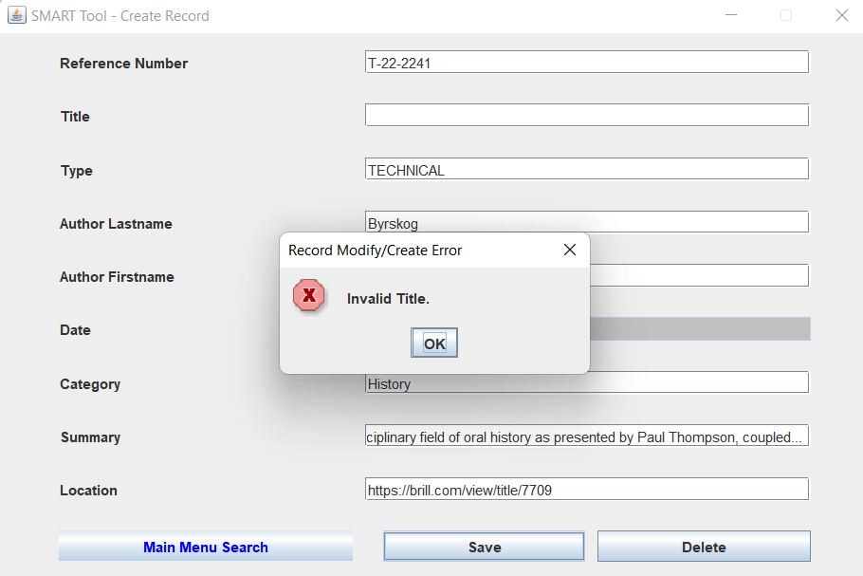

*Figure 114.* Data Set 7

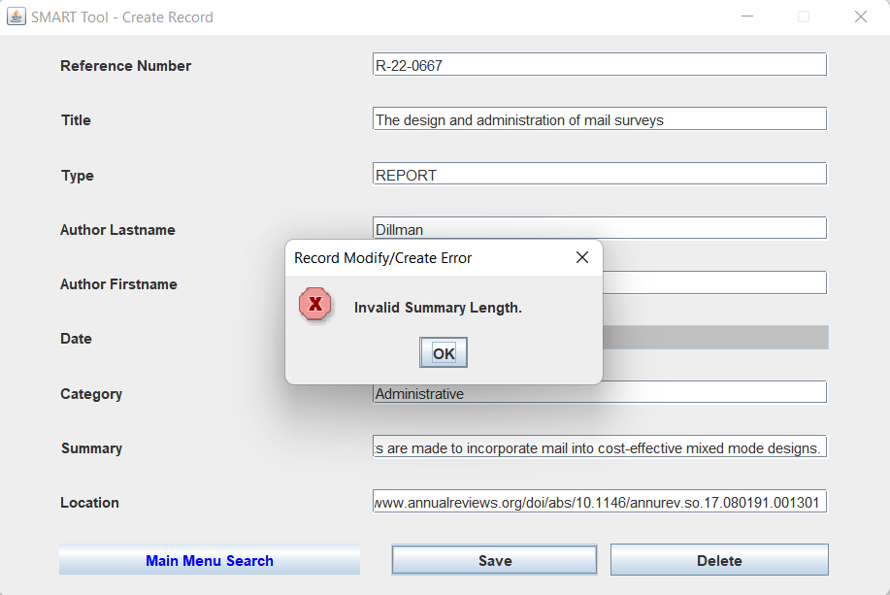

*Figure 115.* Data Set 8

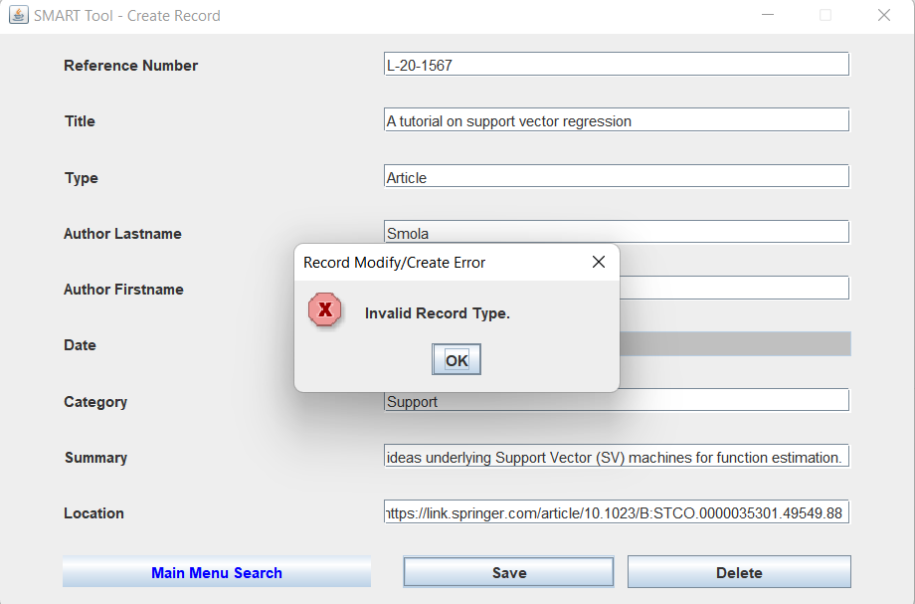

*Figure 116.* Data Set 10

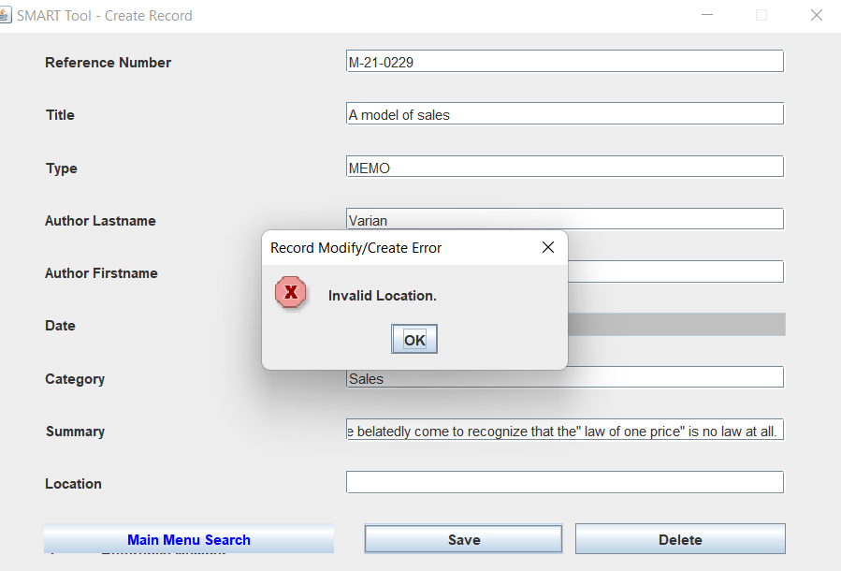

*Figure 117.* Data Set 11

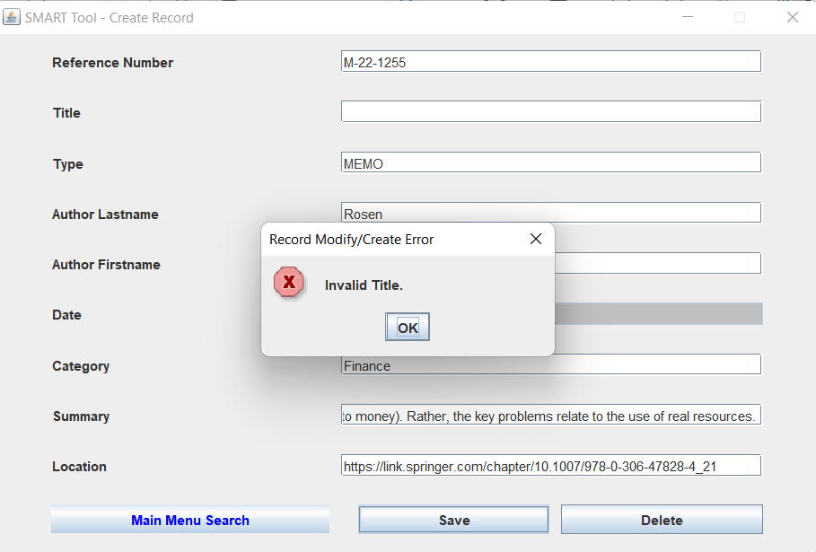

*Figure 118.* Data Set 12

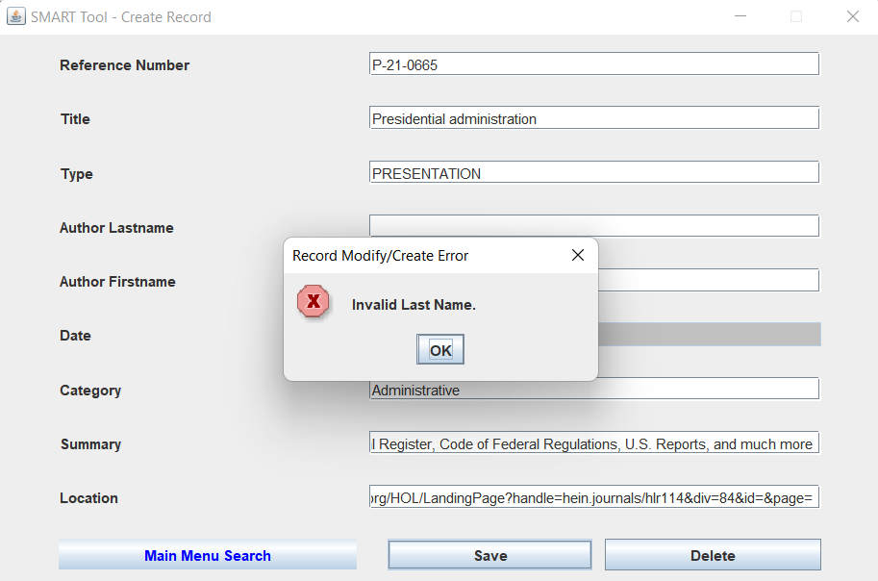

*Figure 119.* Data Set 14

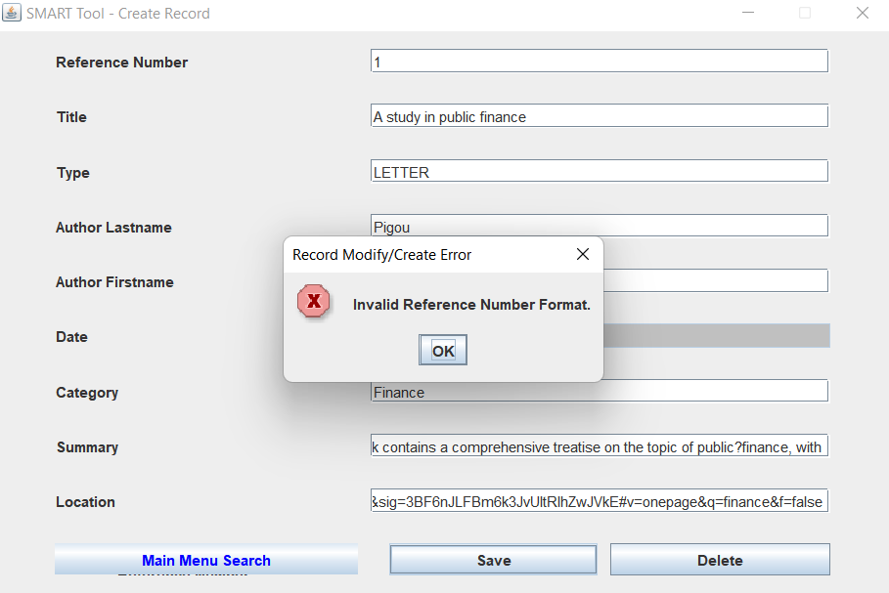

*Figure 120.* Data Set 16

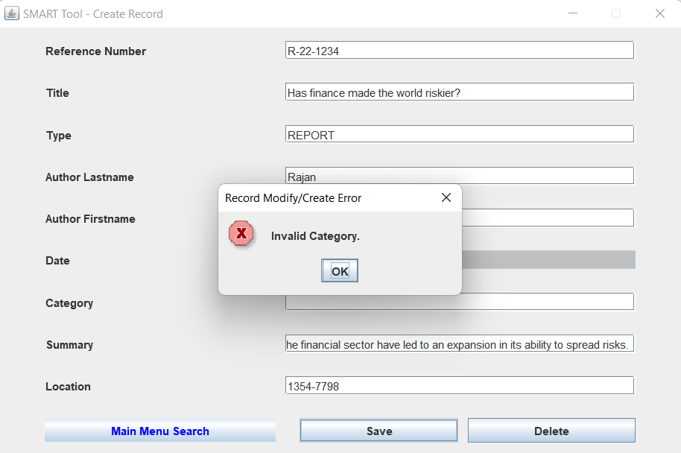

*Figure 121.* Data Set 17

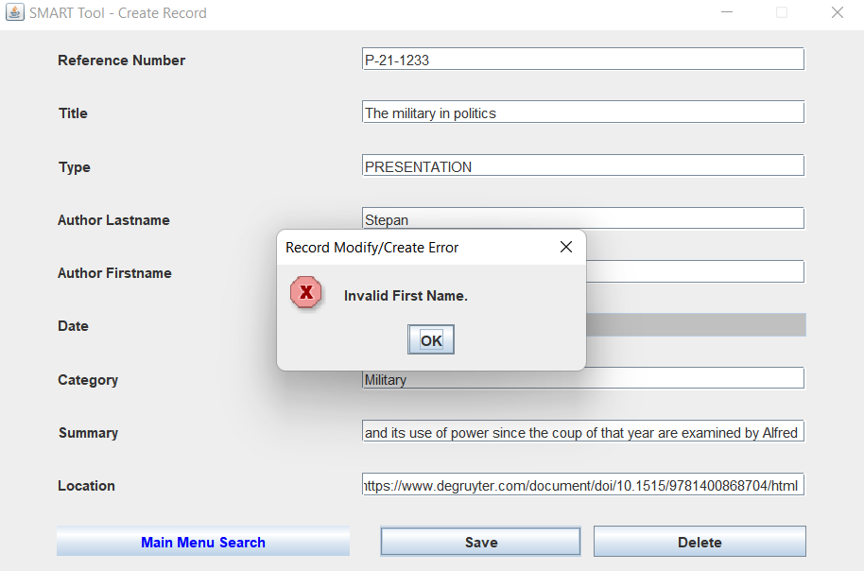

*Figure 122.* Data Set 19

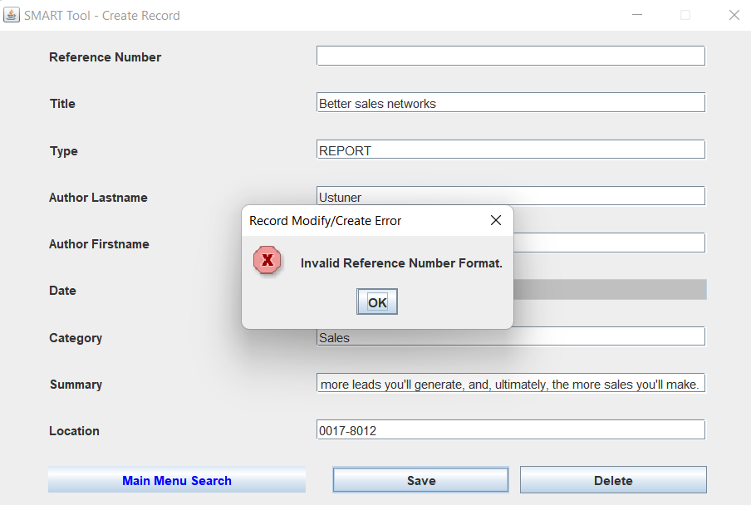

*Figure 123.* Data Set 20

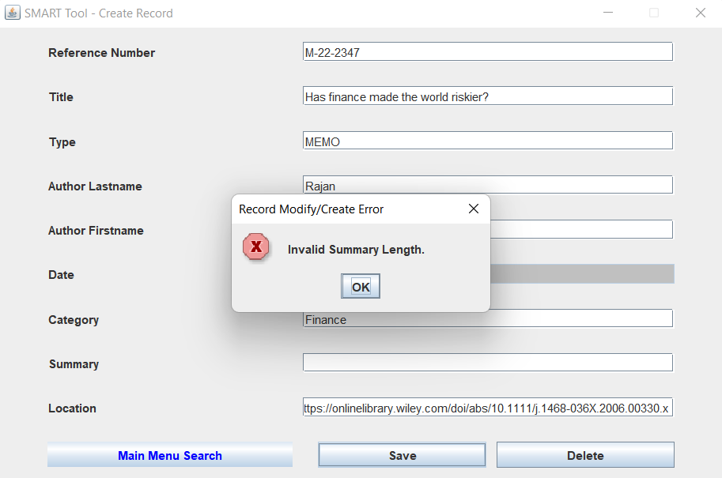

*Figure 124.* Data Set 22

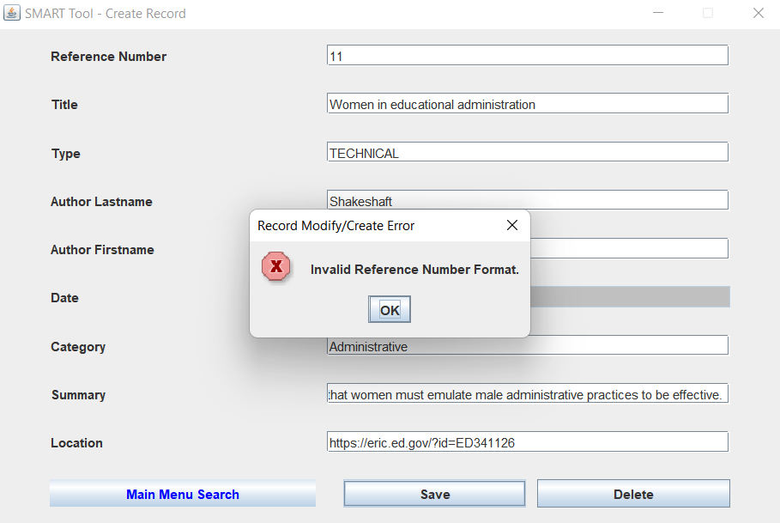

*Figure 125.* Data Set 24

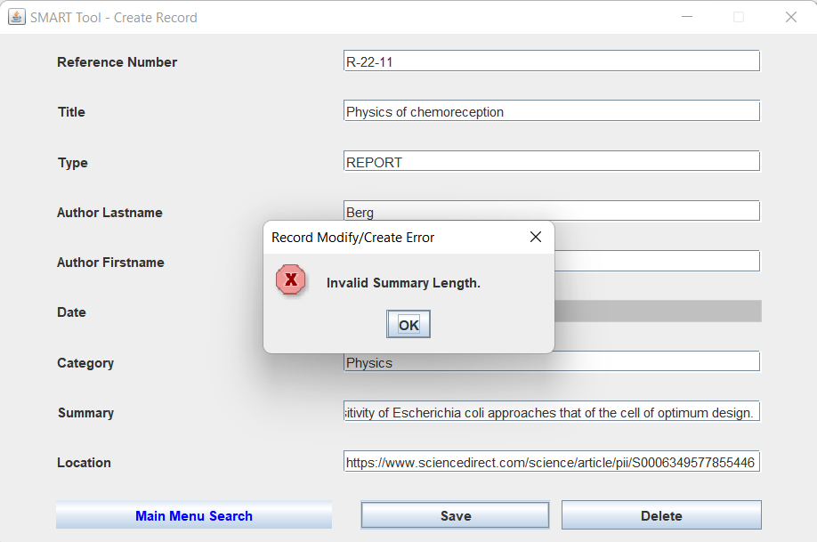

*Figure 126.* Data Set 25

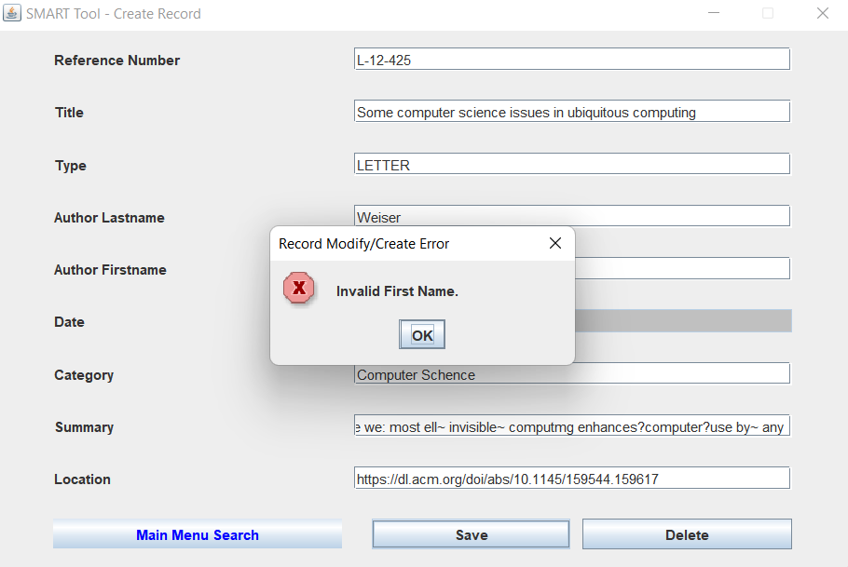

*Figure 127.* Data Set 26

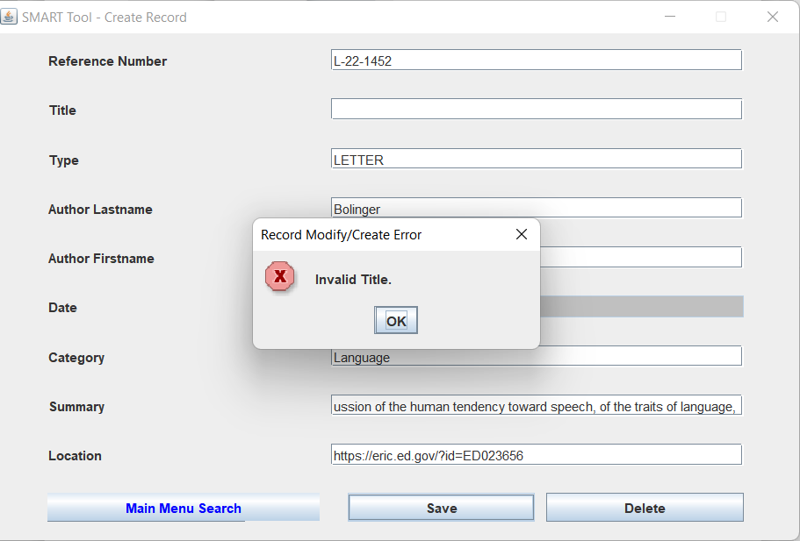

*Figure 128.* Data Set 27

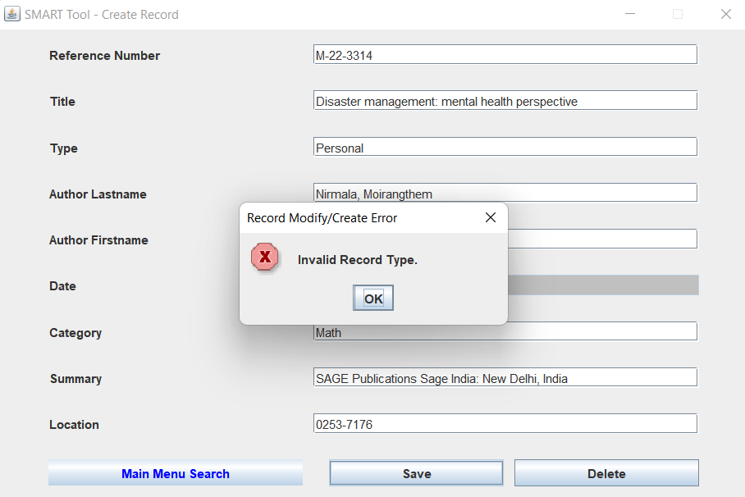

*Figure 129.* Data Set 28

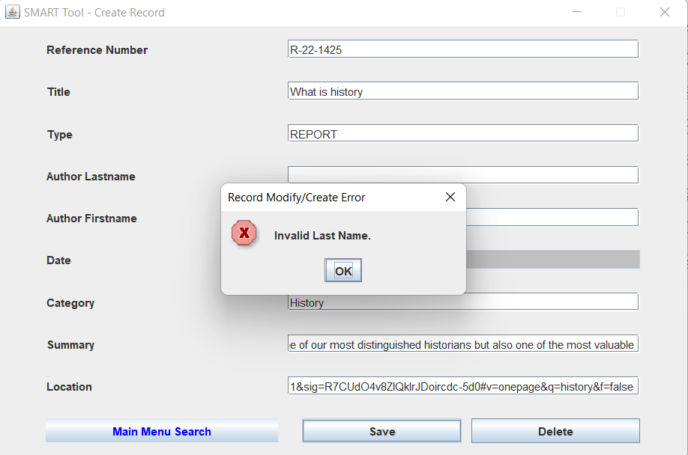

*Figure 130.* Data Set 30

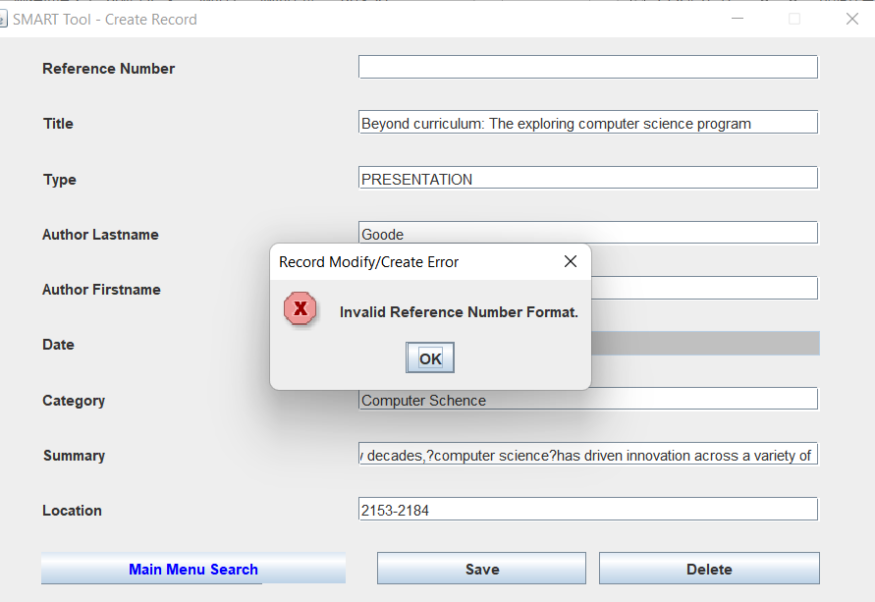

#### Leak Check Result

*Figure 131.* Memory Leaks Check Result

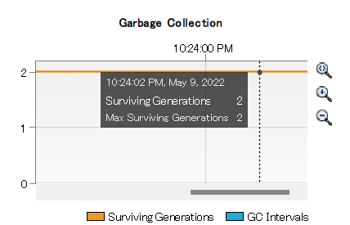

#### Stress Testing Result

*Figure 132.* Stress Test Result - Main Search

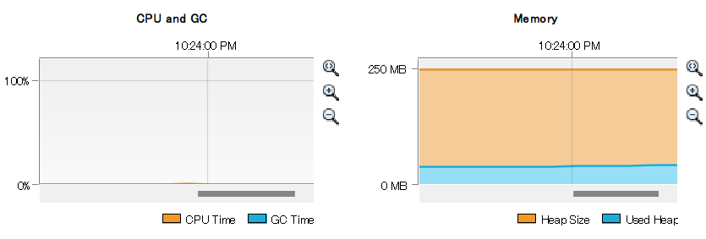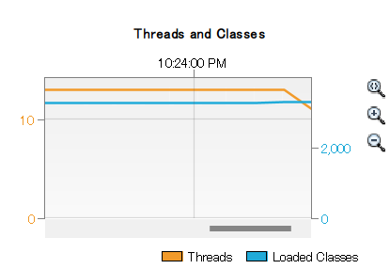

*Figure 133.* Stress Test Result - Advance Search

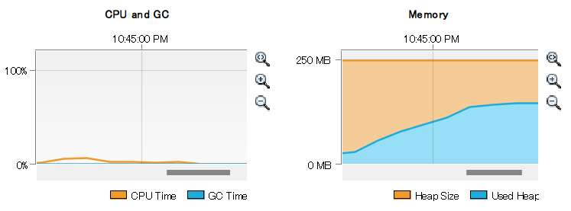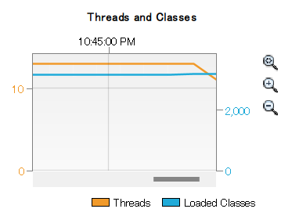

# Design and Alternate Design

## Design Considerations

The team will be approaching this project with a Model View Controller (MVC) style approach.

MVC is a presentation module pattern which aims to separate how the presentation module controls flow, what models of data it is based on and which is the view related logic. As is required for reusability, the View doesn't know about the Model, but it has a reference. The View doesn't hold a reference to the controller either. However the View sends button actions to the controller, so the button must be given a reference to the controller. The Model is not database access object. The Model can use database access object to produces business objects. View layer is simply a user interface presentation. Controller layer contains methods to handle user events such as a mouse click. Although user events are inside the View layer, the handler method itself could be as the Controller. The controller plays as a bridge between the Model and the View. It chooses which model object should be accessed and which view should be presented for that related user event.

The application and business-logic parts of the program will not rely on view and *dataAccessor* implementations. This will prove useful in that a test class for both view and *dataAccessor* were created early on for early tests. Once the *SwingView* class is completed, the last change needed will be to point the application to the new view. Multiple views could be running simultaneously with this approach, though the project will only be running a single view.

Aside from the logical separation, the developers will work on creating a simple skeleton program that compiles and runs. This allows the development team to "flesh out" the program to meet the requirements of our test cases: we are able to program to tests. If any test that was passing no longer passes, we can stop working on further test until the previously-passing-now-failing test is passing again.

## Design Goals and Guidelines

Our goal is to make planned functions work on time

The Weekly milestones and Progression can be found in Phase I, II, and III reports

To achieve our goal, there are guidelines to follow

* Active Communication: Communication is the key to the success. Do not hesitate to ask for help
* Report the status: Report the status of tasks weekly so the team can make decisions fast if needed
* Commitment: Try your best!
* Proper Planning: Follow the Weekly Milestones
* Risk Management: Follow the Risk Register when it happens

## Development Methods

### Package Design Description

The application's package is edu.umgc.smart. The application is comprised of four sub-packages: app, view, data, and model [See Figure 1 SMART UML Diagram 1]. These packages are split by layer, as seen in the Java source code. The app package contains files related to driving the program and also contains the entry point for the program (i.e. the "public static void main(String... args)" method). The view package contains files related to any and all user interfaces. The data package contains files related to the storage and access of data, regardless of medium. The model package contains files related to the modelling of the business logic.

When the Java application is launched, the program runs the "main" method, found within a class of the app package [See Figure 2 SMART UML Diagram 2]. From there, a data storage object is initialized. The program will also initialize a user interface to which the previously initialized data storage object is attached. The program will then start the user interface and, for all intents and purposes, hand off control to the user interface.

From the user interface, the user has the ability to navigate options for sending queries. These queries are passed from the view to its attached data storage object. The data storage object returns the appropriate response object(s) to the view. The results of the query are presented to the user. If an error should occur as part of a query, the user interface handles how to present the error to the user.

The data storage object implements an interface -- or contract -- that outlines all the methods the user interface is expected to send as queries, such as to get all records, add a new record, delete a specific record, or, if living dangerously, delete all records. Thanks to the use of an interface, the rest of the program doesn't know about how the methods are implemented, just that they exist and return certain types.

Since the view and data packages don't know about each other's implementations, a common language is needed to translate information. This is done by creating application-specific objects that act as the intermediary between the other two packages. One such object is a Record that contains all information a single record in storage would contain. These files define what type of information is being used within the application. The data storage medium may contain other, perhaps unrelated, information, but must contain the application-required information. Likewise, the user interface can display other information, but must have the ability to display the application-specific information.

## SMART Package Diagrams

### SMART Package Diagram

*Figure 134.* SMART Package Diagram

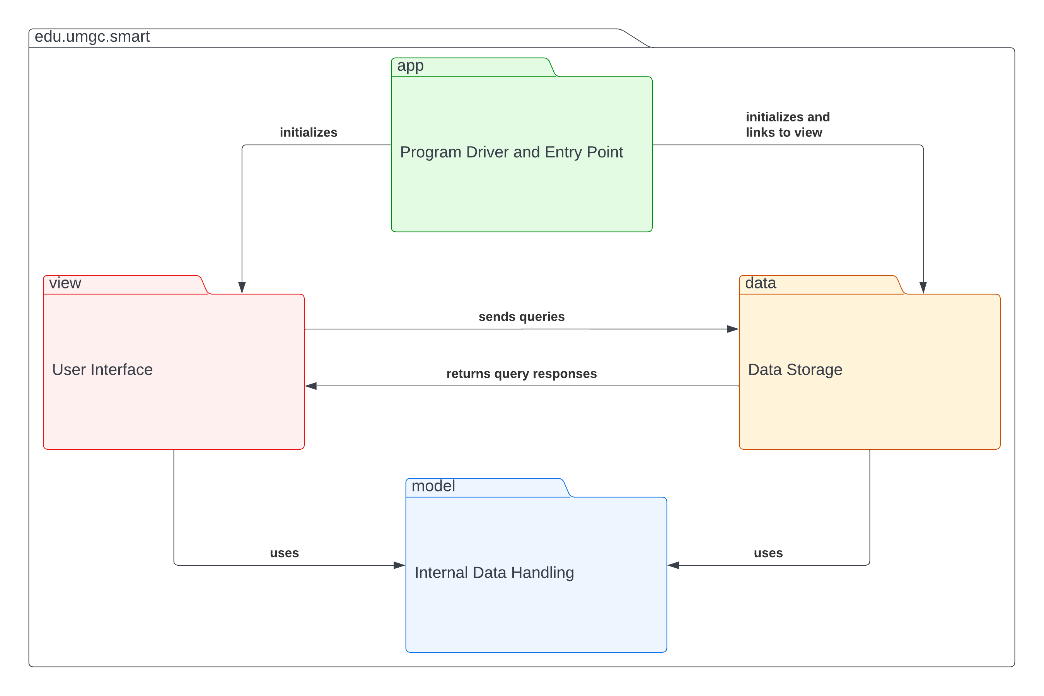

### Class Diagrams

#### App Package

*Figure 135. App Package*

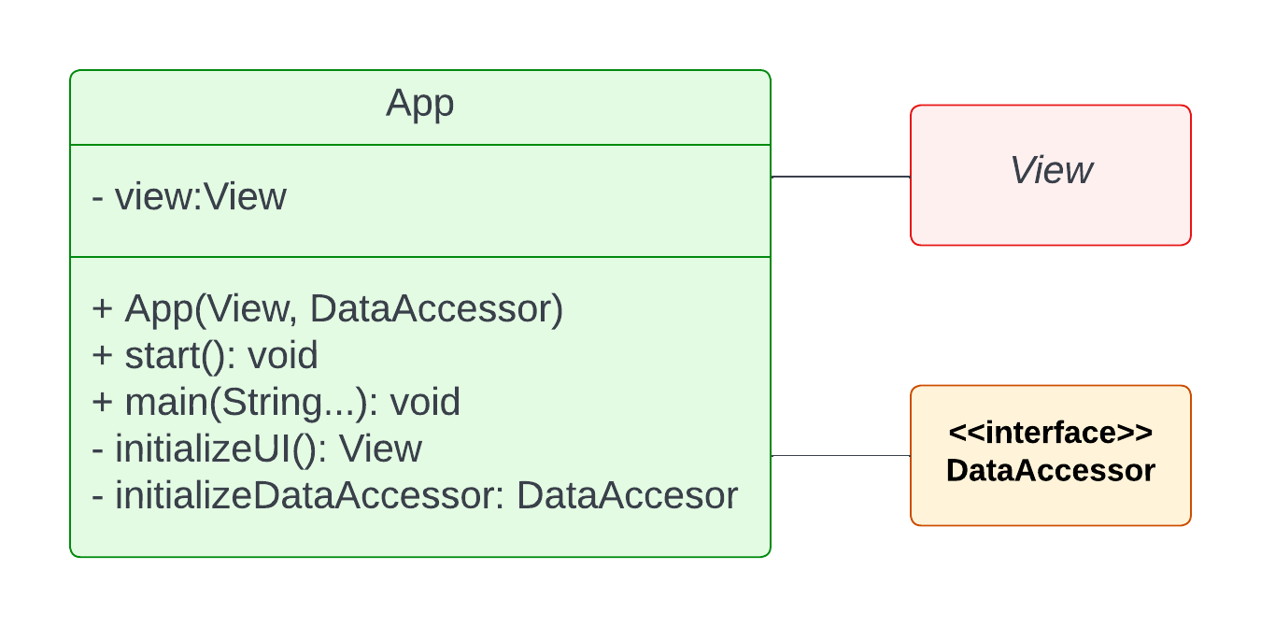

#### Data Package

*Figure 136. Data Package*

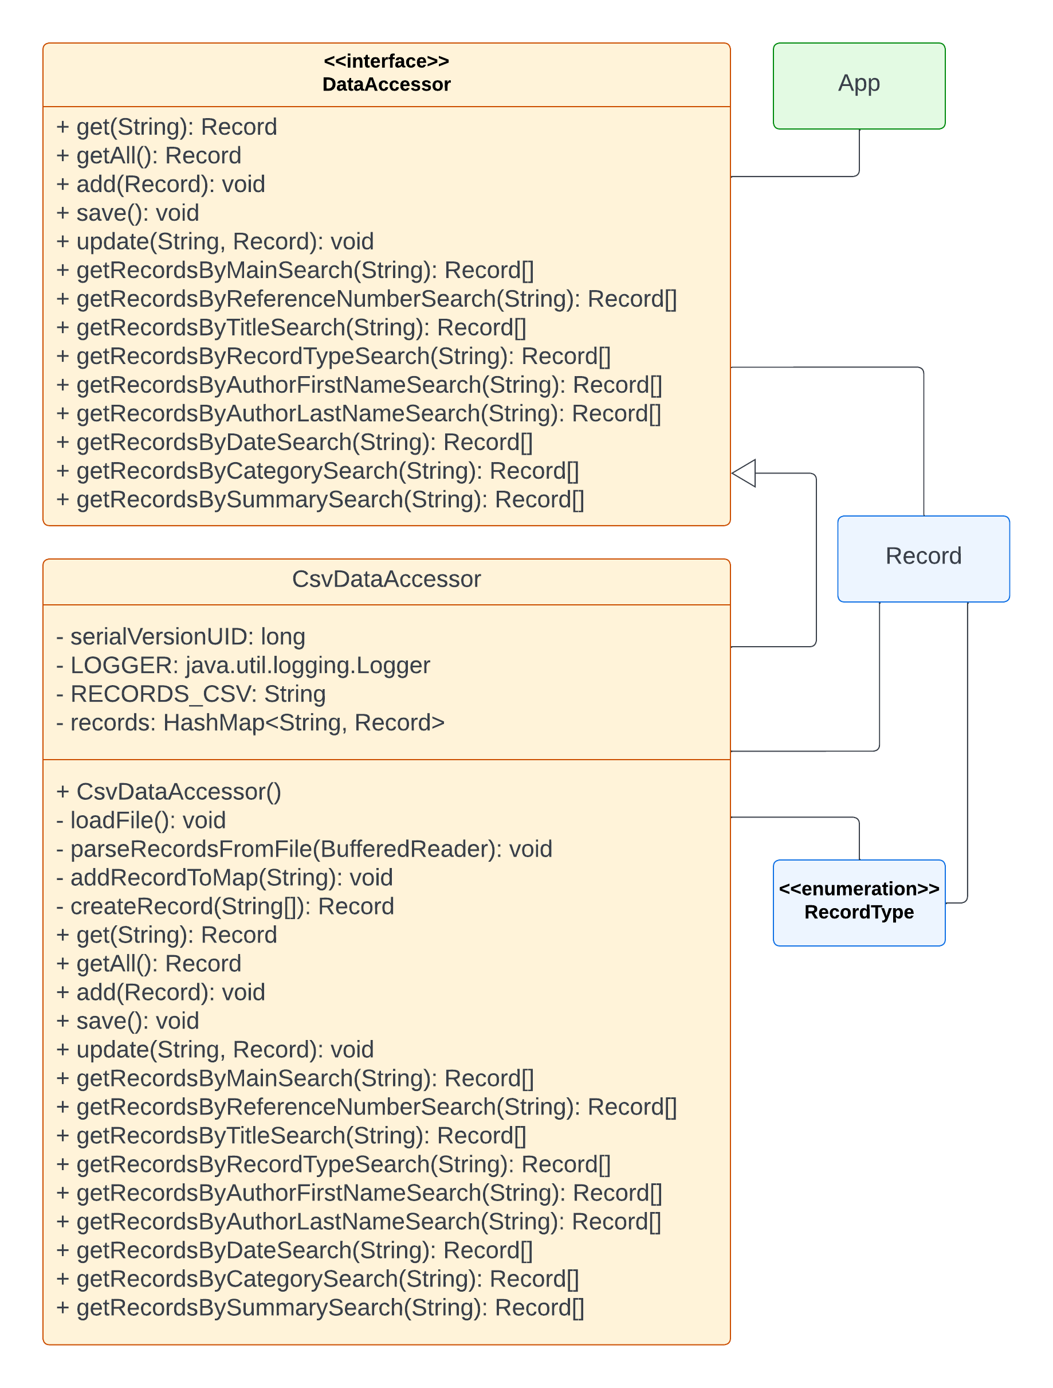

#### Model Package

*Figure 137. Model Package*

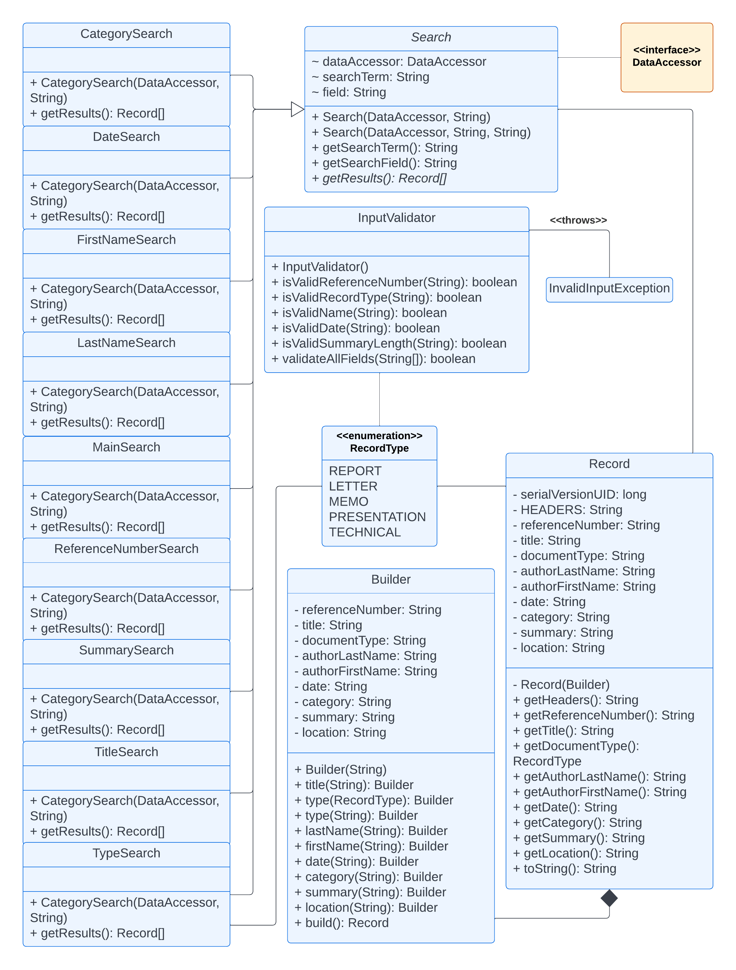

#### View Package

*Figure 138.1. View Package (1 of 2)*

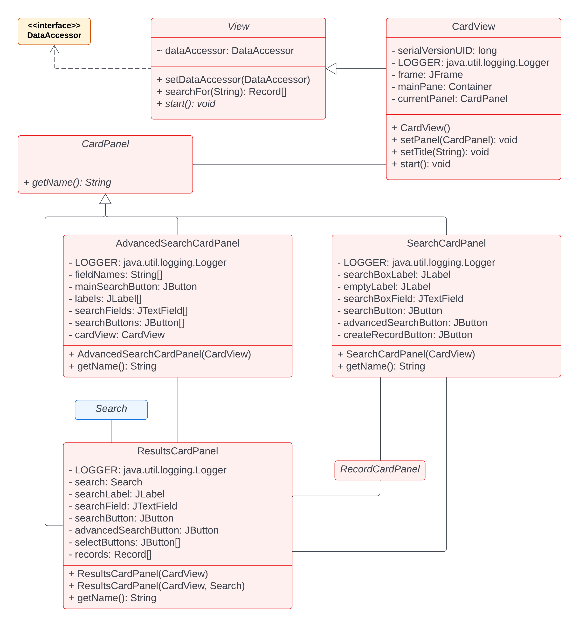

*Figure 138.2. View Package (2 of 2)*

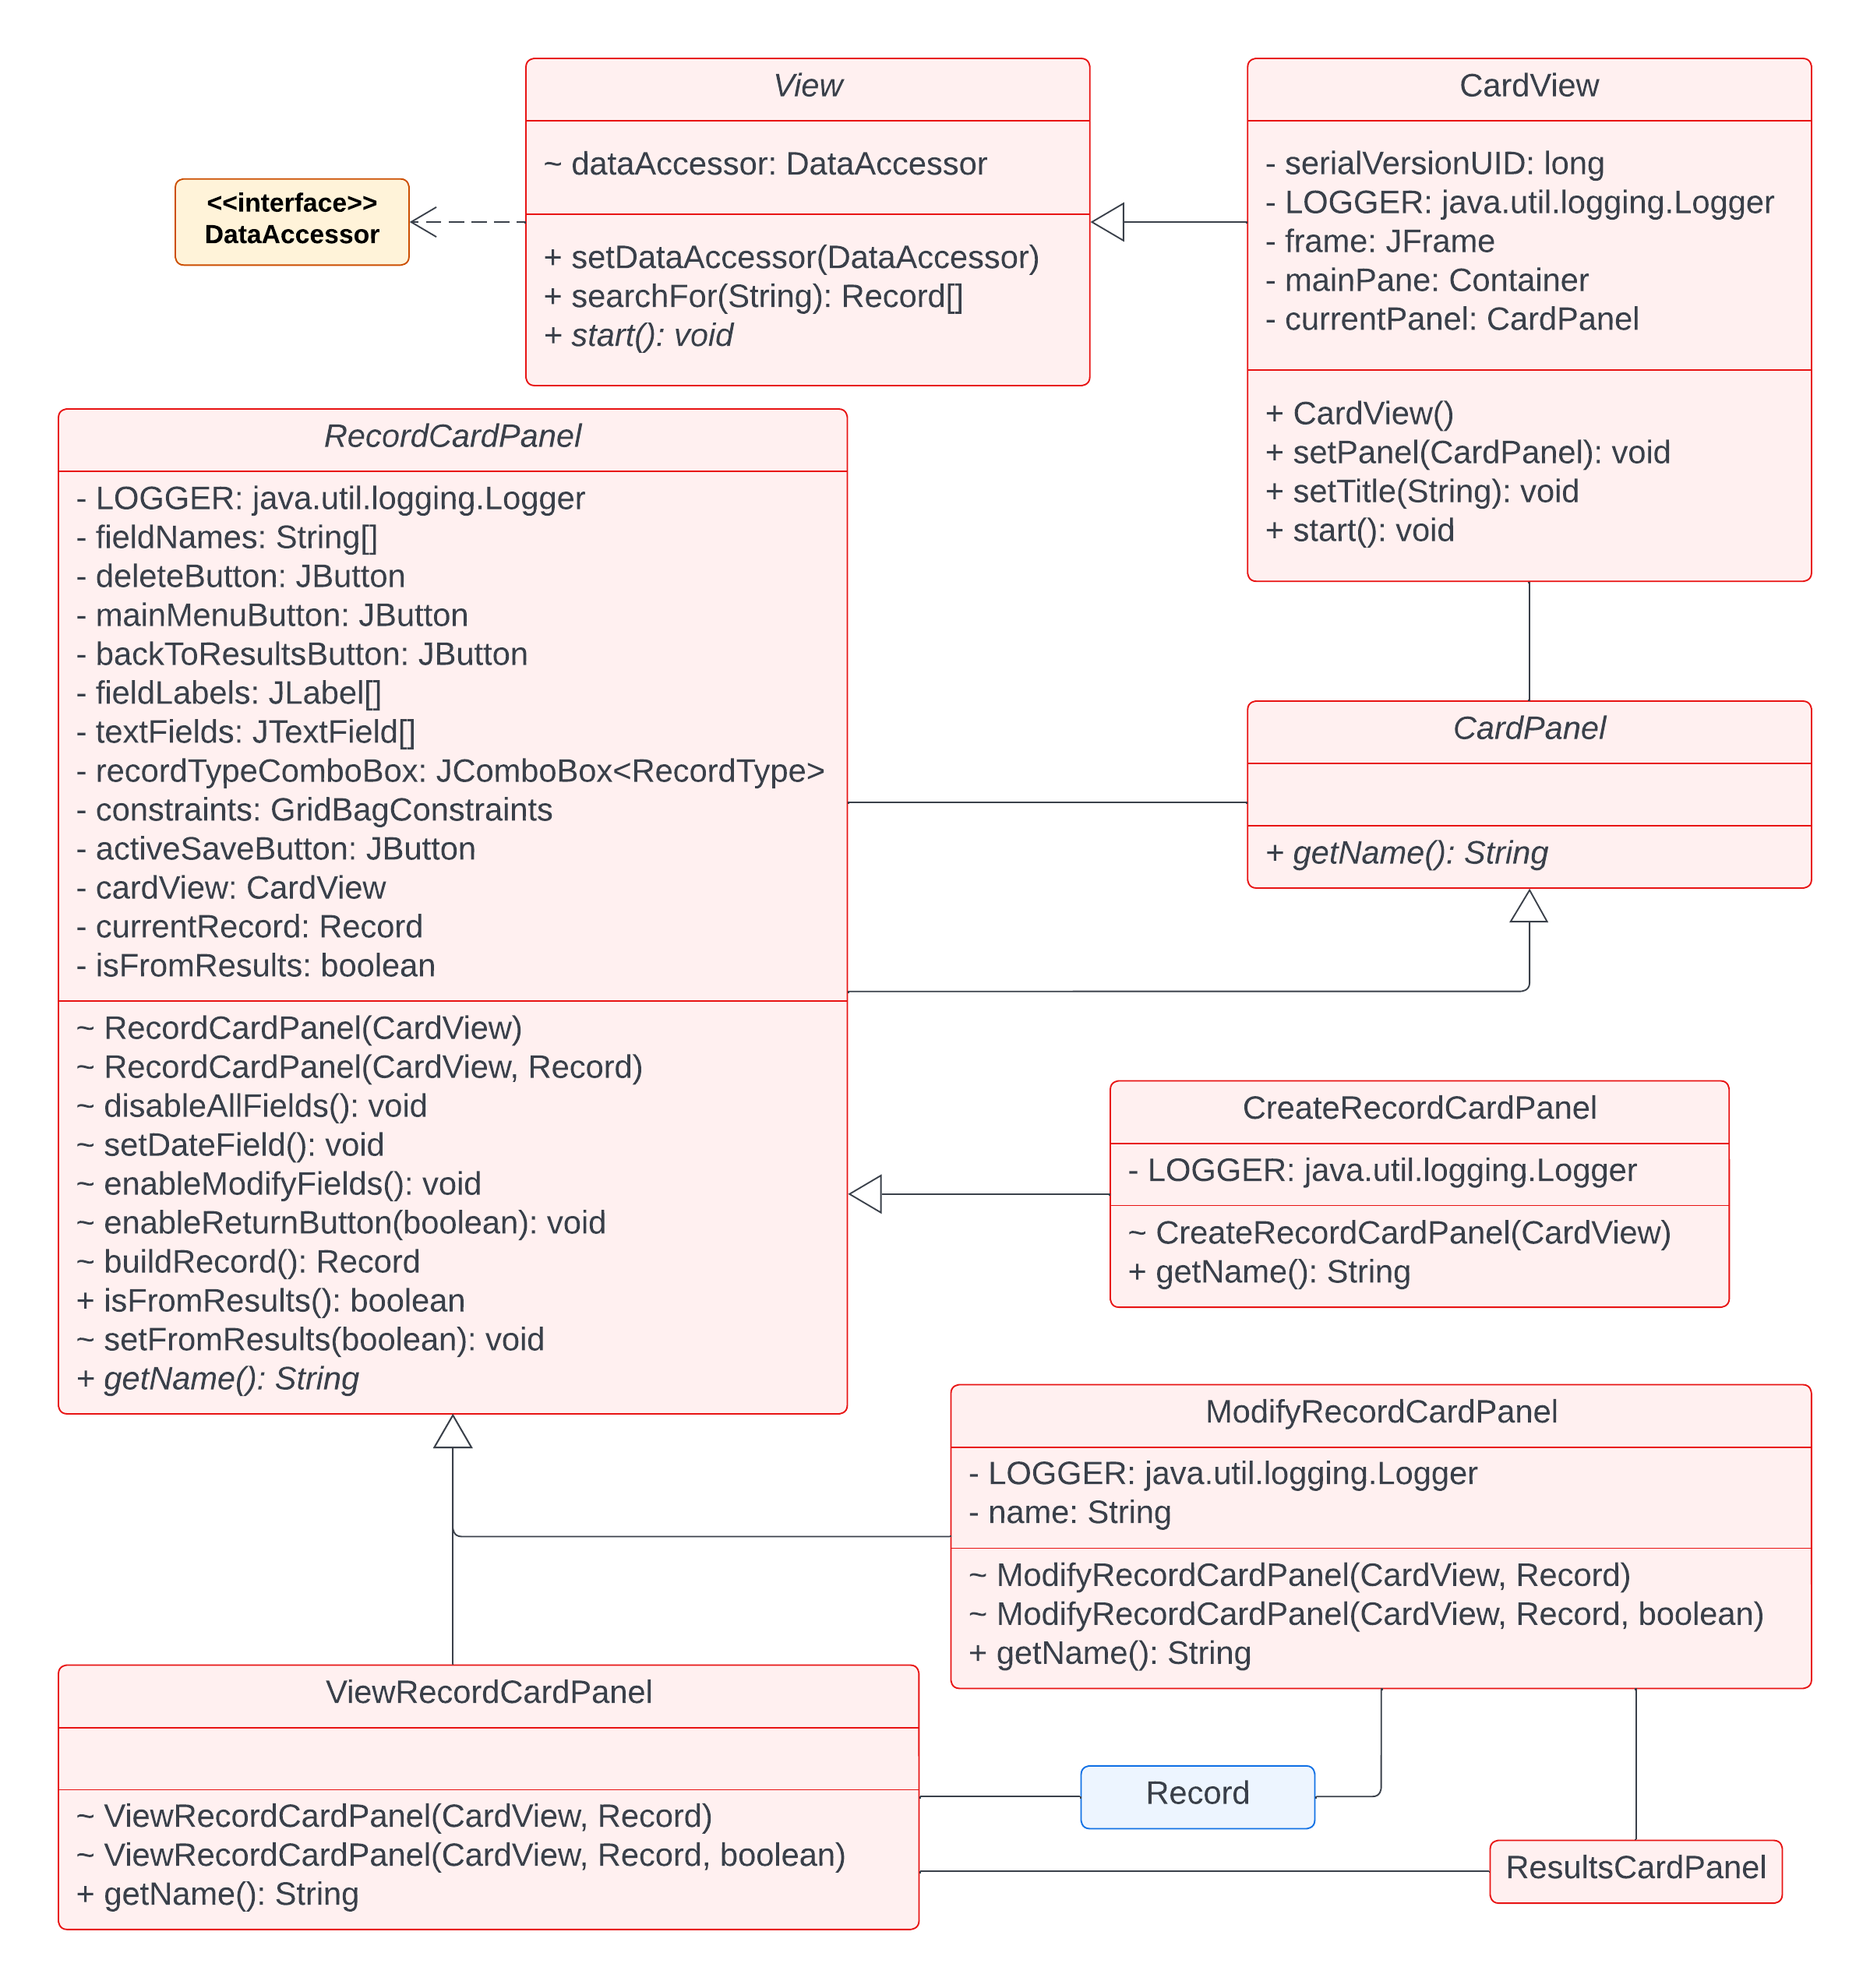

## Architectural Strategies

When the Java application is launched, the program runs the "main" method within the app.App class [see above Figure 2. SMART UML Diagram 2]. This App class is responsible for getting the application into a runnable state and starting it. The class will initialize the View and DataAccessor, as well as attach the DataAccessor to the View. The DataAccessor will begin hard-coded at first, and the View will have a default graphical user interface (GUI). When the command line argument "console" is passed as the first argument, then a console-based user interface will be used instead. Future versions of the program should allow for different Views and DataAccessors to be selected using option-based command-line arguments, such as "-v console -d MSSQL" or "-d CSV -v web". This feature will not be included with the initial release of the program.

When app.App runs the start() method, the control is passed to the selected View object. In order to ensure all Views have a DataAccessor object, an abstract class will be used instead of an interface. The class will contain an implemented setDataAccessor(DataAccessor) method that simply sets the instance's DataAccessor to the DataAccessor passed in as a parameter. An abstract start() method also ensures that any concrete classes must implement this method, much how an interface would require.

The view package will contain two concrete view.View classes: view.ConsoleView and view.SwingView. The former, view.ConsoleView, will be used for testing purposes and to establish a functioning base application. This class has not been fully developed and is not intended for production use. As such, its references will be removed from the production release. The latter, view.SwingView, on the other hand, is the default view used by the application. This class creates a graphical user interface with JAVAX Swing components, including buttons for sending search queries or changing views. The view.SwingView class will also have an internal ViewType enumeration. Information about displaying internal enumerations in a UML Diagram was not forthcoming, so an external representation was used.

From the user interface, the user will have the ability to create searches, or queries, for records. These queries are sent to a data.DataAccessor implementation. The data.DataAccessor interface defines the basic CRUD (Create, Read, Update, and Delete) functions. These will be expanded upon to meet program and/or feature requirements. All classes within the data package that implement this interface follow the parent-child naming convention. The data.MemoryDataAccessor is the data package's test class and, much like view.ConsoleView, was created for internal testing purposes. It simulates a set of Records in storage by using an ArrayList of Record objects with one starting test record. This class enables the rest of the program to function and return "real" data. This data.MemoryDataAccessor class will be replaced by an actual implementation that will store data in a non-volatile medium, such as a file or database.

In order for the classes in the view and data packages to communicate with each other, the "language" of the business records will be created in the model package. The different types of information a record must contain is defined in the model.Record class. This class will be simple object with getter and setter methods for each of its member variables, which equate to a separate data field. One of these metadata fields – documentType – must validate against a list of approved types. This list is contained within the model.RecordType enumeration. It is up to the view and data implementations to display this information. In JAVA, the names of enumerations are easily accessible and can be used by both view and data classes to have human-readable names to display and/or store.

## Data structures

As stated the Main package is edu.umgc.smart.  The development team will have four sub-packages: app, data, model, and view.  Please see the SMART Package Diagram and SMART Class Diagram above (section 6.2 and section 6.3).

The data package is for all our data storage classes and interface.  There will be an interface that defines five methods: get, getAll, save, update, and delete.  The application will also have a functioning class, MemoryDataAccessor, that only functions within RAM: all changes are lost when the program ends.  This works well for testing the functions and everything else in the program works smoothly.  Any other type of DataAccessor can replace the MemoryDataAccessor without changing the view or model.

The model package is where all of the business-logic type classes are stored.  This is where our enums and beans live. In other words, the classes in this package are referenced by both the view and data packages, acting as a common "language" for the two.

The view package contains all user-interface-related classes.  Due to wanting to ensure all View's had a dataAccessor field, an abstract class was used instead of an interface.  The development team will have a ConsoleView that is used for testing while the SwingView is under development.  The default view will always be SwingView, but the ConsoleView can be used instead by providing "console" as the first command-line argument.  No real data manipulation has been implemented before development begins.

Finally, the app package currently only contains one class, App.java, that contains the program's main method.  This is where the view and dataAccessor are selected and initialized.

## Detailed System Design (Functionality)

### Create, Modify, & Remove Records

Users will be able to create new records in the database. The record will consist of various metadata fields. The user will be able to enter the fields into the GUI interface and click a Save button. Users will be able to edit existing records in the database. The user will be able to edit and update existing saved records in the database using a GUI interface and click a Save button. Users will be able to remove and delete existing records in the database. The user will be able to delete existing records in the database using a GUI interface and click a Delete button. The Delete will also need a confirmation message to ask the user if they are sure they want to delete the record.

### Search Records

The application will have two ways to search: Main search and Advanced search

### Main search

The Main Search will consist of a screen displaying a single search bar (google-like). The search bar will be free text entered by the user with a search button. The main search field should do a query on the record titles. The search will be limited to 100 characters.

### Advanced Search

There will be an option for the user the click “advanced search.” This will display another section (or separate search screen) where the user does have the option to search other metadata fields that the application is capturing. Advanced search options by metadata capture includes: Reference Number, Document Type, Author, Date, Category, Summary, and Record Location.

### Search Results

The user will be able to click search and display a screen of search results. This search result screen will display the results in a list view where the user will be able to select an individual item to see the full record contained in the database. The search results screen should include: Record Reference Number, Record Document Type, and Record Title.

## Field Design for Metadata

When users create and edit records, the application will capture and save the metadata for searching. The fields will be entered by the user on a GUI interface where the user will click a Save button. The following sub-sections will detail the fields

### Reference Number

Each Record will be assigned a record number. The record number will need to contain the current year, the document type, and an auto-incremented number. The Reference Number is a mandatory field and should be generated by the application or user. For example: R-22-12345, or M-21-9876. The document type letters “R” “L” “M” “P” “T” will be described below in document types.

### Title

Each record will be assigned a title. The title is free-text to allow for user input to be provided. The Title field is mandatory and will be provided by the user. For Example: Finance Report for FY21 Q3. The title can be limited to 255 characters.

### Document Type

Each record will be assigned a document type. The document types are preset by the application. The user selects the appropriate document type. This is a mandatory field and will be selected by the user. Options include: *Report, Letter, Memo, Presentation, Technical.* The Reference Number field will include the following letters: *R, L, M, P, T.*

### Author

Each record will be assigned an author. The author field can be one single field or many individual fields for last name and first name. If more than one author is included, the user will be able to provide additional authors. A semicolon list will be the base requirement for this field. The author field is mandatory and will be provided by the user. For example (single author): *Lastname, Firstname.* For example (multiple authors): *Kilheffer, Brian; Smith, John; Powell, Sharon.* For example (multiple authors): *Kilheffer, B.A.; Smith, J.; Powell, S.*

### Creation/Modification Date

Each record will be assigned a Date. The field is not able to be entered by the user – instead, the application will auto-generate the date. This is a mandatory field that will be auto-generated by the system. The date will be in the format: *YYYY-MM-DD.* For example: *2021-10-15.* When a record is created or updated, the date should be updated.

### Category

Each record will be assigned a Category (or TAG). The category field would typically be a preset list of options. Because this project does not yet work directory with any company, the categories have not been specified and nailed down. For this reason, the category field will be text. The user will provide the record category or categories. The Category field is a mandatory field that the user will provide. For example: *Finance.* For example (multiple categories): *Finance; Sales; Horse Farm.*

### Summary

Each record will have a summary (or abstract). This will be a free text field for the user to enter a summary of the document/record. The Summary field is a mandatory field that will be provided by the user. The field should have a limit. Arbitrarily the limit can be set at 500 characters. For example: ‘*This report covers the finances for the 3rd quarter of 2021. It was given to the CFO and the Chief of Staff’.*

### Record Location

Each record will have a record location. This will be a free text field for the user to provide the location of the record. The Record Location field is a mandatory field. For example, the location provided can be a digital location, such as, Network location, Web Address location, and Physical location.

Examples:

* Network File Location: /network/folder/reports/FYQ3/
* URL Address: <http://InternalCompany/OrderForms/PurchaseRequest.html>
* Physical Location: the location provided can be a physical location, such as: Room7, Filing Cabinet B.

## Performance Estimates

### Space complexity

Space complexity can be estimated. It can estimate a space complexity of *O(n)*. Even if we were to create indexes for each field, like Author or Date, we would have a constant multiple of *n* record pointers. In other words, *O(5n)* is no different than *O(n)* for very large values of *n*.

### Time Complexity

We can estimate a time complexity of *O(n)*, even if transitioning to a separate full-setup SQL server is required. This is due to the worst-case scenario requiring a scan of every single record, which would only happen once at most. This is especially true if we have indexes for all non-key fields, in which case time complexity would be *O(1)* for all record lookups

## System Architecture (User Interface)

### GUI Development

The development team will start on the various parts of the GUI for the project. The team will create the main menu window, the advanced search window and the create/modify record window. Followed by creating the search results window and will need to fully incorporate the view record window.

The developers will base the layouts of the user interface on the images of the wireframe in below sub-sections (GUI Wireframe Mockups and Application Images). Once the skeleton code for adding functionality for the buttons are created, and once there is more to the logical side of the program, the developers can incorporate the functions for the buttons.

### GUI

*Figure 139. GUI- SMART Search Screen*



*Figure 140. GUI- SMART Advanced Search Screen*



*Figure 141. GUI- SMART Search Results Screen*



*Figure 142.GUI- SMART Selected/Modify Record Screen*



# Development History

## SMART Project Plan

### April 26, 2022

* Added Risk Table that contains Various Project Risks with risk name, likelihood, severity, assignee, solution plan, and priority
* Added Assumptions Checklist Table with assumption name, details, confidence level, impact level, and lead time
* Added Constraints Project Timeline with Constraints Type, Activity Name, Period, Start Date, and End Date
* Added Out of Scope Section
* Merged week1 project plan risks, assumptions, constraints idea.docx to Project Plan.docx
* Table of Content needs rework

### May 2, 2022

* Complete and ready to be resubmitted

### May 7, 2022

* Modified 6.4 database description.
* Modified 6.5.4 reference number needs to be unique.
* Modified 6.5.6 Search result displays, Record Reference Number, Record Title, and Date.

## SMART User’s Guide & Test Plan

### April 12, 2022

* Rework on Section-5/Captured Executions
* Add sub-section A’s missing info
* Recheck sub-sections b, c, and d if screenshots follow. If it follows, move them up for readers.
* Add more screenshots : On hold until Week 7
* Section 7.2 4 types of testing is missing formula
* Section-8, 8.1, Test Case #5, include unique test case for each text box

### April 26, 2022

* Test cases were modified to fit current project status
* Added section-3 from SMART_UserGuideTestPlan.pdf to final version (SMART_UserGuideTestPlan_4-4-1)

### May 2, 2022

* Working on the user guide with the smart-tool-2022.05.01

### May 3, 2022

* Test Plan Introduction Section was updated.
* Test Plan Identifier Section was added.
* Test Plan References Section was added.
* Software Risk Issues Section was added.
* Features to be Tested Section was added.
* Approach Section was added and modified testing process.Previous White Box Testing, Performance Testing, System Testing and Regression Testing were included to this section.
* Item Pass/Fail Criteria Section was added.
* Suspension Criteria and Resumption Requirement Section was added.
* Test Deliverable Section was added and modified test cases and check lists. Previous Check List Section was involved this section.
* Environment Needs Section was added.
* Staffing and Responsibilities Section was added.
* Schedule Section was modified. Previous Test process was converted to this section.
* Approval Section was added.

### May 8, 2022

* Modified Section 5.1 and changed name to Preparation.
* Modified Function Section 5.2.
* Added Section Section 5.3, help module.

## SMART Project Design

### April 12, 2022

* Section-6 (Data Structures), Section-7 (Design Functionality), Section-8 (Metadata), Section-9 (Performance Estimates) and Section-10 (GUI)  are Complete.
* Design considerations and assumptions, constraints, dependencies, etc. are needed.
* Make sure that Design documents include all the sections listed here : Title, Introduction, System Overview, Design Considerations, Assumptions and Dependencies, General Constraints, Goals and Guidelines, Development Methods, Architectural Strategies, System Architecture(User interface), Policies and Tactics, Detailed System Design(Functionality), Glossary.

### May 9, 2022

* Added section 7.4.1 and 7.4.2 and replaced UML diagrams.

## Application

A full differential view of the current project can be found at <https://github.com/umgc-smart-tool/smart-tool/commit/3a2a4b98f02098391fc349704429536afb3d48a4>.

### April 26, 2022

* Created a CardPanel abstract class that all panels in the program must use. These are used for swapping out new panels at runtime.
* ResultsCardPanel was created for displaying search results.
* Updated the SearchCardPanel to display a ResultsCardPanel with the results of the search.
* RecordCardPanel abstract class was created to create base layout of all RecordCardPanels.
* Updated the SearchCardPanel to display a ResultsCardPanel with the results of the search.
* RecordCardPanel abstract class was created to create base layout of all RecordCardPanels.
* ViewRecordCardPanel was created to set up the view record panel with all fields disabled – no modifications permitted.
* Buttons without an active function now display a JOptionPane message notifying the user the feature is not yet implemented.
* Serialized some classes as recommended by SonarLint security practices. This is most important for the Record objects.
* Converted the Record constructor into a private constructor accepting an inner Builder object.
* Created an inner Builder class in Record for building Records with only the provided data: each field has its own method. This required modifying the code where the Record constructor had been used to use the new Builder methods.
* Modified CsvDataAccessor’s search methods to use ArrayLists instead of arrays so the returned array only contained valid records; previously, null values would be present.
* Modified all CsvDataAccessor’s search methods to use “.contains” instead of “.equals” so search terms can be in any part; this is especially useful for the summary field.
* Although not actively used in the code, we refactored SwingView to use smaller methods.

### May 1, 2022

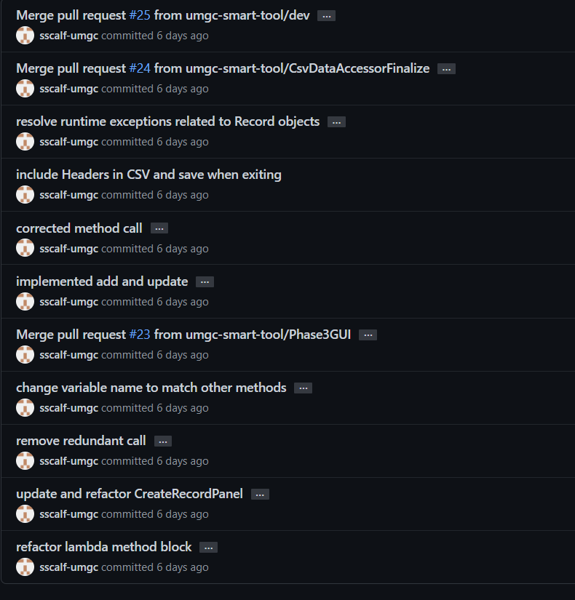

### May 2, 2022

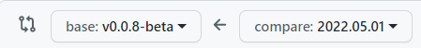

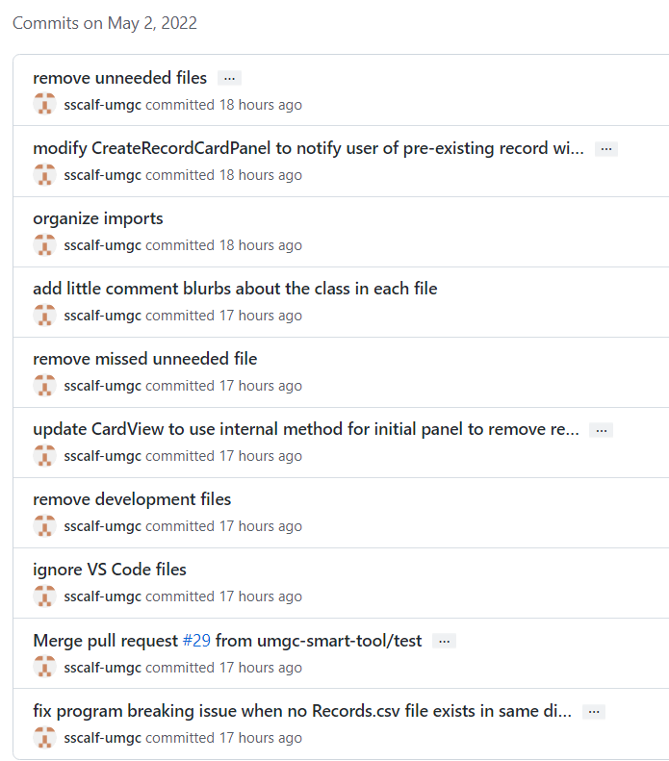

### May 4, 2022

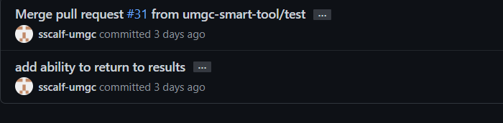

### May 5, 2022

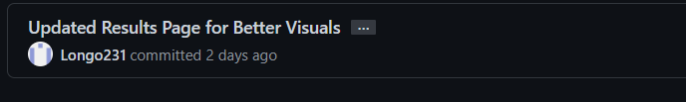

### May 6, 2022

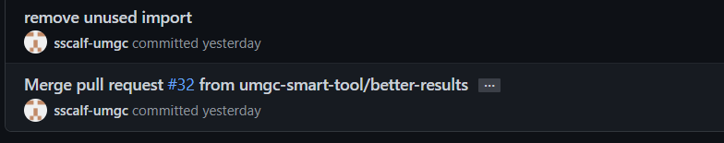

### May 7, 2022

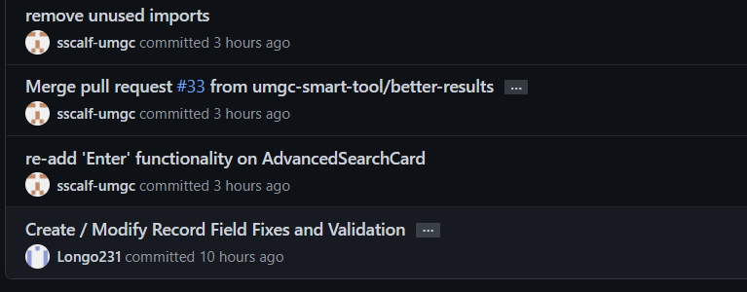

# Conclusion

## Lessons and Learned

### Brian Kilheffer

I have covered many topics in these weeks regarding software development. The discussion posts, article reviews, and peer responses covered various topics, including project management, the history of computing, technical documentation, requirements analysis, open-source software, and security. I have learned many lessons from the topics covered and gained interest in some topics whose knowledge I could apply in my future career pursuits.

I learned that project management is constantly evolving in nature. Project management involves applying knowledge, skills, tools, and techniques to project activities to meet the project requirements. Trends in project management show an increasing emphasis on complex issues and large-scale project management. These trends indicate that the growing complexities stem from advancements in technology, tools, and techniques. Therefore, project managers need to adopt agile project management methods to deal with the growing complexities. Additionally, they need to stay updated with changes in project management trends to ensure efficiency in project delivery and efficiency.

I learned about the importance of quality requirements analysis to the efficiency of the project. Requirements analysis is a crucial phase in project management whose mistakes carry the highest costs. A mismatch between the requirements analysis and project design may force developers to redesign the project, costing them time and other finances. Therefore, understanding who the stakeholders are, what data is used, and how it is used is crucial in refining the requirements to ensure efficiency in project implementation.

Technical documentation and its importance to software development. Technical documentation explains the software design and implementation to users. Therefore, it is necessary to include technical documentation in software development to allow developers to implement software and use it efficiently. Some articles posited that technical documentation should be formulated focusing on developers, who are the primary users. Therefore, resource developers should ensure high findability, readability, and usability of technical documentation. Furthermore, they posit that readability and usability can be improved by making documentation more interactive by using multimedia such as e-books and graphical images. Moreover, it is essential to preserve the relevant technical documentation to give the software historical context for future scholars when preserving computer software.

Lastly, by reviewing my classmate's assignments and commenting on them, I have learned to appreciate and feel appreciated for work done. I have also gained a sense of curiosity whenever a question is posed or when I read an interesting fact or piece of research.

### Samuel Scalf

I found the group work to be the most interesting, which was very surprising to me. Before taking this class, I groaned when I learned it would be mainly group work as all previous group assignments I had involved many non-participants. My group in this class, however, was very active and made the whole experience much more enjoyable.

I have never really done project planning as in-depth as this course required, so seeing all the groups documents was very mind-opening. I would love to apply that new knowledge to all of my personal projects, if not any of my professional projects. If nothing else, I learned the power of documentation -- less comment-style and more report-style. Reading the reports of other teams helped me to better understand their projects without seeing a single line of code.

This summer, I will be starting work as a Software Engineer at Microsoft. I hope to be able to use the information I learned about reports, planning, and git/GitHub in my new role. I have never worked as a developer before, just a System Administrator. I've created extensive PowerShell modules to assist with our most time-consuming tasks, cutting the time required by 75%. Those modules were not planned ahead, nor was any version control or issue tracking used. As a result, my modules are not very clean -- easy to follow -- and I haven't captured any of the issues I ran into, meaning I may not remember how I solved it the first time.

Overall, this course has been a great learning experience, albeit a bit rough at first.

### Josh Longo

I think the biggest topic I learned about in this class is how to work within a team. I've taken many classes prior to this one, and none of them had any group projects with the depth and length of this one. All the assignments I've done up to this point I mostly did myself, doing my own research, learning what I needed to and getting job done. I found that I enjoyed not being the only one working on a project - that having a team there to help with certain aspects of the project is nice to have. It also taught me that the project I'm working on not only affects me, but everyone within the group; if I for some reason could not finish an aspect of the project in time, somebody else would have to pick up the slack, and if they couldn't, then their grade would be affected too.

Another massive topic I learned about in this class is that communication is key. When the group I'm in first started communicating, it was through email, which to me proved to be a bit confusing since all the different responses pointed to a single thread in a cluttered way. Thankfully, we were able to setup a Discord server, which helped greatly with organizing all the different aspects of the project, and for sharing progress and critiques along the way. This leads me to another topic, being able to handle critiques. When working within a team, especially when others have knowledge and experience in what you're doing, you need to be able to accept constructive criticism and work to fix the flaws or slight issues others point out that you may not have noticed.

I think these lessons will be applied in the real world as soon as I get my first job relating to programming. I have not yet had a technical job, but I'm sure most employers put people into teams to get large projects done, rather than having them do everything on their own. Because of this, I think the experience gained from this class will be quite helpful for me when transitioning from class to the real world.

### Chris Ames

In the beginning few weeks, the Code Squad discussed app features and design from a coding perspective regularly in order to come up with a base design and approach to the application. When it came time to code, I used Sam and Josh's skeleton to create the CsvDataAccessor class which handled the loading and saving the CSV file of records, adding/modifying/deleting record objects, as well as accessing the data within each object when conducting the searches based upon user input. Sam and Josh were fantastic resources and did an amazing job on this project. They both helped me with things I was unfamiliar with and were able to help with issues that came up related to my portion of the code. Also converted the data structure of the CsvDataAccessor from an ArrayList to a HashMap, which greatly reduced read and write times, bringing the worst case down from O(n) to O(1), at least when the Reference Number was known.

### Young Jin Jeon

The most interesting topic was project planning and report-based documentation. I did not expect to see these many lists of things to write. There were so many things to consider when starting a project. For example, I did not know about the risks, constraints, assumptions, and out-of-scope sections that I had to look up online for the meanings and samples.

Now I see why a table of content is mandatory. Without the table of content, it would be hard for readers to understand what’s going on and where to navigate. When I was working with the User Guide, I was confused about how to write a guide without having the actual program. I learned that in absence of real screens, made-up screenshots for preview are helpful.

There are so many things I learned in this class. I learned the existence of version control through git, industry-standard reports, and how to work as a team. All the stuff I learned will be helpful when I get into the IT-related field.

### Akane Amagai

This class was memorable than I expected. It was my first experience of making an application as a team. I learned most from this class was playing a role in the team. I was assigned as a documentation squad but I had many question marks in my mind at the beginning of the class because I didn’t know much about project plan, user guide, test plan and project design, I mean none of documentations… Our team managed to make project plan, user’s guide and test plan with everything we came up with. However, we received long feedbacks from professor about lacking information of each plans. I was shocked to receive it but it made my mind changed. It gave me a hint of my role for the team. I decided to deepen my knowledge about each of them.

Especially, I was interested in testing. Before taking this class, I had ever conducted only a test using test cases. But I was wondered, in the real life products, what kinds of tests are required before a firm release it. So I read three books about software testing. I understood the concepts of tests so I could make a list of tests required to our application but still I had hard time to conduct them practically. Because there are too many tools exist. I need to try them to check if which is the best for our application one by one. Then I noticed most of them were very user friendly. I was very appreciated the tool developers. Testing takes forever without these items.

Another lesson of the class was communication. We used discord as communication tool but I live another side of earth from other members. It was difficult to have on time communications and I also have language barrier too. I hoped I could support other members more smoothly. For example, I released test results at every phases. Test results were written as “yes” or “no”, very assertive way. I wrote report with hoping it can assist coding team to improve application with less work. I didn’t have enough skills to express it. I hope they didn’t get impression that the reports were too judgmental. Communication is not easy. So my lesson is ongoing…

Other than above, I learned a lot from the class. It gave me many thoughts. Project, process, design, costs, law and ethics. It was very practical.

Pulling together as a team is not easy. Team members live in distance and time is limited. Even though, working as a team and producing a product was valuable experience for me.

## Design Strength

This application is based on the Model View Controller. The strengths of MVC are faster development process, ability to provide multiple views, support for asynchronous technique, the modification does not affect the whole model, and returns the data without formatting.

Faster Development Process: MVC supports rapid and parallel development. This enabled our group’s coders to work on separate parts, speeding up the development.

Ability to provide multiple views: MVC allows multiple views for a model. It separates business from data logic. There are new ways to approach the application and MVC is in demand these days.

Support for asynchronous technique: Because the MVC model can integrate with JavaScript Framework, it can be made to work with PDF files, site-specific browsers, and desktop widgets. It also enables the application to load faster.

The modification does not affect the whole model: Because the model part and view parts are separate, the modification does not affect the whole model.

Returns the data without formatting: MVC pattern returns the data without formatting so the same component can be called multiple times with any interface.

## Limitations and Suggestions for Future Improvements.

The limitation the app currently has is that each metadata field must be typed by the user. Since users have control of handling data, human error can occur. This can be solved when scan and review functions are added in the future. In the future, users can enter the metadata fields via scanning or cell phone camera, then review them before the submission.

For future improvements, adding functions like deliverable, assigned ref#, generate routing, review document, final approved, document inventory, more metadata, and searchable records can be added.

* Deliverable: add a function to send a link to a certain document.
* Assigned ref#: add a function to scan reference numbers via cellphone (something like QR code). This scanning method is being used in TurboTax where it scans tax information via a cellphone camera.
* Generate routing: add a function to generate the routing number.
* Review Document: add a function to review the document. Currently, it only provides categories and locations.
* Final approved: add a function to review and finalize documents before submission
* Document inventory: add a function to store documents online
* More Metadata: add more Metadata functions
* Searchable records: add a function to search records other than current search functions